CHAPTER 1

ANSWERS TO QUESTIONS

1. Internal expansion involves a normal increase in business resulting from increased demand for products and services, achieved without acquisition of preexisting firms. Some companies expand internally by undertaking new product research to expand their total market, or by attempting to obtain a greater share of a given market through advertising and other promotional activities. Marketing can also be expanded into new geographical areas.

External expansion is the bringing together of two or more firms under common control by acquisition. Referred to as business combinations, these combined operations may be integrated, or each firm may be left to operate intact.

2. Four advantages of business combinations as compared to internal expansion are:

(1) Management is provided with an established operating unit with its own experienced personnel, regular suppliers, productive facilities and distribution channels.

(2) Expanding by combination does not create new competition.

(3) Permits rapid diversification into new markets.

(4) Income tax benefits.

3. The primary legal constraint on business combinations is that of possible antitrust suits. The United States government is opposed to the concentration of economic power that may result from business combinations and has enacted two federal statutes, the Sherman Act and the Clayton Act to deal with antitrust problems.

4. (1) A horizontal combination involves companies within the same industry that have previously been competitors.

(2) Vertical combinations involve a company and its suppliers and/or customers.

(3) Conglomerate combinations involve companies in unrelated industries having little production or market similarities.

5. A statutory merger results when one company acquires all of the net assets of one or more other companies through an exchange of stock, payment of cash or property, or the issue of debt instruments. The acquiring company remains as the only legal entity, and the acquired company ceases to exist or remains as a separate division of the acquiring company.

A statutory consolidation results when a new corporation is formed to acquire two or more corporations, through an exchange of voting stock, with the acquired corporations ceasing to exist as separate legal entities.

A stock acquisition occurs when one corporation issues stock or debt or pays cash for all or part of the voting stock of another company. The stock may be acquired through market purchases or through direct purchase from or exchange with individual stockholders of the investee or subsidiary company.

6. A tender offer is an open offer to purchase up to a stated number of shares of a given corporation at a stipulated price per share. The offering price is generally set above the current market price of the shares to offer an additional incentive to the prospective sellers.

7. A stock exchange ratio is generally expressed as the number of shares of the acquiring company that are to be exchanged for each share of the acquired company.

8. Defensive tactics include:

(1) Poison pill – when stock rights are issued to existing stockholders that enable them to purchase additional shares at a price below market value, but exercisable only in the event of a potential takeover. This tactic is effective in some cases.

(2) Greenmail – when the shares held by a would-be acquiring firm are purchased at an amount substantially in excess of their fair value. The shares are then usually held in treasury. This tactic is generally ineffective.

(3) White knight or white squire – when a third firm more acceptable to the target company management is encouraged to acquire or merge with the target firm.

(4) Pac-man defense – when the target firm attempts an unfriendly takeover of the would-be acquiring company.

(5) Selling the crown jewels – when the target firms sells valuable assets to others to make the firm less attractive to an acquirer.

9. In an asset acquisition, the firm must acquire 100% of the assets of the other firm, while in a stock acquisition, a firm may gain control by purchasing 50% or more of the voting stock. Also, in a stock acquisition, formal negotiations with the target’s management can sometimes be avoided. Further, in a stock acquisition, there might be advantages in keeping the firms as separate legal entities such as for tax purposes.

10. Does the merger increase or decrease expected earnings performance of the acquiring institution?

From a financial and shareholder perspective, the price paid for a firm is hard to justify if earnings per

share declines. When this happens, the acquisition is considered *dilutive*. Conversely, if the earnings

per share increases as a result of the acquisition, it is referred to as an *accretive* acquisition.

|  |  |
| --- | --- |
| 11. Under the parent company concept, the writeup or writedown of the net assets of the subsidiary in the consolidated financial statements is restricted to the amount by which the cost of the investment is more or less than the book value of the net assets acquired. Noncontrolling interest in net assets is unaffected by such writeups or writedowns. | |
| The economic unit concept supports the writeup or writedown of the net assets of the subsidiary by an amount equal to the entire difference between the fair value and the book value of the net assets on the date of acquisition. In this case, noncontrolling interest in consolidated net assets is adjusted for its share of the writeup or writedown of the net assets of the subsidiary. | |
|  | |
| 12. | a) Under the parent company concept, noncontrolling interest is considered a liability of the consolidated entity whereas under the economic unit concept, noncontrolling interest is considered a separate equity interest in consolidated net assets.  b) The parent company concept supports partial elimination of intercompany profit whereas the economic unit concept supports 100 percent elimination of intercompany profit.  c) The parent company concept supports valuation of subsidiary net assets in the consolidated financial statements at book value plus an amount equal to the parent company’s percentage interest in the difference between fair value and book value. The economic unit concept supports valuation of subsidiary net assets in the consolidated financial statements at their fair value on the date of acquisition without regard to the parent company’s percentage ownership interest.  d) Under the parent company concept, consolidated net income measures the interest of the shareholders of the parent company in the operating results of the consolidated entity. Under the economic unit concept, consolidated net income measures the operating results of the consolidated entity which is then allocated between the controlling and noncontrolling interests. |
| 13. The implied fair value based on the price may not be relevant or reliable since the price paid is a negotiated price which may be impacted by considerations other than or in addition to the fair value of the net assets of the acquired company. There may be practical difficulties in determining the fair value of the consideration given and in allocating the total implied fair value to specific assets and liabilities.    In the case of a less than wholly owned company, valuation of net assets at implied fair value violates the cost principle of conventional accounting and results in the reporting of subsidiary assets and liabilities using a different valuation procedure than that used to report the assets and liabilities of the parent company. | |
| 14. The economic entity is more consistent with the principles addressed in the FASB’s conceptual framework. It is an integral part of the FASB’s conceptual framework and is named specifically in SFAC No. 5 as one of the basic assumptions in accounting. The economic entity assumption views economic activity as being related to a particular unit of accountability, and the standard indicates that a parent and its subsidiaries represent one economic entity even though they may include several legal entities. | |
| 15. The FASB’s conceptual framework provides the guidance for new standards. The quality of comparability was very much at stake in FASB’s decision in 2001 to eliminate the pooling of interests method for business combinations. This method was also argued to violate the historical cost principle as it essentially ignored the value of the consideration (stock) issued for the acquisition of another company.  The issue of consistency plays a role in the recent proposal to shift from the parent concept to the economic entity concept, as the former method valued a portion (the noncontrolling interest) of a given asset at prior book values and another portion (the controlling interest) of that same asset at exchange-date market value. | |
| 16. Comprehensive income is a broader concept, and it includes some gains and losses explicitly stated by FASB to bypass earnings. The examples of such gains that bypass earnings are some changes in market values of investments, some foreign currency translation adjustments and certain gains and losses, related to minimum pension liability.  In the absence of gains or losses designated to bypass earnings, earnings and comprehensive income are the same. | |
|  | |

# ANSWERS TO BUSINESS ETHICS CASE

1. The third item will lead to the reduction of net income of the acquired company before acquisition, and will increase the reported net income of the combined company subsequent to acquisition. The accelerated payment of liabilities should not have an effect on net income in current or future years, nor should the delaying of the collection of revenues (assuming those revenues have already been recorded).
2. The first two items will decrease cash from operations prior to acquisition and will increase cash from operations subsequent to acquisition. The third item will not affect cash from operations.
3. As the manager of the acquired company I would want to make it clear that my future performance (if I stay on with the consolidated company) should not be evaluated based upon a future decline that is perceived rather than real. Further, I would express a concern that shareholders and other users might view such accounting maneuvers as sketchy.
   1. Earnings manipulation may be regarded as unethical behavior regardless of which side of the acquirer/acquiree equation you’re on. The benefits that you stand to reap may differ, and thus your potential liability may vary. But the ethics are essentially the same. Ultimately the company may be one unified whole as well, and the users that are affected by any kind of distorted information may view any participant in an unsavory light.
   2. See answer to (a).

ANSWERS TO ANALYZING FINANCIAL STATEMENTS

AFS1-1 Kraft and Cadbury PLC

(1) Discuss some of the factors that should be considered in analyzing the impact of this merger on the income statement for the next few years.

Factors to consider would include items such as a) cost savings b) increasing global presence and increased revenue (from increased market share) c) gaining access to emerging markets, d) geographical and cultural differences between the two companies. Companies generally project EPS for a few years following the merger, and compare these proforma calculations to the EPS prior to the merger. If the EPS increases, the merger is viewed as accretive. If not, it is dilutive. If costs can be eliminated due to redundancies, this helps move toward an accretive EPS. These costs may be related to personnel, computer systems, advertising, etc. However, the impact on the attitudes and incentives of the remaining personnel is not always easy to predict or to quantify. Synergies, in contrast, may serve to boost EPS and create an even more positive environment going forward than anticipated.

(2) Discuss the pros and cons that Kraft might have weighed in choosing the medium of exchange to consummate the acquisition. Do you think they made the right decision? If possible, use figures to support your answer.

The use of each to consummate a merger represents an opportunity cost, in that the cash obviously cannot be used elsewhere. A company needs to weigh the alternative uses available at a given point in time. The use of stock increases the denominator of the EPS calculation thus diluting the earnings for a the existing shareholders. This is not necessarily a poor choice, though, as long as the increase in the numerator justifies the impact on the denominator. The current stock price of the two companies determines the exchange ratio, and most companies are more comfortable using stock when its value is high because it takes fewer shares to reach a specified acquisition price. This view is not entirely sound, however, as the price of the target may be inflated also when the market prices are generally higher. The use of debt to consummate a merger is associated with increased interest costs; hence, debt is generally a wiser choice when interest rates are low.

(3) In addition to the factors mentioned above, there are sometimes factors that cannot be quantified that enter into acquisition decisions. What do you suppose these might be in the case of Kraft's merger with Cadbury?

One issue to consider is the cultural differences between the two companies. If one company has a _______ management style while the other is predominantly ________, the merger can create morale problems for individuals accustomed to being evaluated and treated in a different fashion.

(4) This acquisition is complicated by the lack of consistency between the two companies' methods of accounting and currency. Discuss the impact that these issues are likely to have on the merged company in the years following the acquisition.

Differences in methods, such as depreciation, approaches to estimated bad debts and other reserves, inventory valuation, etc. can lead to headaches and soaring costs following a merger. Translating currency into uniform denomination, whether dollars or euros, leads to translation gains or losses, which impact either earnings or other comprehensive income and more headaches.

AFS1-2 Kraft and Cadbury PLC

A. Cadbury’s Performance



AFS1-1 (continued)

Part A

Computations



Discussion

AFS1-1 (continued)

Part A

The trend in Cadbury’s performance from 2007 to 2009 is very strong. The profitability ratios all increases. ROE increased from 9.7% to 14.5%, while ROA increased from 3.6% to 6.3%. The profit margin decreased slightly in 2008 but was still strong at 6.8%. The gross margins (not shown) remained fairly constant over the three years averaging around 46%. Cadbury generated more than 8% cash from operation (CFO) in each year. The leverage ratio decreased and the market value to book value ratio increased every year to 3.483 in 2009 (indicating good growth potential). The asset turnover ratio (sales to assets) increased in every year, primarily from increased revenues and decreasing assets. Working capital was negative in every year but also has been improving as Cadbury has been reducing the amount of current liabilities over time.

|  |  |  |  |
| --- | --- | --- | --- |
|  | 2007 | 2008 | 2009 |
| Gross margin percentages | 46.7% | 46.7% | 46.3% |

Cadbury’s ROE and ROA

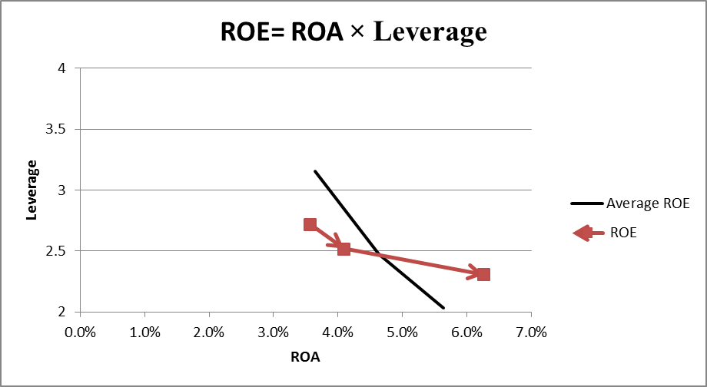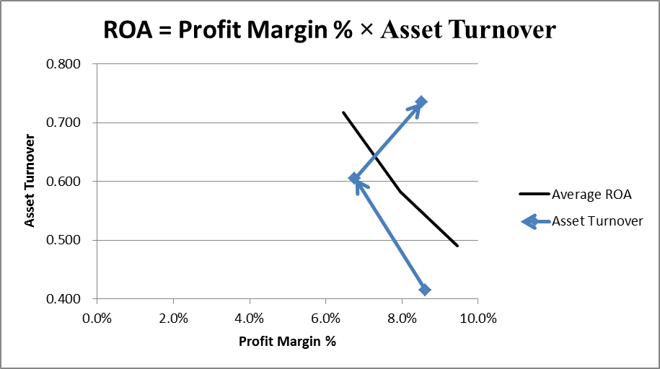

The solid lines in each graph represent a line where the ROE or ROA is equal to the three year average ROE or ROA for Cadbury. As shown in the last year (2009) both ratios exceeded the three-year average for both ROE and ROA. Consider the ROA graph. Even though the profit margin percentage was relatively constant (hovering around 8%) because the asset turnover was increasing (increased sales and decreasing assets), ROA was increasing over time. Consider the ROE graph. Because Leverage was decreasing and ROA was increasing, ROE was increasing over time.

AFS1-2 (continued)

B. Kraft Foods Ratio Analysis



AFS1-2 (part b continued)

Computations:



Discussion

The trend in Kraft Food’s performance from 2007 to 2009 is strong. The profitability ratios have generally increased over time with a slight decrease in 2009. ROE increased from 9.5% to 11.6% (decreasing by 1.3% in 2009), while ROA increased from 3.8% to 4.5% (with a 0.1% decline in 2009). The profit margin increased every year and was 7.8% in 2009. The gross margins (not shown) remained fluctuated over the three years averaging around 34%. Kraft generated around 10% cash from operation (CFO) in each year. The leverage ratio has fluctuated and the market value to book value ratio initially increased but then decreased by 0.6 in 2009 (indicating potential growth issues). The asset turnover ratio (sales to assets) is showing an overall increasing trend relative to 2007. Working capital has been negative but turned positive in 2009 current assets have been growing while current liabilities are decreasing.

|  |  |  |  |
| --- | --- | --- | --- |
|  | 2007 | 2008 | 2009 |
| Gross margin percentages | 33.8% | 32.9% | 36.0% |

Kraft Foods ROE and ROA

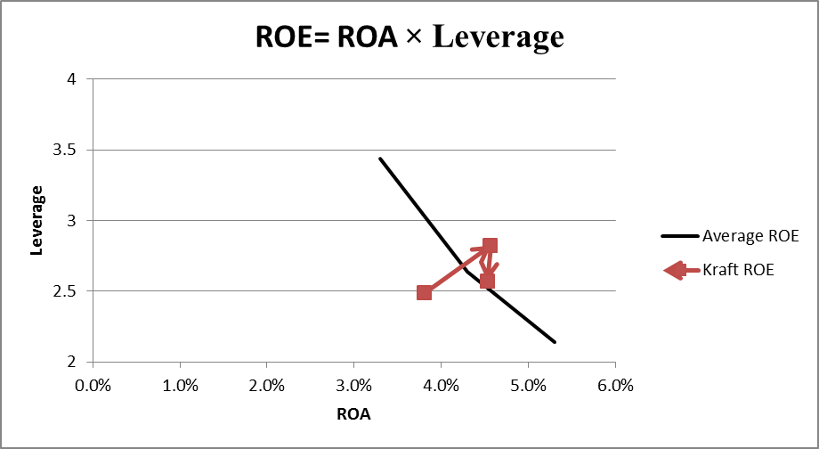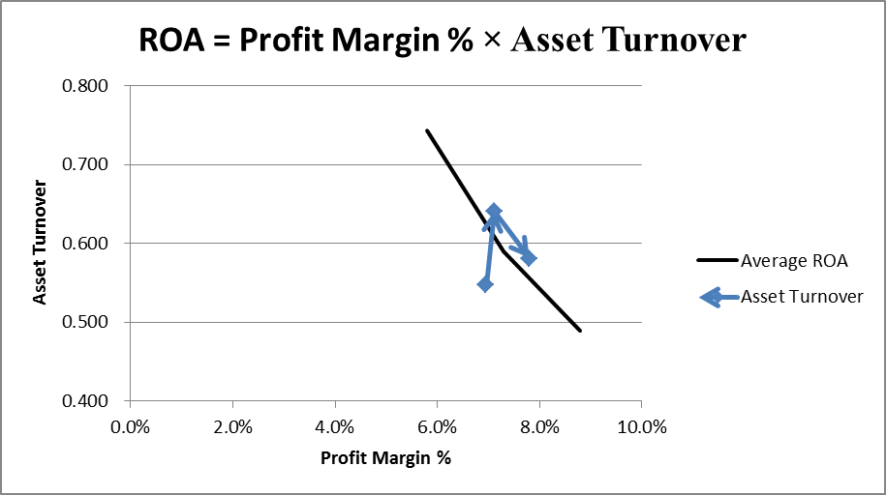

The solid lines in each graph represent a line where the ROE or ROA is equal to the three year average ROE or ROA for Kraft Foods. As shown in the last two years (2008 and 2009) both ratios exceeded their three-year averages. Consider the ROA graph. Even though the profit margin percentage increased in every year, the increase in the profit margin in 2009 was able to offset the decreased asset turnover keeping ROA constant from 2008 to 2009. Consider the ROE graph. In 2009, ROE dropped even though ROA remained fairly constant from 2008 to 2009 because leverage decreased in 2009.

ANSWERS TO EXERCISES

# Exercise 1-1

**Part A** Normal earnings for similar firms = ($15,000,000 - $8,800,000) x 15% = $930,000

Expected earnings of target:

Pretax income of Condominiums, Inc., 2017 $1,200,000

Subtract: Additional depreciation on building ($960,000 × 30%) (288,000)

Target’s adjusted earnings, 2017 912,000

Pretax income of Condominiums, Inc., 2018 $1,500,000

Subtract: Additional depreciation on building (288,000)

Target’s adjusted earnings, 2018 1,212,000

Pretax income of Condominiums, Inc., 2019 $950,000

Add: Extraordinary loss 300,000

Subtract: Additional depreciation on building (288,000)

Target’s adjusted earnings, 2019 962,000

Target’s three year total adjusted earnings 3,086,000

Target’s three year average adjusted earnings ($3,086,000 ÷ 3) 1,028,667

Excess earnings of target = $1,028,667 - $930,000 = $98,667 per year



Present value of excess earnings (perpetuity) at 25%: = $394,668 (Estimated Goodwill)

Implied offering price = $15,000,000 – $8,800,000 + $394,668 = $6,594,668.

**Part B** Excess earnings of target (same as in Part A) = $98,667

Present value of excess earnings (ordinary annuity) for three years at 15%:

$98,667 × 2.28323 = $225,279

Implied offering price = $15,000,000 – $8,800,000 + $225,279 = $6,425,279.

Note: The sales commissions and depreciation on equipment are expected to continue at the same rate, and thus do not necessitate adjustments.

# Exercise 1-2

**Part A** Cumulative 5 years net cash earnings $850,000

Add nonrecurring losses 48,000

Subtract extraordinary gains (67,000)

 Five-years adjusted cash earnings $831,000

Average annual adjusted cash earnings $166,200

(a) Estimated purchase price = present value of ordinary annuity of $166,200 (n=5, rate= 15%)

$166,200 × 3.35216 = $557,129

(b) Less: Market value of identifiable assets of Beta $750,000

Less: Liabilities of Beta 320,000

Market value of net identifiable assets 430,000

Implied value of goodwill of Beta $127,129

**Part B** Actual purchase price $625,000

Market value of identifiable net assets 430,000

Goodwill purchased $195,000

# Exercise 1-3

**Part A**

Normal earnings for similar firms (based on tangible assets only) = $1,000,000 x 12% = $120,000

Excess earnings = $150,000 – $120,000 = $30,000

(1) Goodwill based on five years excess earnings undiscounted.

Goodwill = ($30,000)(5 years) = $150,000

(2) Goodwill based on five years discounted excess earnings

Goodwill = ($30,000)(3.6048) = $108,144

(present value of an annuity factor for n=5, I=12% is 3.6048)

(3) Goodwill based on a perpetuity

Goodwill = ($30,000)/.20 = $150,000

**Part B**

The second alternative is the strongest theoretically if five years is a reasonable representation of the excess earnings duration. It considers the time value of money and assigns a finite life. Alternative three also considers the time value of money but fails to assess a duration period for the excess earnings. Alternative one fails to account for the time value of money. Interestingly, alternatives one and three yield the same goodwill estimation and it might be noted that the assumption of an infinite life is not as absurd as it might sound since the present value becomes quite small beyond some horizon.

**Part C**

Goodwill = [Cost less (fair value of assets less the fair value of liabilities)],

Or, Cost less fair value of net assets

Goodwill = ($800,000 – ($1,000,000 - $400,000)) = $200,000

ANSWERS TO ASC (Accounting Standards Codification) EXERCISES

**ASC1-1 Cross-Reference** The conditions determining whether a the acquisition date was prescribed in *SFAS No. 141R*, paragraph 10. Where is this located in this Codification?

Step 1: Choose the cross reference tab on the opening page of the Codification.

Step 2: Use the ‘By Standard’ drop down menu. Choose FAS as the standard type and 141R as the standard number. Click on ‘Generate Report.’

Paragraph 10 of *SFAS No. 141R* is included in the Codification; FASB ASC paragraphs 840-10-25 1,29,30,31, and 41. FASB ASC paragraph 805-10-25-6. The date of acquisition is the date on which it obtains control of the acquire.

**ASC1-2 Cross-Reference** The rules defining the conditions to classify an item as extraordinary on the income statement were originally listed in *APB Opinion No 30*, paragraph 20. Where is this information located in the Codification?

Step 1: Choose the cross reference tab on the opening page of the Codification.

Step 2: Use the ‘By Standard’ drop down menu. Choose APB as the standard type and 30 as the standard number. Click on ‘Generate Report.’

Extraordinary items are no longer reported in the financial statements. Accounting standards update No. 2015-01 Simplifying Income Statement Presentation by Eliminating the concept of Extraordinary Items removed this topic.

**ASC1-3 Disclosure** Suppose a firm entered into a capital lease (or a right-of-use asset), debiting an asset account and crediting a lease liability account for $150,000. Does this transaction need to be disclosed as part of the statement of cash flows? If so, where?

Disclosure requirements are always section 50 in the Codification (ASC xxx-xx-50-x). Presentation of the statement of cash flows is found under general topic number 200 as topic 230, (ASC 230-xx-50-x).

Yes FASB ASC paragraphs 230-10-50-3 and 4. Information about all investing and financing activities of an entity during a period that affect recognized assets or liabilities but that do not result in cash receipts or cash payments in the period shall be disclosed. Examples include obtaining an asset by entering into a capital lease.

**ASC1-4 General Principles** Accounting textbooks under the former GAAP hierarchy were considered level 4 authoritative. Where do accounting textbooks stand in the Codification?

The topic that established the Codification as authoritative GAAP is Topic 105. FASB ASC paragraph 105-10-05-3 states that accounting textbooks are nonauthoritative accounting guidance and literature.

**ASC1-5 Presentation** How many years of comparative financial statements are required under current GAAP?

Authoritative guidance for financial statement presentation is found in FASB ASC Topic 205 [, Presentation of Financial Statements] FASB ASC paragraph 205-10-45-2 states that it is desirable that the statement of financial position, the income statement, and the statement of changes in equity be presented for one or more preceding years, as well as for the current year.

**ASC1-6 Overview** Can the provisions of the Codification be ignored if the item is immaterial?

Overview and background requirements are always section 05 in the Codification (ASC xxx-xx-05-x). In the search box on the Codification homepage, search for Immaterial. In the ‘narrow by area’ column, click in the box next to ‘general principles’ since the question asks whether GAAP needs to be followed if an item is immaterial. Click on go. The result indicates that FASB ASC paragraph 105-10-05-6 states that the provisions of the codification need not be applied to immaterial items.