4

C H A P T E R

Paleontology

Exercise 4-1 Determining rock age from fossil assemblages in Southwest Missouri
Suppose that a geologist had collected the following suite of fossils from a quarry in southwestern Missouri. Given the ranges of each fossil, determine the age of the rock in the quarry. Document how you reached your answer (see above, Fig. 4.9).
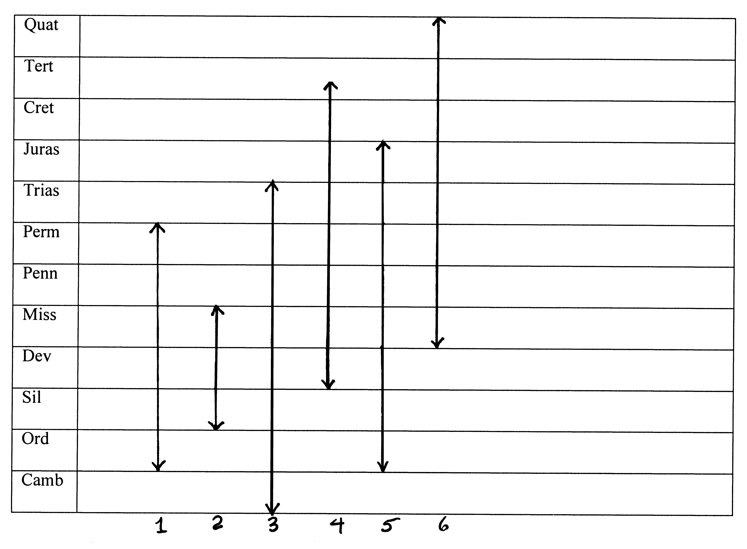
a. What system of rocks was sampled? (Remember system refers to rocks deposited during a geologic period.)
MISSISSIPPIAN

b. Which is the best index fossil?
SPECIMEN 2 (SIL-MISS)

c. Which is the poorest index fossil?
SPECIMEN 4 (DEV-EOC)

d. If you had only two fossils, which two would give you the age of the rock without needing any others?
SPECIMENS 2 AND 6

Exercise 4-2 Determining age of a limestone from fossil assemblage
The following list of fossils represents an assemblage collected from a limestone. Using these fossils and their geologic ranges in the manual, determine to which geologic system the formation belongs.
The geologic system is _MISSISSIPPIAN____________________________________________

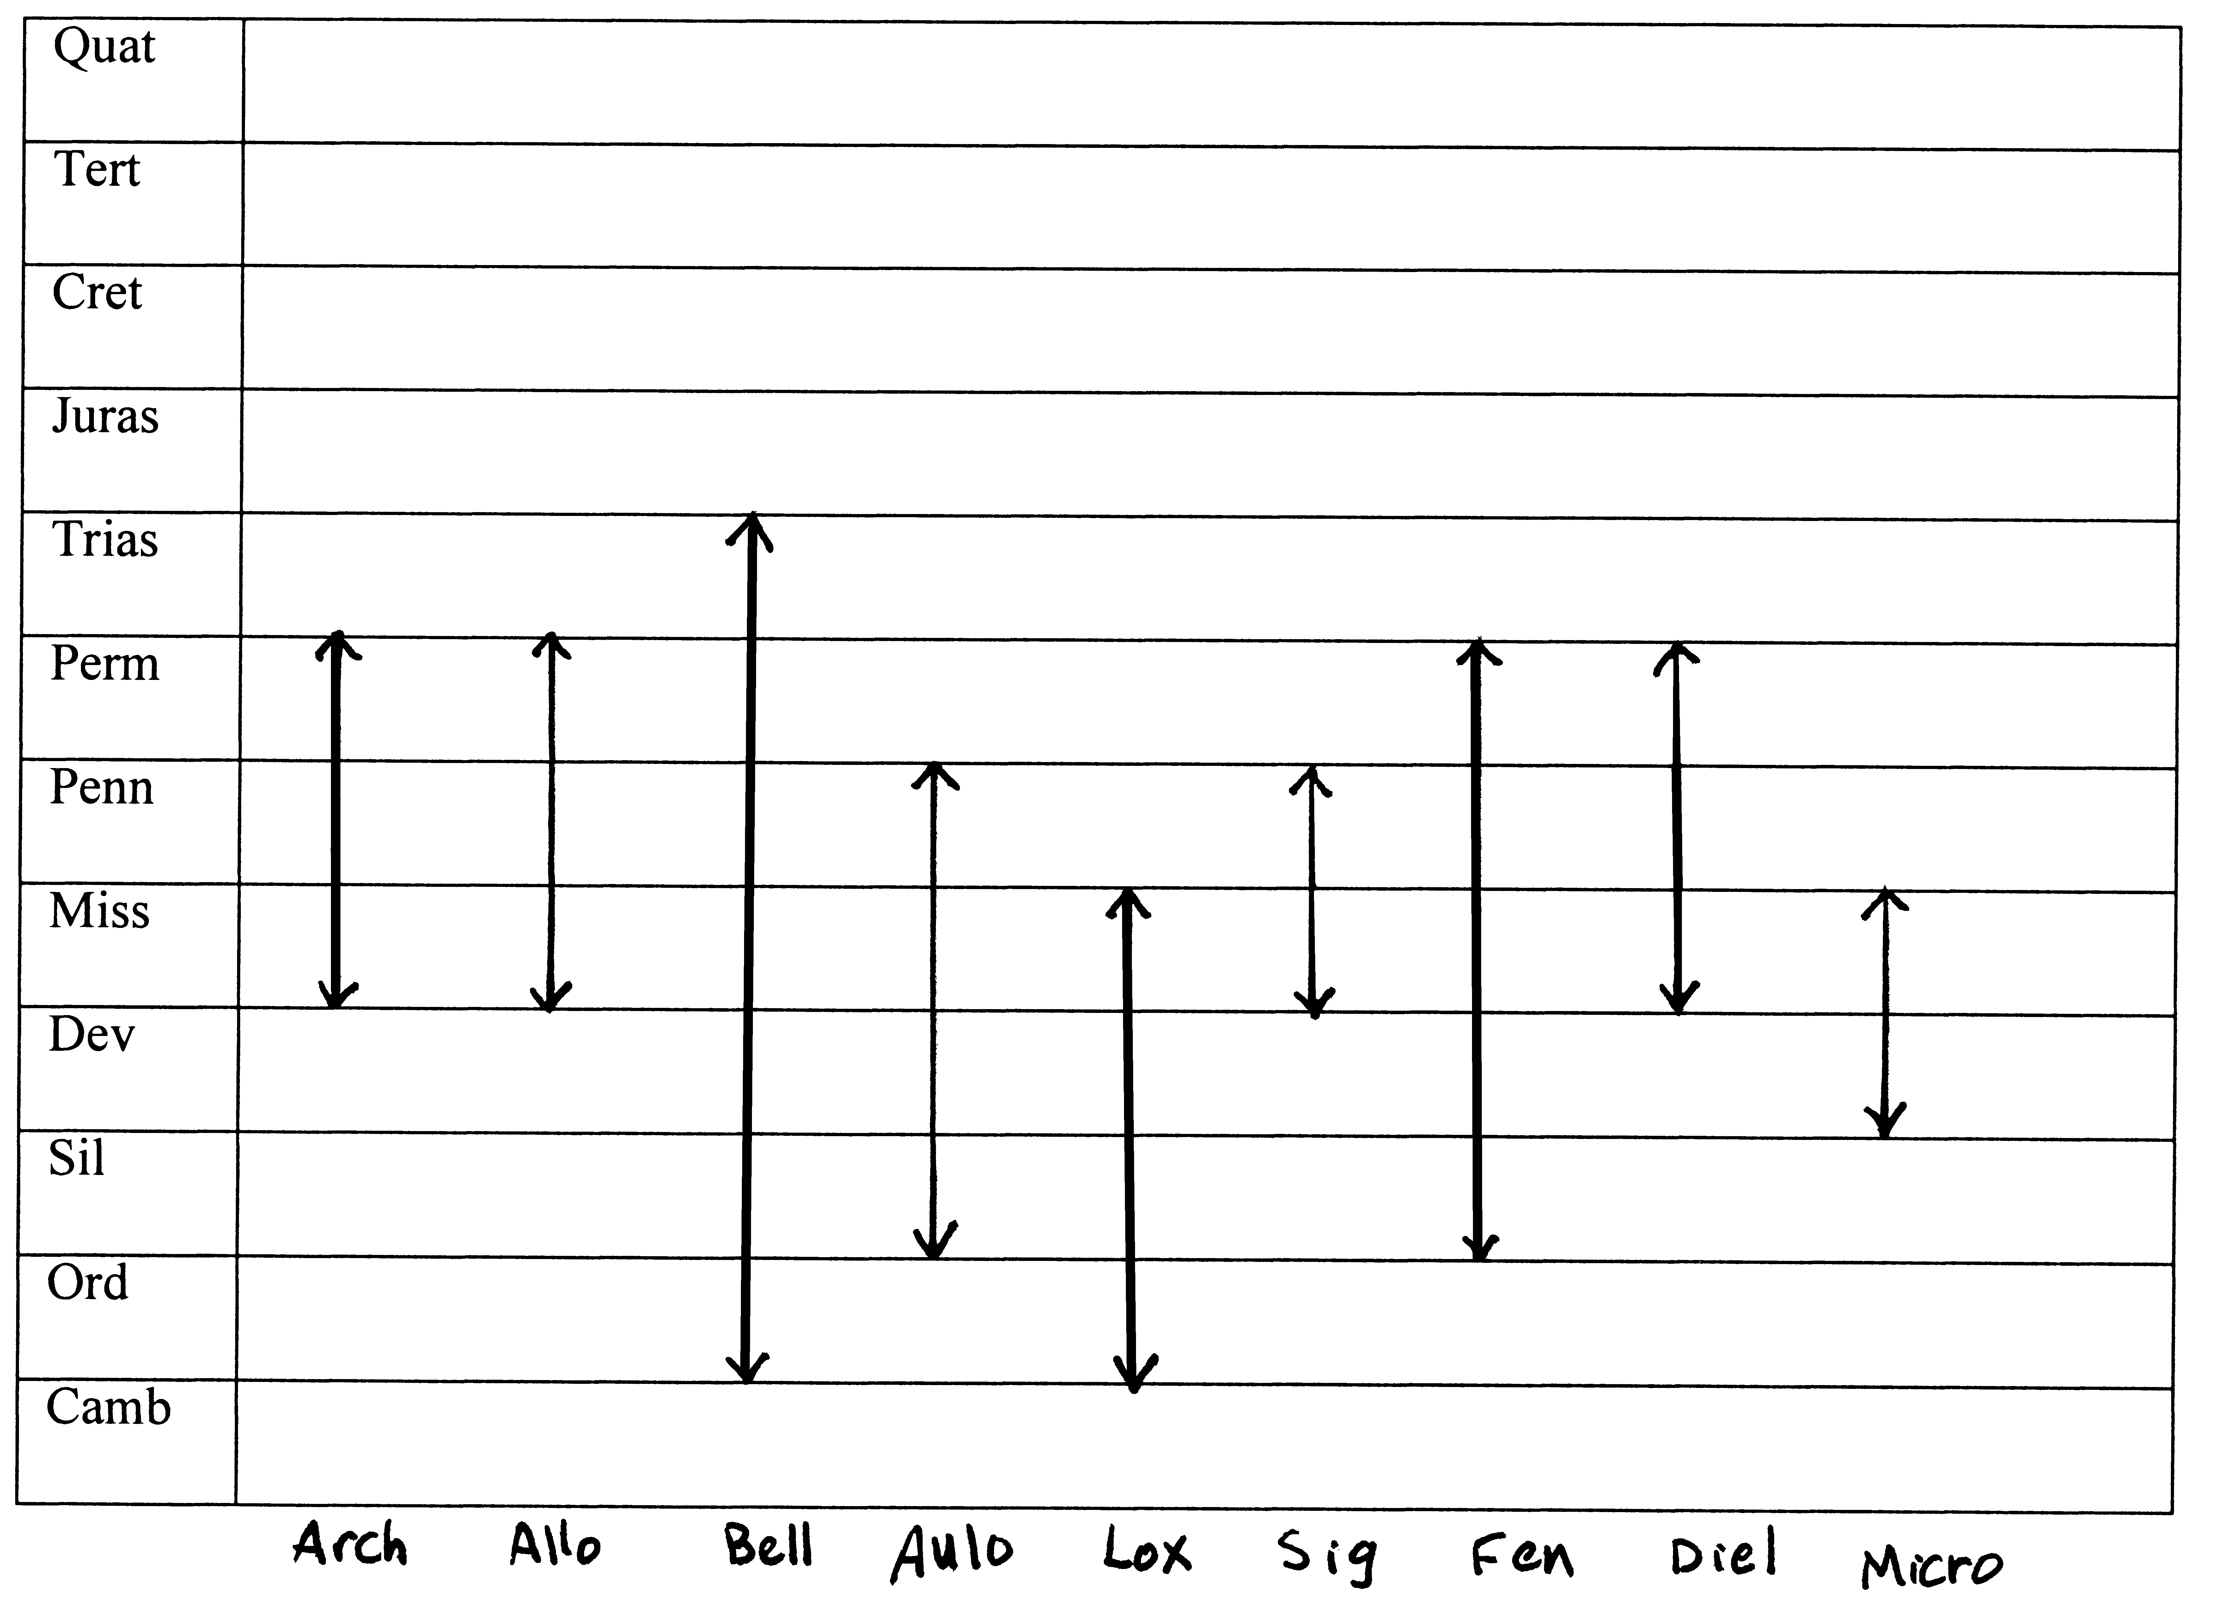

Exercise 4-3 Cretaceous fossil
While fishing from the banks of the Missouri River in eastern Montana, you noticed some shiny fragments of fossils lying in the gray, shaly mud of the banks. The nearby outcrops are known to be composed of Cretaceous strata. Upon closer inspection, you discover that the fragments were from a coiled “critter” that had very ornate “curved” lines across the very shiny pearly or lustrous outer layer. What is this fossil “critter”? AMMONITE

Exercise 4-4 Determining age of a limestone in Northeast Oklahoma
A geology teacher and his students went to a limestone quarry in northeastern Oklahoma and collected a group of fossils. After the students identified the following group of fossils, they concluded that the rocks belonged to the _PENNSYLVANIAN_________________________ system.

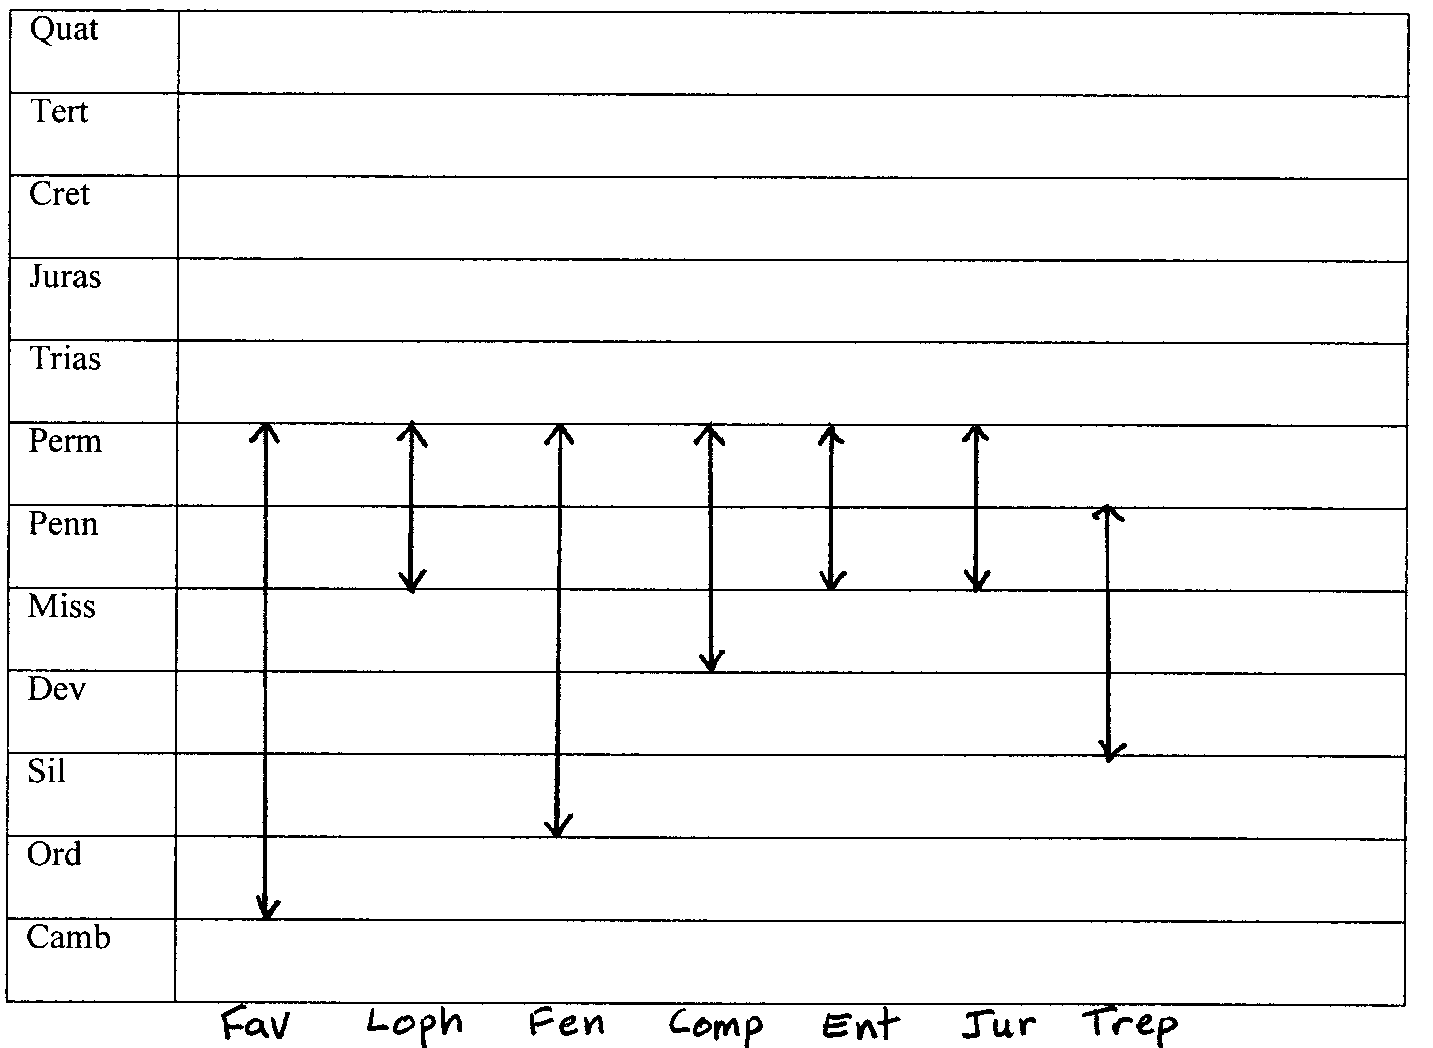

Exercise 4-5 Determining age of a limestone
Determine the geologic system of the major limestone unit in the center of the two columns in Fig. 4.10. For all of the animals found in the same stratigraphic unit, there should be one common interval of geologic time. This period of geologic time is ___SILURIAN__________________________________________.

Exercise 4-6 Using trilobites to determine rock age
All of the fossils named in the column in Fig. 4.11 are trilobites. During which geologic system was the cherty limestone deposited? SILURIAN OR DEVONIAN

Exercise 4-7 Age determination and correlation
Correlate the stratigraphic columns in Fig. 4.12 on the basis of fossils, and determine the approximate missing interval (periods) of geologic time represented by the unconformity. This interval is ____TRIASSIC AND JURASSIC_________.

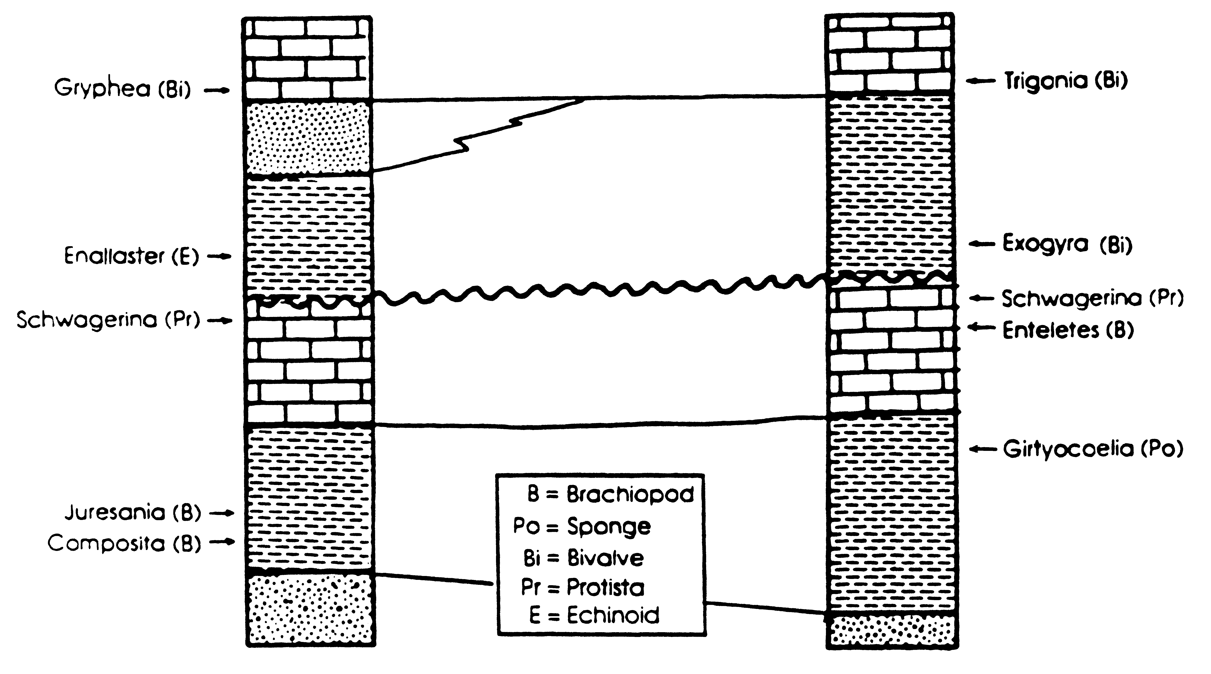

Exercise 4-8 Investigating the Burgess Shale
a. Describe the sedimentary environment of the Burgess Shale and the associated formations. How does that environment differ from the environment in this part of Canada today?
Burgess Shale organisms lived on mud banks built up against an algal reef along the continental margin in the middle Cambrian of western Canada. Today the area is part of the Canadian Rocky Mountains.

b. How were the Burgess organisms preserved, and why is that preservation so unique?
The organisms were transported by mud slumps from shallow water into deeper, more anoxic water where decay was limited. Preservation is unique because soft body parts are preserved as carbon films in the rock.

c. Go to the fossil menu. Using it and the information on fossil groups in this manual, create a Burgess Shale ecosystem. Find one or more representatives of each of the following categories:
Producers: algae and cyanobacteria: Yuknessia and Marpolia
Benthic mobile grazers:
arthropods: Aysheaia, Canadaspis, Marella and others
miscellaneous: Hallucegenia, Wiwaxia
sessile filter feeders:
brachiopods: Diraphora, Micromitra; miscellaneous: Dinomischus; mollusca: Hyolithes; sponges: Choia, Vauxia
burrowers:
worm: Ottoia
Nektonic:
Predator:
miscellaneous: Anomalocaris
scavenger:
worm: Canadia
filter feeder:
chordate: Pikaia; jellyfish: Eldonia
Planktonic:
no specifically planktonic organisms are described

d. Which Burgess Shale species seem particularly peculiar or even bizarre to you? Why?
Hallucegenia, Anomalocaris, Opabina seem bizarre, among others. They don’t look like anything we are used to seeing.

e. Are there some Burgess Shale species which seem to have no living relatives? What might account for
that?
Many in themiscellaneous category have no living relatives, such as Anomalocaris, Opabina, Wiwaxia. Extinction of an entire higher taxonomic group such as phylum or class would account for it.

f. What does discovery of well-preserved faunas such as the Burgess Shale suggest about the
“completeness” of faunas from fossil localities elsewhere?
Most fossil preservation preserves only the hard parts; thus a lot of the diversity that was present at the time is missed.

Exercise 4-9 Vendian “animals”
a. List and describe three Vendian fossils whose affinities are fairly well established. In other words, three fossils on which there is some agreement about what they are.
Students may variously list and describe specimens such as Cyclomedusa, Charnia, Dickinsonia, or Spriggina.

b. List and describe three Vendian fossils whose affinities are in doubt or simply unknown.
Students may variously list and describe specimens such as Tribrachidium, Akarua, Pteridinium, Eoporpita, Nemiana, Kimberella.

c. After reading the descriptions of these “critters,” would you be inclined to consider them as a fauna, that is, a group of animal species?
They have been classified variously as algae, lichens, giant protozoans, or a kingdom unrelated to anything today. For some of them we just don’t know if they were animals or not.

Exercise 4.10 Silurian Reef
What is a reef? What environmental factors are common to reefs throughout geologic time? Why would central North America be a good place to find Silurian reefs?
A structure built by organisms that rises above the surrounding seafloor. Environmental factors are warm, shallow seawater in tropics and subtropics, free of land-derived suspended sediment. In the Silurian central North America was an inland sea that received little clastic material, and the area was situated at the equator due to the position of the North American plate.

a. List the five major types of organisms and their roles in the life of a reef.
Constructors, Bafflers, Binders, Dwellers, Destroyers

b. Look at organisms of the Silurian reef and click on each listed. Determine into which of the five categories (from question B) each organism fits.
Algae: binders
Receptaculitids: dwellers
Stromatoporoids: constructors
Rugose corals: dwellers, colonial were constructors
Tabulate corals: constructors
Brachiopods, Gastropods, Cephalopods, Trilobites: dwellers
Bryozoans, Crinoids: dwellers and bafflers
Other echinoderms (cystoids and blastoids) dwellers

c. What caused the demise of Silurian reefs in Wisconsin? What kinds of environmental factors threaten reefs today?
Local environmental change due to shallowing of the sea. Tidal flat deposits buried reefs, salinity increased, and salt was deposited. It was not an extinction event. Modern reefs are threatened by human activities: over fishing, increased sedimentation from runoff, pollution.

Exercise 4-11 Three solutions to flight
a. Describe the differences in the flight structures, particularly the wing structures and the thoracic structures for each group of vertebrate fliers. How are the wings supported? What structures in the chest power the flight?
Pterosaur: keeled sternum, wing supported by humerus, radius, ulna and elongated
fourth digit, pteroid bone on wrist supporting part of wing
Bird: keeled sternum and wishbone; short, stout humerus, elongate radius and ulna and modified wrist bones support wing
Bats: wing supported by arm and greatly elongated finger bones and by calcar bone at heel.

b. Look at the “Origins of Flight” section. What are the two main scenarios for how flight evolved?
Ground up scenario: bipedal cursorial ancestor
Trees down scenario: arboreal glider ancestor
Neither scenario can be tested directly.

c. Decide which scenario each of the three flying vertebrate groups might have used in initiating flight.
Pterosaurs: bipedal, cursorial archosaur ancestor, ground up scenario
Birds: dromaeosaurs as bipedal cursorial ancestor, ground up scenario
Bats: arboreal glider ancestor, trees down scenario

Exercise 4-12 Examining fossils
The following 10 questions require a simple set of fossils to be available in the laboratory. Answers to a-f, and h, will depend on what specimens are chosen by individual instructors.

g. Coral: outline would have septa pointing to the center; Crinoid: columnal would have round or star-
shaped hole in center; Bryozoan: circular outlines are very small with no septa; Belemnite: solid crystals
would radiate from center; Nautiloid: coiled nautiloid would show curved sutures

j. Fossil wood is hard and heavier, can have different colors due to impurities in the silica, and can show loss
of some internal structure.

Exercise 4-13 Using fossils for paleoenvironmental interpretation
a. There is an unconformity between the Clayton Formation and the Nanafalia Formation. What evidence can you cite to support this fact?
Sinkholes in Clayton are filled in by Zone B sediments. Karst topography occurs by solution weathering.

b. What environment and water depth could be envisioned for zone B?
shallow marine or estuary

c. Give a brief summary of the depositional history of the outcrop from zone A to zone F, using the faunal
and sedimentary evidence available.
Zone A: marine limestone, exposed and eroded at surface forming karst structures; Zone B: shallow water nearshore sediments filled in sinkholes; Zone C: open marine shelf, wave action, clean sand; Zone D: nearshore, delta plain; Zone E: flood deposits or stream channel; Zone F: continental shelf

Exercise 4-14 Fossils and radiometric dating
a. Using the decay curve in Fig. 2.25, determine the ages of the two igneous intrusions.
Intrusion Q = 300 m.y.; Intrusion R = 85 m.y.

b. During what geologic period did mystery fossil Z probably live? _Cambrian__

c. Is intrusion Q older or younger than unit B? _younger_______

d. Stratigraphic unit C was deposited during the _Silurian_____ period.

e. Note the contact metamorphism associated with igneous intrusion R. Using this evidence, is unit D younger, older, or the same age as intrusion R?
Younger: D includes eroded pieces of R

f. What is the specific nature of the contact between unit R and unit C?
Intrusion and contact metamorphism

g. Give a brief narrative summary of the geologic history represented by this geologic cross section.
Unit A was deposited in the Cambrian, unit B in the Ordovician and unit C in the Silurian. Intrusion Q intruded during the Pennsylvanian, intrusion R intruded during the Cretaceous. Erosion occurred followed by deposition of unit D after Cretaceous time.

Exercise 4-15 Review Questions
- List the three requirements that must be met before a fossil can be classified as an index fossil.
Short geologic range and abundant; wide geographic distribution and not facies-dependent; distinctive appearance, easily recognized

- What are two major prerequisites that must be met for most organisms to be fossilized?
Hard parts and rapid burial

3. Are both the genus and species name of a fossil capitalized? Give an example.
Only the genus name is capitalized: Homo sapiens

- Why are there so few Precambrian fossils?
Precambrian organisms did not possess hard parts.

- Would the open prairie country of the midwestern United States be a better place to preserve a vertebrate animal than a lake? Explain.
No. On a prairie bones would be subject to scavenging, trampling, and weathering. A lake provides the protection of rapid burial.

- Would you expect better preservation of very thin shelled bivalves in an ocean front environment or in a sheltered lagoon? Explain.
Sheltered lagoon; the wave action is less severe. Thin shells would be broken by oceanfront waves.

- Describe a natural environment near your home or college where fossil preservation may be taking place. What does this environment provide to enhance preservation?
(Various answers: pond, seashore, lake, river floodplain, swamp, lagoon, delta, etc.)

- What characteristics might distinguish a radiolarian from a foraminiferan?
Forams have a larger, chambered test, commonly of calcite. Radiolaria have an open meshwork of silica.

- Spicules are a means of structural support for the skeleton of a __sponge_______.

- Sponges are sessile benthic organisms; therefore they live in trees close to swamps. True or false; if false, explain why.
False. Sponges are attached benthics in marine or freshwater.

11. How would you distinguish among rugose, tabulate, and scleratinian corals?
Rugose corals have rugae (ridges on the shell). Tabulates have obvious tabula but septa are weak or absent and are colonial only. Scleractinians have easily visible septa in sets of six and are mostly colonial.

- What can corals tell us about past climates and environments?
Reef-building corals today are restricted to warm, clear, tropical waters. Fossil coral reef localities would indicate past tropical marine conditions.

- Corals are not found growing at the mouth of the Mississippi River even though the water is warm and ample nutrients are available. Why are the corals absent from this environment?
There is too much sediment in the water. The symbiotic algae cannot photosynthesize in muddy water. Clays carried by the river also inhibit filter feeding.

- How would you distinguish a bryozoan from a colonial coral?
Bryozoan zooecia are much smaller than the calices of colonial corals. Bryozoa do not possess septa.

- If a fossil brachiopod were found to be composed entirely of pyrite, would you suspect that replacement had taken place? Why?
Yes. Brachiopod shells are originally composed of calcite.

- What distinguishes the coiling in many cephalopods from that of the gastropods?
Most cephalopods coil in a flat (planispiral) coil and have chambers in the shell. Most gastropods coil in a cone-shaped spiral (conispiral). Gastropod shells have no internal chambers.

- Ostracodes, brachiopods, and clams all have two valves. How would you differentiate each of these groups?
Ostracodes are very small and are studied with magnification. Brachiopods have valves which are dissimilar. Clams have valves which are similar.

- Trilobites are known to have molted their exoskeletons. How would this affect their preservation potential?
Wave action on molted exoskeletons tends to detach heads and tails. Molting would increase the potential for fossilization of at least one exoskeleton since each trilobite would have shed several over its lifetime.

- Why are so many subdivisions of the arthropods poorly represented in the fossil record?
The chitinous exoskeletons of arthropods are not easily preserved.

- Describe the symmetry of the phylum Echinodermata.
Pentameral or five-sided symmetry

- What is an endoskeleton and what is an exoskeleton? Which of the following groups have endoskeletons and which have exoskeletons: brachiopods, bryozoans, belemnites, ammonoids, corals, crinoids. Trilobites, gastropods, sponges, and vertebrates?
Endoskeletons are located within the soft tissue of the body and exoskeletons are an external covering. Endoskeletons: belemnites, vertebrates. All the others have exoskeletons.

Exercise 4-16 Fossils as Paleoenvironmental Indicators
a. Which rock layers (1–6) belong to the offshore, barrier island, and lagoon/marsh facies? Cite evidence.
1) marsh; 2) marsh-barrier island; 3) offshore; 4) barrier island; 5) marsh; 6) marsh

b. Which set of fossils—(P + Q), (W + X), or (Y + Z)—goes with each sedimentary environment?
P+Q = marsh; W+X = barrier island; Y+Z = offshore

c. Considering your answers to the first two questions, which of the following events would you say had taken place in the region represented by the stratigraphic section: a transgression, a regression, both, or neither? Discuss your answer.
Both transgression and regression

The following data are given:
- A cross-section of a modern environment.

2. A partial list of the common species occurring within the environment. (Table 4.2).

3. Marsh deposits will often have a distinctive dark gray or black color. What causes this color, and how it is related to the presence of marsh grasses such as Spartina and Salicornia? What does this suggest about the completeness of the fossil record?
Dark color is due to decomposing Spartina and Salicornia. These plants, like soft-bodied animals, are removed from the fossil record by decomposition.

4. The small shrimp Callianassa lives primarily in the relatively clean sand portions of the beach face within the intertidal (littoral) zone. Could Callianassa burrows be of value in interpreting sea level changes?
Yes, fossil Callianassa burrows (Ophiomorpha) could be used to trace shoreline positions over time.

5. What might the recognizable effects in the geologic and biologic record be if this modern environment were hit by a hurricane?
Barrier island sediments could be spread over the marsh as washover fans. This would terminate the marsh environment and change the faunal assemblage. Flood tides would bury marsh in deeper water and kill marsh-adapted plants and animals.

