Chapter 1
Operations Strategy and Global Competitiveness

Chapter Summary

This is one of the most important chapters in the text as it defines operations management as the activities associated with transforming inputs into valued outputs. The chapter also shows that the actual production system is defined in terms of its environment, inputs, transformation system, outputs, and the mechanism used for monitoring and control. In our definition of the production system, we define all transformation systems as services—with or without facilitating goods (physical entities accompanying the transformation process).

This chapter continues with a definition of customer value as perceived benefits divided by costs. Customer costs include upfront monetary investment, other lifecycle costs for maintenance, and the hassles involved in obtaining the product or service. Discussion of customer benefits focuses on innovative products and services, functionality, quality, customization, and responsiveness.

Following the discussion of customer value, the chapter continues with a discussion of strategy and competitiveness. Global trade trends are discussed. Next, the chapter provides an overview of the business strategy formulation process and includes timely material on vision and mission statements, internal and external forces, business strategy, the business model, and business unit strategies. After that, business unit strategic frameworks are described: the life-cycle approach, the performance frontiers concept, focus on one or two key areas of strength, and the sand cone model. Finally, the chapter concludes with a discussion of core capabilities, outsourcing, and offshoring.

The chapter concludes with a discussion of productivity as a key measure to assess how well the value-creating process is performing. Included in the discussion of productivity are alternative productivity measures including single factor, multifactor, and total factor productivity measures. After discussing these measures, the topic of productivity is linked to the standard of living and the productivity of alternative countries discussed.

Chapter Teaching Tips

There are a number of ways to introduce the course material. Many MBA students work at companies that have recently initiated a Lean/Six Sigma project, have outsourced processes to suppliers in low-wage countries, or have implemented an Enterprise Resource Planning system. Therefore, students naturally should be inquisitive about operations management and the aforementioned topics.

One approach is to have the students read cases prior to first class. “Wyatt Earp – The Buffalo Hunter” case is a short, but interesting case, that touches upon many aspects of operations strategy. A second case, “American Outsourcing” discusses the outsourcing of manufacturing and service jobs from the United States to Mexico, China, and India. Citations for these cases can be found at the end of these notes.

Another useful approach for illustrating the importance of operations management is to have students read the Harvard Business Review article “Fast Heat: How Korea Won the Microwave War (January/February 1989). The article emphasizes a number of important themes including:

- A strong production orientation. Samsung emphasized production over marketing.
- Design done with manufacturing in mind.
- Measures like payback and return on investment were not used.
- The customer should never be kept waiting.
- Engineers travel, not just the sales force.

Other benefits of using the Fast Article, is that it is a brand students are likely familiar as it is a major player in smartphones and it has continued to achieve considerable success in a number of other industries.

Another approach is to start with a movie or video that illustrates the operations activities of some firm or organization and use this to lead to a discussion of the operations function.

Then, the instructor can introduce the topics of global competiveness and strategy by asking students for the slogans of firms they are familiar with (e.g., "Everyday low prices—always!"). From this, the number of areas of strength that are in the operations area can be counted. Typically, 80-90% will fall in the operations area indicating its strategic importance. The discussion can then move to the Chinese successes in world markets and American firms' often typical lack of attention to operational activities.

Illustrative Answers to Expand Your Understanding Questions

- Services are typically more customized than products and thus less subject to repetitive automation, which could increase their efficient production. Second, the technology of service production is nowhere as advanced as that for products. Last, because services cannot be stored, this makes their timely production more expensive.

- Services do seem to be protected because of their high provider-customer interaction, which is difficult for foreign firms to offer due to distance, language, culture, and other such matters. It is commonly believed that, because services have less foreign competition, domestic firms are better at providing services than products. This is probably a great fallacy, as anyone who has experienced service offerings in multiple foreign countries can tell you.

- The Japanese work more diligently in designing and planning their operations and exert less effort in controlling them. In fact, much of their design efforts are directed toward eliminating the need to control their work, for example, by making errors or mistakes more obvious and easily corrected. They thus offer better designed outputs and also spend less on correcting, counting, monitoring, and controlling those outputs with the result that they are often more competitive in global markets.

- A manufacturer would see that the physical product was only a part of the total package being sold to satisfy a customer, and that a service provider might consider adding a facilitating good to their offerings to enhance the service.

- Previous problems with acquisitions have been due to attempts to grow for purely financial reasons instead of good business reasons; essentially playing a financial game. Wise acquisitions are conducted slowly, with long and intensive analysis, and bring true synergy to the firm's existing products, services, distribution network, or other (and frequently multiple) aspects of their focus.

- Some other potential areas of focus include being able to acquire and assimilate companies, the use of data to gain a competitive advantage, and in the case of a non-profit, fund raising.

- China possesses a core capability of cheap, abundant labor. India possesses a core capability of abundant and skilled, English-speaking labor. Japan has always had a strong capability in teamwork and execution, while the U.S. has always been known for its creativity, innovativeness, and flexibility.

- Obviously, the student will have to choose a point of reference to determine if an action is ethical, a topic worth discussion all by itself. That is, the student can look at the action from the view of the one taking the action, from the one affected by the action, or from a disinterested observer. Whose laws are relevant: home country, foreign country, both?

- The cost savings largely arise from the discipline required to produce quickly: Fewer errors, fewer operations, smoother processes, less labor, fewer inventories. Other savings also accrue to fast response, however, such as less time for engineering changes to the product and, more important, less time for the customer to request changes, or even cancel the order! Last, though not a cost, faster response means faster revenue generation too.

- One example of a company that has moved the performance frontier of its industry is Southwest Airlines—Southwest offers delivery speed, dependability, and low costs. A second example would be Dell in entering the market for plasma televisions by offering televisions with high quality at a cost lower than competitors’ prices.

- In Japan, protectionism was used to nurture infant industries and protect them from foreign competition until they could compete on their own. In particular, after WWII, Japan began to emphasize product and process quality. At the same time, U.S. producers, believing that they already manufactured the world’s best products, emphasized marketing of those products. The American proficiency in marketing enables U.S. producers to continue to sell products/services that in some cases are of lower quality than those sold by Japanese producers. The Japanese emphasis on engineering enables their producers to introduce products faster, to improve processes more dramatically, etc.

- Based on Figure 1.4, we would expect between 1/5 and 3/5 of the reduction in the response time, with an average of ½. Since a cut by a factor of ten means a 90% reduction, we would thus expect a unit cost reduction between 18% and 54%, with an average of 45%.

- Walmart’s order winners are price and product variety. Walmart’s qualifiers include quality and delivery reliability. Toyota’s order winners are quality, innovation, product reliability, and performance. Toyota’s qualifiers include price and delivery reliability. BMW’s order winners include performance and innovation while BMW’s qualifiers include quality and delivery reliability. Sony’s order winners include innovation and performance. Sony’s qualifiers include price and delivery reliability.

- Given the recent trends in products and services, i.e. consumers demanding better performance on all competitive dimensions, one could make a valid argument for use of the Sand Cone model over the focus strategy because companies must be able to deliver multiple core capabilities.

- The systems perspective emphasizes the relationships between various system components. Since the system boundary defines what is considered to be part of the system and what is considered to be part of the environment and thus beyond the decision maker’s control, the way the system boundary is defined profoundly affects the results of systems analysis. On the one hand, if the boundary is defined too narrowly, important relationships among the system components may be omitted. Conversely, increasing the system boundary increases the complexity and costs associated with developing and using the model. Unfortunately, determining the system boundary is more of an art than a science and is based on the experience, skill, and judgement of the analyst.

- Since efficiency is output divided by input, the expected output increase due to the new equipment might be less than the cost (an input) of the new equipment. Thus, replacing labor with equipment only improves efficiency if the equipment is cheap relative to the amount of labor it is displacing. Also, the organization needs to consider the cost associated with setting up and maintaining the equipment. Systems engineers tend to be a more expensive resource than shop floor workers.

- One of the hardest decisions for a manager to make is laying off employees. Yet, this is frequently basic to productivity improvements. For example, when demand drops, the output will also drop and without a commensurate reduction in the inputs productivity will also decline. Of course firms don’t like to lay off employees for a number of reasons including reduced employee morale, negative publicity, and because in the near future business may pick back up that will require hiring more employees who are likely to be less experienced than the ones that were fired. Therefore, organizations often delay layoffs. Obtaining desperately needed equipment is another difficult situation if the capital is hard to acquire.

- Pump: output divided by electricity cost. Warehouse: annual shipments (units or dollars worth) divided by annual cost of maintaining the warehouse. $1000: output obtained divided by $1000. Market survey: information obtained (subjective value or increase in sales) divided by cost of survey. Kilowatt-hour: work accomplished divided by cost of 1 kilowatt-hour.

- Efficiency was defined as doing the thing right while effectiveness was defined as doing the right thing. Since it makes little sense for an organization to do the wrong thing efficiently, effectiveness is more important. Indeed there are numerous examples of organizations that have obtained long-term success that are not efficient (e.g., Steinway pianos, Rolls Royce cars). It is hard to identify organizations that have obtained long-term success that were not effective.

APPLY YOUR UNDERSTANDING

Izmir National University (INU)

Teaching Tips for Case

This case illustrates the importance that a well-defined strategy plays in helping coordinate and guide employees. In addition, the case provides students with an opportunity to develop a strategic planning process for the Business School to reinforce their understanding of the hierarchical nature of strategic planning. Instructors have a great deal of flexibility in terms of the level of detail they wish to go into. For example, instructors that want to go into more detail can require the students to develop a vision and mission statement for the Business School. This exercise can be significantly enhanced by asking the students to search the Web for existing Business School vision/mission statements and then having the students evaluate and critique these statements in terms of the language used and what their reaction would be to the statements if they were a student, faculty member, or company that recruited students from the school.

The case also exposes students to the difficulty of measuring productivity, especially in organizations that produce multiple outputs and where one or more of these outputs is an intangible service.

- The variety of goals and concerns expressed by the professors indicates an absence of a well-defined strategy. This can be illustrated by discussing the lack of consistency in the faculty’s comments. For example, one docent/professor commented, “research is our primary mission” while another stated “there is far too much emphasis placed on research.” Another way to illustrate this is to list the wide range of priorities expressed by the professors. The suggestions made by the professors range from improving student/teacher ratios to getting a Ph.D. program approved to increasing the travel budget to getting better secretarial support to allowing professors more time for consulting. Thus, the comments suggest that the professors are pursuing their own personal objectives and not supporting a common university or school-wide strategy. After making this point, the instructor may want to spend some time discussing the likely outcomes and problems associated with not having a well-defined strategy at INU.

- As the leader of a university operating division, one primary role of a Dekan (administrative head, dean) is to ensure that the actions and decisions made at the school level are consistent with and support the overall university strategy. Of course, this may be complicated by the absence of a well-defined overall university strategy or one that has not been effectively communicated. It is quite likely that this is the case at INU given its short existence and overwhelming success. Administrators may simply feel that INU is doing fine without having a formal strategic plan.

At any rate, the first step for the Dekan is to determine what the university’s overall mission and strategy is. If it turns out that the university does not have a well-defined mission, the Dekan can use this to the Business School’s advantage by convincing the President and Provost of the need for a university strategy and then proactively helping formulate the strategy so that the Business School’s interests are reflected in the strategy.

Once the Dekan has a good understanding of the overall university mission and strategy, she can initiate an effort to develop a strategic plan for the Business School. To ensure buy-in and commitment to the school’s strategic plan, the Dekan should include as many of the professors in the process as possible. Perhaps she may decide to chair a committee composed of several of the full professors, a couple of the docents, one or two staffers, one or more business professionals, and perhaps even a student or two to begin drafting a vision/mission statement and strategic plan for the Business School. In formulating a vision/mission statement that supports the university’s mission, the committee needs to consider the school’s strengths and weaknesses, its resources, its culture, the environment, and the desires of its faculty and other stakeholders. Further, given the small size of the Business School, it would be highly desirable to get feedback from all faculty members. One way to accomplish this would be to invite all faculty members and staff to periodic meetings to solicit their reactions and input to the vision/mission statement as it is being drafted.

After the vision/mission statement has been developed, the committee can turn its attention to developing a strategic plan for achieving the school’s mission. One key component of the strategic plan is the identification of the school’s core competencies and how these competencies will be developed on an ongoing basis. In addition, the committee needs to determine how the strategic planning process will be continued in the future. One option would be to have the Dekan serve as the chair of a Priorities and Goals Committee. Faculty could be selected or elected to serve on this committee for a specified term. The committee could develop a list of priorities at the beginning of each year and meet periodically during the year to assess the school’s progress.

- There are a number of ways the productivity of the Business School could be measured. Potential partial productivity measures include:

- Total Student Credit Hours Taught/Professor and Instructor Salaries
- Total Student Credit Hours Taught/Full Time Faculty Equivalents
- Grants Received/Full Time Faculty Equivalents
- Papers Published/Full Time Faculty Equivalents

The ability to develop a multifactor productivity measure is extremely difficult given the absence of a common monetary unit with which to express the various outputs in, such as Euros or Yeni Lira (Turkish currency). For example, there is no easy way to combine total student credit hours taught and papers published into a meaningful measure of output. Therefore, more than likely, the Business School will need to develop a number of partial productivity measures including separate ones for tracking teaching productivity and research productivity. Of course, the problem is still complicated by qualitative differences that exist in the inputs and outputs. For example, not all journal publications are equal. Journal publications can differ in terms of the rigor of the research, the impact the paper has on research, the impact the paper has on practice, the number of pages in the article, and the respectability of the journal the paper is published in. As another example, how does teaching a 5-hour survey course with 250 undergraduate students compare to teaching an advanced 5-hour graduate class with 20 students? Alternatively, for that matter, how does teaching a Principles of Management course compare to teaching the Statistics course, assuming an equal number of students?

The impact that a 10% raise will have on productivity is also difficult to assess. According to the first partial productivity measure above, increasing salaries while holding everything else constant would appear to lower productivity. On the other hand, if the second partial productivity measure is used, the raise in salaries would appear to have no effect on productivity. In actuality, assessing the change in productivity is again influenced by a number of qualitative factors. For example, although the first partial productivity measure appears to indicate a reduction in productivity, it does not allow for the fact that the professors may become more effective over time and that the students learn more as a result. In addition, the measure does not consider the fact that once a teacher preps a course the first time, teaching the same course requires less effort and therefore the professor may have more time to devote to other activities. In other words, once a professor preps a course, considerably less effort is typically required to teach the course at a later date.

Discussion Outline for Case

I. The Current Situation
- Discuss what the faculty comments tell you about INU’s strategy
- Comments often contradictory and lack consistency
- Professors pursuing own objectives not supporting school’s or university’s objectives
- Major problem is there appears to be no well defined or articulated strategy

II. What Should the Dekan Do
- Dekan’s Role
- As leader of Business School, he must formulate vision and mission for school
- Dekan’s vision and mission must support overall university strategy
- Developing a Vision/Mission Statement
- How much and who should be involved
- Developing Strategic Plan
- Core competencies
- Developing Strategic Planning Process

III. Measuring Productivity at the Business School
- Partial Measures
- Multifactor Measures
- Difficulties
- No aggregate measure of output
- Qualitative differences difficult to account for
- Effect of 10% Raise on Productivity
- Different measures give different results
- Influence of qualitative factors
- Productivity Measures Should be Tracked Over Time

Taracare, Inc.

Teaching Tips for Case

This case is designed to illustrate the problem of sub-optimization. The case can also be used to demonstrate how individual components of a system interact and/or the roles played by various functional departments. In addition, the case can be referred to when the topic of strategy is discussed in the next chapter. For example, the case can be discussed in conjunction with the strategy formulation process to demonstrate how a vision and mission statement might help align the decisions being made in different functional areas. In addition, appropriate core competencies for Taracare can be identified and discussed.

- On the surface, it might appear as though outdoor furniture and replacement windows have very little in common. Therefore, it might be argued that Jorge made a mistake in hiring a new manufacturing manager without the proper qualifications. Thus, some students may argue that Alfredo be given some period of time to familiarize himself with the operations of the new production facility. However, the evidence in the case suggests that Jorge is not overly concerned with the plant’s performance and that the pressure for improvement is coming from Alfredo himself. On the other hand, it should be noted that in actuality both products do have much in common. For example, both products are assembled from extruded aluminum. Second, aluminum and glass are key raw materials of both products. Finally, both products are sold to similar customers. Thus, to the contrary, it would appear that Alfredo’s previous experience does qualify him for the position at Taracare (assuming he performed well in his previous position).

- Given Alfredo’s responsibility and concern for meeting delivery commitments and product quality he would likely make recommendations such as the following:
- Have the purchasing agent consult with someone in production before switching suppliers to determine the impact on operations of such a switch.
- Include someone from production on product design teams.
- Get the accounting and finance people off his back so he can do his job.

- Given Jorge’s background in sales, it is reasonable to assume that this is the area with which he is most concerned. The evidence in the case certainly supports this view. For example, Jorge’s first initiative was to triple the sales force. Also, he did not seem to be overly concerned with production’s performance:
- Rather than address the issues Alfredo raised in the meeting, he deferred them to be resolved at a later date.
- He gave no indication that he believed the issues were important and that he would deal with the issues (“Then perhaps I will call a meeting…”)
- In actuality, it appeared that he was inclined to dismiss the problem (“… our production is no worse than our competitors…” “we don’t expect you to solve all our problems overnight…” “Keep up the good work…” “send me that memo at your earliest convenience” not as soon as possible).

Although Jorge may be giving sales his highest priority, it is a reasonable assumption that his real objective is to maximize his wealth. Clearly, the way to do this is by maximizing Taracare’s profits given his 75 percent stake. Thus, given Jorge’s previous experience and background in sales, it is not surprising that he has chosen to focus his efforts on the sales function.

For Alfredo to get Jorge to buy into improving operations, he first needs to demonstrate the connection between operations and Taracare’s profits. Jorge must recognize that maximizing profits is his primary objective and that each functional area contributes to this objective. Based on this broader perspective, Alfredo can demonstrate that optimizing one area can negatively affect the overall organization. The issues he raised in the meeting can be used to demonstrate this point (e.g., buying cheaper raw materials that ultimately cost the company more, designing products that are difficult to produce, and so on). Employing a broader system perspective, Jorge can consider the way each functional area can best contribute to the overall organizational goals.

Discussion Outline for Case

- The Current Situation
- Discuss Alfredo Diaz's primary concerns
- Discuss Jorge Gonzalez’s reaction to Alfredo’s concerns
- These are really symptoms of larger problem
- The real problem is sub-optimization

- Jorge’s Approach
- Sales background
- Most likely interested in maximizing his wealth
- Seems to be focusing on what he knows best

- Need Systems Approach
- Goal of entire organization (system) needs to be made clear
- Each functional area must consider how it can contribute to the accomplishment of the overall organizational goal

SOLUTIONS TO EXERCISES (Excel file also available)

1.
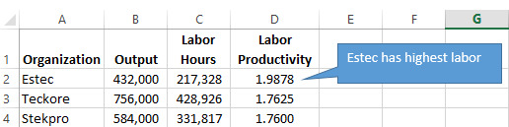

2.
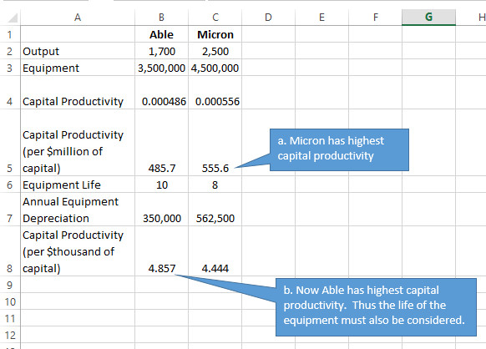

3.
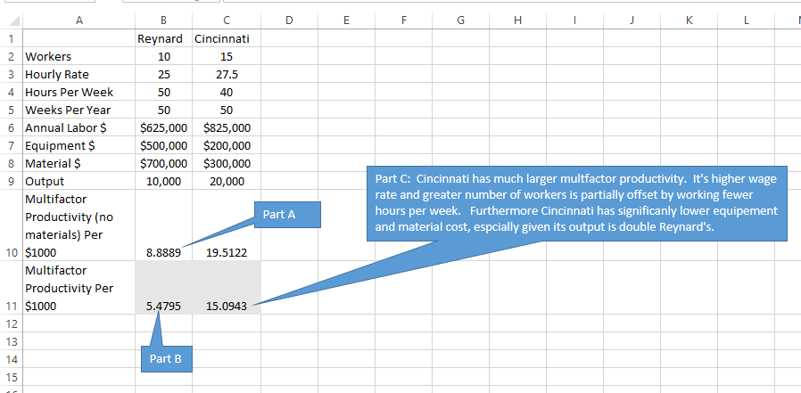

4.
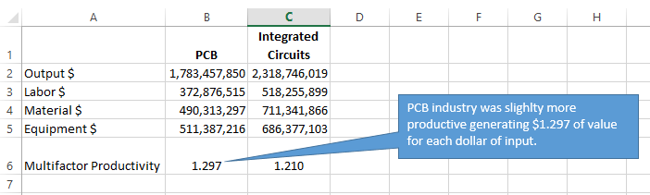

5.
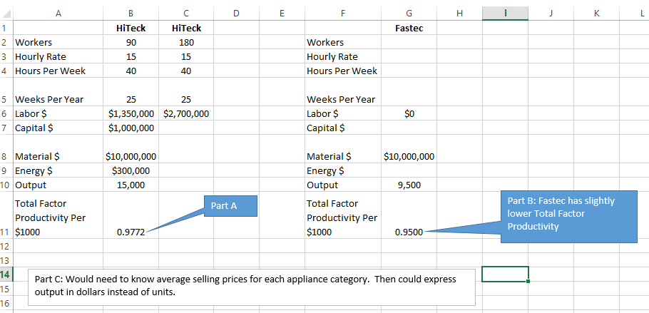

6.
a.
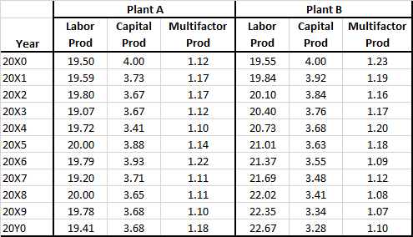

b.
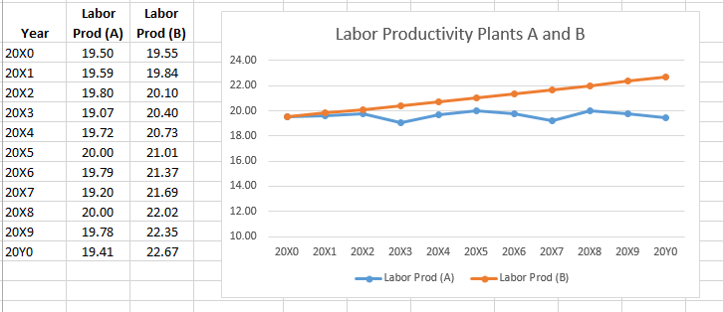

c.
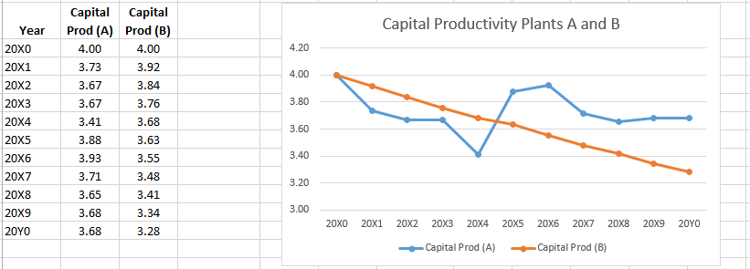
d.
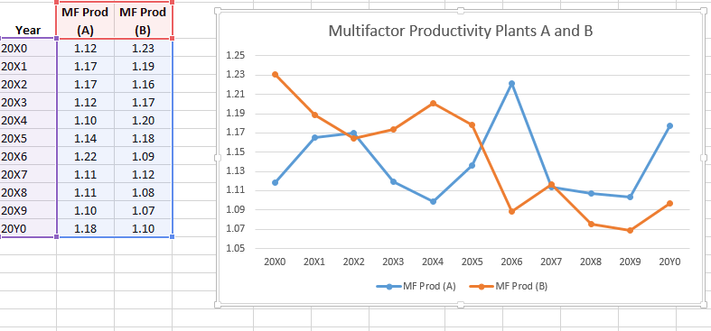

e.
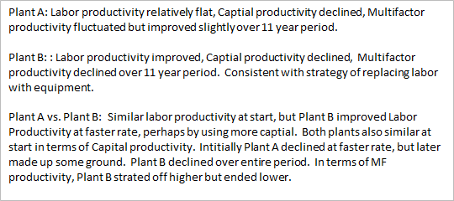

7.
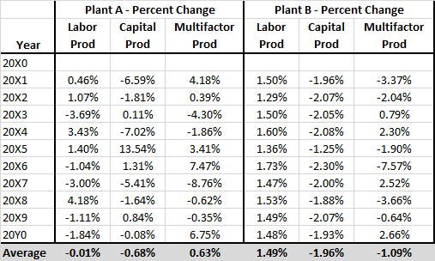

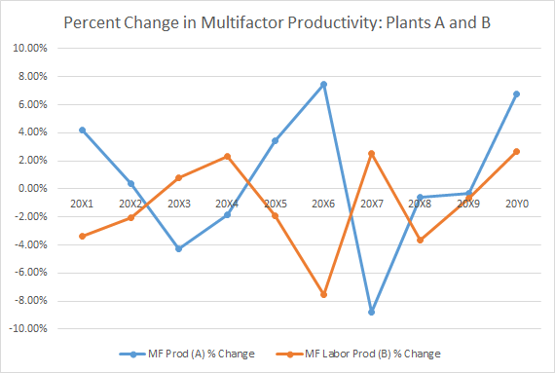

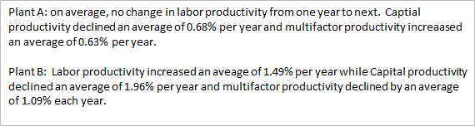

8.
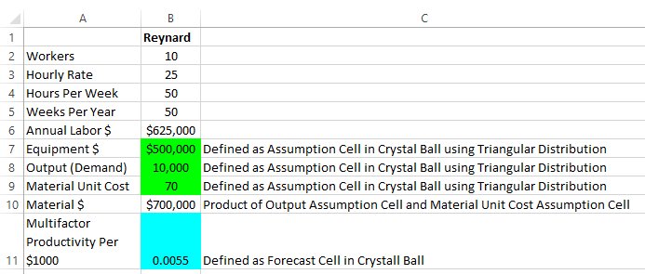

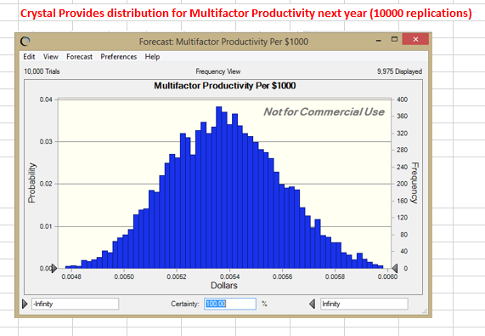

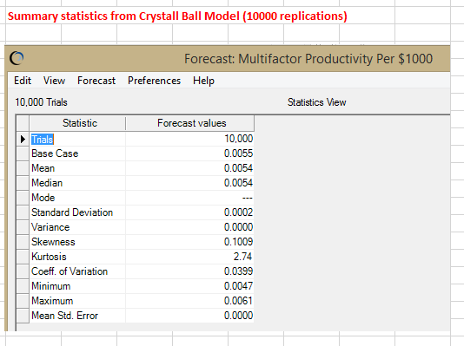

Suggested Cases/Readings

Case: Wyatt Earp – The Buffalo Hunter (F. Robert Jacobs, Irwin/McGraw-Hill, 1998)
This case discusses Wyatt Earp’s innovations in operations to hunt and hide buffalos. Issues discussed in this case touch upon process choice, capacity, quality control, compensation, work structuring, and organizational structure. This case also lends itself well to a lively discussion of sustainable competitive advantage and sustainable operations management.

Case: American Outsourcing (2005) (Hvd 9-705-037)
This case includes a review of the Mexican Maquilodoras, special economic areas in China, and service outsourcing to India. The case also considers General Electric’s outsourcing of jobs to these countries.

Case: Copeland Corporation (A) (Hvd. 9-686-088, TN 5-688-074))
Perhaps the penultimate operations strategy case, this situation describes the typical plant producing everything for everyone in one mixed up mess. A new manager arrives and begins to focus production by moving particular types of jobs to other plants and thereby obtains tremendous improvements in quality, productivity, market share, volumes, and margins. Focus is by product in some cases and by process in others. Finally, the original plant is left and a decision about how to focus its production remains.

Case: Intel Systems Group (Hvd. 9-691-040, TN 5-692-034))
The Intel Systems group is facing a shift from producing large customized computer systems in small batches to small standardized desktop systems in very large batch sizes. The case provides students with the opportunity to analyze this shift on both product development and manufacturing. Case also lends itself to an analysis of issues related to handing off products from product design to process design to manufacturing.

Case: Taco Bell (Hvd. 9-692-058, TN 5-692-091 and 5-196-073)
This excellent case involves issues of layout, quality, labor staffing, product design, and information systems, all coordinated with a unique strategy driven from the top. Moreover, the strategy is misleading to an outside observer and is only successful because of its totally integrated nature. Rich enough to do some quantitative data analysis also.

Case: The Great Nuclear Fizzle at Old B&W (H.B. Meyers, Fortune, Nov. 1969)
This article provides an excellent illustration of the many potential problems of applying the same production strategy to a new product that appears to be simply the next evolutionary step of the current product. The article has no numbers to analyze but on the other hand can be read in class in a short period. Thus, it can be discussed en masse or by dividing the class into small groups and having group leaders address one of the many relevant issues. Note: this case is particularly appropriate for a first meeting of the term when the class has not yet had an assignment to prepare.

Case: Eli Lilly and Company: Manufacturing Process Technology Strategy (1991) (Hvd 9-692-056, TN 5-692-109)
Case can be used to illustrate the stages of operational effectiveness framework, the link between operations strategy and product development, and the importance of developing a manufacturing capability.

Case: Eli Lilly and Company: The Flexible Facility Decision (1993) (Hvd 9-694-074, TN 5-696-041)
Key issues concerns whether Lilly should continue to build highly specialized facilities or develop more flexible facilities that can produce a wider range of outputs. Case provides students with opportunities to perform discounted cash flow analysis and breakeven analysis. Case also ties in nicely with performance frontier framework. Case can be combined with Eli Lilly and Company (9-692-056) to create module on technology and facilities strategies.

Case: McDonald’s Corporation (Hvd 9-693-028, TN 5-693-106)
Addresses challenges to McDonald’s operational strategy resulting from growing range of products. Also addresses issues related to the development of a corporate environmental strategy and provides students with an opportunity to analyze environmental management issues.

Case: Nucleon, Inc. (Hvd 9-692-041, TN 5-692-095)
Case addresses key strategic issue, namely, whether a R&D intensives start-up should manufacture its products in-house or outsource. Case lends ties in very nicely with topic of core competencies/capabilities. Case also provides students to perform discounted cash flow analysis of the options.

Case: Whistler Corporation (A) (Hvd 9-690-011, TN 5-692-108)
This case also ties in nicely with topic of core competencies/capabilities. Whistler previously achieved competitive success through R&D and marketing but is encountering problems because of weaknesses in manufacturing. Students must first determine the basis on which Whistler should choose to compete. Once this decision is made, more detailed analysis of the options on the table can be undertaken. A (B) case is also available (9-692-072)

Case: Managing Orthopaedics at Rittenhouse Medical (Hvd 607152)
This case presents an overview of an orthopaedics department at a medical center that is running a private business practice and an academic faculty practice. The case lends itself to discussion of operational focus within a service setting.

Case: Daewoo Shipbuilding and Marine Engineering (Hvd 609018)
This case discusses the ability of a major Korean shipbuilder to develop its learning capability. The firm is faced with a competitive threat from Chinese competitors and must decide what parts of its operations to outsource.

Case: New Balance Athletic Shoe, Inc. (Hvd 606094)
This case analyzes aspects of New Balance’s strategy of employing domestic manufacturing when most of its competitors outsource production to Asian suppliers. The case requires that students determine which aspects of its operations strategy New Balance should change.

Reading: Plant and Service Tours in Operations Management (R. Schmenner, Pearson Custom Publishing, 2004)
This paperback book contains a nice variety of both manufacturing and service facility tours featuring job shops, assembly lines, mass services, professional services, etc. Does an excellent job of giving students who are less experienced in the variety of ways that production can be organized some insight into what we mean by each.

Reading: Welcome to the Experience Economy (B. J. Pine, II and J. Gilmore, Harvard Business Review, July-Aug. 1998, pp. 97-105, Reprint # 98407)
This article describes the evolution of the economy from one of products to services to experiences and what it means for both providers as well as consumers. Prognosticates about the future of services in terms of experiences.

Reading: A Glossary of TOM Terms (Hvd. 9-687-019)
This brief 4-page note introduces the student to terms such as cycle time, bottleneck, capacity, utilization, throughput time, lot size, run time, etc.

Reading: Fast Heat: How Korea Won the Microwave War (I.C. Magaziner and M. Patinkin, Harvard Business Review, Jan.-Feb. 1989, pp. 83-92, Reprint # 89114)
Although the microwave was invented in the U.S., Korea's Samsung is now the largest producer of microwave ovens. A story of world-class competition and how third-world countries are winning markets.

Reading: Deep Change: How Operational Innovation Can Transform Your Company (M. Hammer, Harvard Business Review, April 2004, pp. 84-93)
This article focuses on breakthrough operational innovations and the strategic, marketplace, and operational benefits that result from those innovations.

Reading: Manufacturing Strategy: At the Intersection of Two Paradigm Shifts (R.H. Hayes and G.P. Pisano, Production and Operations Management, 5(1), 1996, pp. 25-41)
Nice overview of the evolution of manufacturing strategy. Also discusses performance frontier framework.

Reading: Competing Through Manufacturing and The New Manufacturing Paradigm: Is Manufacturing Strategy Passe? (K.B. Clark, Production and Operations Management, 5(1), 1996, pp. 42-58)
Nice discussion of performance frontiers and advanced manufacturing systems.

Readings: What Really Makes Factories Flexible? (D.M. Upton, Harvard Business Review, Reprint 95410) and The Management of Manufacturing Flexibility (California Management Review, Winter 1994, pp. 72-89)
Two excellent articles on flexibility.

Reading: Manufacturing—Missing Link in Corporate Strategy (W. Skinner, Harvard Business Review, May-June 1969, pp. 136-145, Reprint # 69312)
Probably THE classic operations strategy article. Old but still valuable.

Reading: The Focused Factory (W. Skinner, Harvard Business Review, May-June 1974, pp. 113- 121, Reprint # 74308)
Probably the second classic article. Details the original conception of “focus.”

Reading: A Strategic Approach to Evaluating Manufacturing Performance (P.R. Richardson, Interfaces, Nov.-Dec. 1985, pp. 15-27)
An excellent analysis of the different forms of operations strategies and the actions that managers should take to implement these strategies.

Reading: Beyond Products: Services-Based Strategy (J.B. Quinn et al., Harvard Business Review, Mar.-Apr. 1990, pp. 58-67, Reprint # 90212)
Describes the process of identifying a firm’s competitive strength(s) and focusing on that while outsourcing everything else.

Reading: The Icarus Paradox: How Exceptional Companies Bring About Their Own Downfall (D. Miller, Business Horizons, Jan.-Feb. 1992, pp. 24-35)
The article insightfully illustrates how four different types of competitive strengths can easily turn into four different types of competitive liabilities. Examples of such firms are given and guidelines to avoid these perils of success are described.

Reading: Mass Customization at Hewlett-Packard: The Power of Postponement (E. Feitzinger and H. L. Lee, Harvard Business Review, Mar.-Apr. 1997, pp. 116-121, Reprint # 97101)
Describes the power of the concept of postponing the addition of product differentiating characteristics until as late as possible in the supply chain. This allows the producer to achieve the marketing benefits of customization while still reaping the cost benefits of high-volume, standardized production.

Reading: Innovation and Efficiency: It Is Possible to Have It All (M. Sarkees and J. Hulland, Business Horizons, Jan.-Feb., 2009, pp. 45-55).
This article discusses a strategy of pursuing both innovation and efficiency simultaneously. The authors provide the results of a cross-industry survey of marketing managers in U.S. firms to support the viability of this strategy.

Reading: Process Completeness: Strategies for Aligning Service Systems with Customers’ Service Needs (G. Piccoli, M. Brohman, R. Watson, and A. Parasuraman, Business Horizons, July-Aug., 2009, pp. 367-376).
This article discusses developing strategies for service businesses. The authors argue that those strategies should strive to achieve process completeness, i.e., linking the service system to the customer’s expectations.

Reading: Going “Purple”: Can Military Jointness Principles Provide a Key to More Successful Integration at the Marketing-Manufacturing Interface? (M. Douglas and D. Strutton, Business Horizons, May-June, 2009, pp. 251-263).
This article discusses the U.S. armed services’ ability to integrate quickly the strategies, strengths, and capabilities of two or more branches of the armed services. The authors provide a methodology for a firm’s marketing and manufacturing functions to use this same type of integration to meet the global challenges they face.

CASE: BPO, Incorporated: Call Center Six Sigma Project
Allen Lauren, executive vice president of BPO, Incorporated (BPO) has received an email complain from the CEO of one of their major clients stating that he was very dissatisfied with their service and demanding an audit and possible renegotiation of their contract. He is trying to decide how to respond.
Question 1: Is the variability in the times required by the benefits administrators (BA) excessive? If so, what might be done about it?
Loading data took an average of 80 minutes but could vary between 20 minutes and 300 minutes (five hours). Contacting the client regarding errors took between 10 and 60 minutes 95 percent of the time and 150 to 210 minutes the other five percent of the time. Determining eligibility of participants who had made a change averaged 90 minutes with a range of five minutes to 300 minutes. Producing an audit report took an average of two hours with a range of 15 minutes to six hours.
Manually updating the database took an average of 85 minutes with a range of 10 minutes to five hours. Downloading changes took an average of 50 minutes but ranged from 15 to 120 minutes. Based on this new information, participate eligibility was again run, requiring an average of 90 minutes with a range of five minutes to 300 minutes.
Report generation took about 40 minutes with a range of five minutes to 120 minutes. Importing reports into Access took an average of 25 minutes with a range of as little as five minutes and as long as 60 minutes. Auditing these reports took an average of 45 minutes with a range of 15 to 180 minutes. Finally, uploading the results of everything took an average of 180 minutes with a range of 30 minutes to as long as 495 minutes.
These results show a very wide range of variations. No doubt some of the variation is due to varying sizes of clients. To the extent that the variations are due to other factors, BPO should investigate best practices and additional training to reduce the variation. In addition, many of these steps appear ripe for automation.
Question 2: Jerry Small observed “a number of CSRs putting clients on hold despite the fact that they are trained not todo this.” Why might they be doing this?
The BPO phone system is designed to automatically track the duration of each call and presumably this is used at some point to evaluate the customer service representatives (CSR) and their performance. One of the things Jerry discovered in his investigation is that the BPO phone system does not include hold time in the call duration. Thus, a CSR can reduce their apparent call duration time by placing the client on hold while researching their issue.
Question 3: CSR utilization is only 37 percent. Why so low? How might it be raised?
Two issues are likely at play here. The first is the phone system not tracking call duration while the call is on hold. Thus, the CRS is working doing research but that time is not being logged. Second, there is a large variation in call volume from a high of 60 per hour 11:00–12:00 to a low of 10.2 7:00–8:00 p.m. While BPO had staggered scheduling, it is likely that there were periods of time when the CSRs had fewer calls than they could handle, leading to a lower utilization.
BPO clearly needs to fix the issues with its phone system so hold time is counted as part of call duration. This will give much better planning data and allow for better evaluations of the CSR employees. Additionally, BPO may wish to look into using part-time BPO employees during periods of high demand.
Question 5: Does the Health and Welfare Service Delivery Process appear to be fundamentally broken to you? Are incremental improvements likely to help?
The fact that BPO is losing money while revenues have been growing at 30 percent annually does indicate a serious problem that clearly cannot be solved by growth alone. They wide variations in processing times by the BA’s indicates that the process is not well standardized and is poorly automated. All of this would seem to indicate a fundamentally broken process.
The low utilization of the BA’s and CSR’s indicates that better scheduling and changes to staffing levels might improve the profitability picture somewhat. However, this seems unlikely to improve customer service. For that, better processes and more automation are likely required.
Question 6: How would you suggest that Allen Lauren respond to Sam Regan?
To begin with, the email from Sam Regan provides no details on why he was dissatisfied with the service provided by BPO. Did it take too long? Was the service provider rude? Were the answers wrong? Without knowing the exact nature of the problem, any response to Regan would be premature.
Assuming the dissatisfaction steams from the service taking too long or related issues, then Lauren can respond by discussing the improvement processes currently in the works. If the dissatisfaction came from other reasons, that information might suggest other areas for Jerry Small to investigate.

CASE: Peerless Laser Processors
Peerless Saw Company was in dire straits when they decided to purchase their first laser cutting system. Even though they could not justify the ROI, in retrospect, the investment “saved” the company. The following factors contributed to this situation:
- Peerless was selling to the same customers, but the laser system had created a new and growing market that had not previously existed.
- The original ROI would have been based on a single shift. Because of the new market, the company actually operated the laser on two shifts.
- To successfully apply ROI, Peerless would have had to predict the creation of the new market, a nearly impossible task.

Question 1: How did the laser cutter “save” Peerless Saw Company when it could not be justified on payback or ROI grounds? Does this mean that the economics of automation is not important, or at least were not for Peerless?
In 1981, the company faced a do or die decision that forced them to use new technology. If the lasers failed, the company would have had nothing to fall back upon. There was no good economic justification available at the time upon which to base the decision. By contrast in 1984 the company had a track record with the technology, had a good feel for the market and its potential growth, and was in a much stronger position financially. Ted can be much more comfortable making this decision because of the reduction in uncertainty. The decision is harder on one way though. When the company had it’s back to the wall, it was clear that something different had to happen and quickly. When the company is in a more comfortable position, the pressure to make a decision is greatly reduced, making it easier to procrastinate.
Question 2: Compare the decision Ted faces now—the 1200-watt laser purchase—with the decision he faced in 1981 when he was considering the three punch presses. Structure the investment decision for each of these cases. (Assume a computer costs about $20,000 and software about $80,000. Training costs are included in this charge.) Consider costs, benefits, and risks. How has the decision environment changed? Is Ted more or less comfortable with this decision? How is this decision easier? How is it harder?
There are some potential problems with the new laser:
- Peerless will be creating products that are unfamiliar to them.
- Peerless has no way of knowing if the new market will respond as well as the saw blade market did to the anticipated improvements in quality and cycle time coming from the laser.
- The new product line will require different distribution channels, different marketing techniques, and will draw new and different competition.
- Peerless may not be able to attract enough business to keep the system productive.
The potential benefit is, of course, a new large market to successfully apply Peerless’s laser cutting experience. A significant strategic variable that Peerless should consider is the long-term viability of the saw blade market. The success of laser cutting (as Peerless has experienced) and other technologies has the potential to reduce the overall market for mechanical cutting devices over the long term.
Question 3: What do you think the potential problems might be in purchasing the 1200-watt laser? What about the potential benefits? Will this laser have the same impact on the business as the first laser? What are the strategic variables involved in these decisions?
The following steps are needed to estimate the payback:
- Estimate the amount of laser cutting needed using a 14” saw blade as a typical product. The blade would have approximately a 44” circumference. Doubling this amount to account for teeth and adding 9” for the arbor gives approximately 97” of linear cutting distance required to manufacture the blade.
- Based on the cutting speed of 40”/minute, the cutting would take 2.4 minutes. Adding time to handle the blade, and maintain the workstation, estimate the total time at 3 min/blade.
- Exhibit 3 estimates the operating cost of a 1200 watt laser at $.10/min, making the laser’s portion of the blade cost $.30/blade; not a particularly significant amount for a $25 blade.
- Exhibit 3 estimates the cost of the laser to be about $200,000. Assume an additional $100,000 for computers and training bringing the total to $300,000.
- If the laser can produce a blade every 3 minutes, than it could produce 160 in eight hours at $25 a unit. Based on Exhibit 1, the current profit margin is 12%, so it’s safe to assume that the single shift daily profit would equate to 160 X $25 X 12% or $480.
- Given the $300,000 cost of the laser, the single shift payback period would be 625 days or half that amount for a two-shift operation.
In addition to the brisk payback, the laser improves quality, cycle time and flexibility in responding to customer demand.
Question 4: Estimate costs and revenues for this new system to perform a payback analysis. Use the variable cost data in Exhibit 3; assume the laser cuts at the rate of 40 inches per minute, that a typical blade of 14 inches sells for $25 (33% discount for volumes near 100 units), and the same computer and software will be used as currently. Material load time for a 10-blade sheet of steel is one minute. Use a 3-inch arbor hole size and assume that a cut tooth doubles the cut distance. How would you address the quantification of the intangible benefits the new system might provide? Is the new system justified on an economic basis? How might this system be more or less justifiable on an economic basis than the first laser system?
The new laser system adds to the high tech image of the company and reinforces the employee’s pride. The original laser system was probably viewed as a threat to jobs when it was first implemented. Now that the company has experience with the benefits of laser cutting, they are in a better position to justify the investment both on non-economic and economic grounds.
Question 5: What are the organizational/behavioral considerations involved in this purchase? Are they the same as the first laser? How might this system be more or less justifiable on a noneconomic basis than the first laser system?
The laser itself would use cybernetic systems to control the cutting process. The first implementation project would have benefited most from cybernetic processes as well because of Peerless’s unique position. Since they were in a do or die position, they would not have wanted to kill the project for the conventional reasons. In fact, based on the typical parameters used for go/no-go controls, Peerless would have been justified in killing the first laser project. Instead, because of their dire circumstances, they stuck to their guns and eventually achieved success. The second implementation project would benefit from go/no-go controls because it is being conducted in a much more stable business environment in which where the company could back away from the project if necessary.
Question 6: Ted is thinking about offering 25 of his largest customers the opportunity to tie into his system directly from their offices. What benefits would this offer to the customers and Peerless? What problems might it pose?
The direct interface with customers could have several benefits:
- It speeds turnaround time and allows the customer to experiment with new products.
- It helps build loyalty among the customer base to the Peerless products and services.
- It reduces overhead costs and errors by eliminating some of the handoffs the data goes through using the conventional process.
The direct interface could also have some problems:
- The customer’s data may cause problems in the machine’s operation, potentially even causing a prolonged shutdown.
- Peerless would have to work out a scheduling system to insure that customers are not interfering with Peerless’s or other customer’s schedules.
- Peerless would lose control of the expertise applied by its sales and technical personnel.
- Peerless would be subject to data security and virus issues that could cause problems with its machine or customer’s products.
Question 7: Advise Ted on the purchase of the new laser system.
I would recommend the purchase of the new system.

Solution Manual Files:

