Fundamental Managerial Accounting Concepts, 9e (Edmonds)
Chapter 1 Management Accounting and Corporate Governance

1) Ashley Bradshaw is the manager of one department in a large store. In this capacity, which of the following kinds of information would she be interested in?
A) Economic data
B) Financial data
C) Nonfinancial data
D) Financial, economic, and nonfinancial data

2) All of the following are features of managerial accounting except:
A) information is provided primarily to insiders such as managers.
B) information includes economic and non-financial data as well as financial data.
C) information is characterized by objectivity, reliability, consistency, and accuracy.
D) information is reported continuously with a present or future orientation.

3) Choose the answer that is not a distinguishing characteristic of financial accounting information.
A) It is global information that reflects the performance of the whole company.
B) It is focused primarily on the future.
C) It is more concerned with financial data than physical or economic data.
D) It is more highly regulated than managerial accounting information.

4) Managerial accounting information is limited or restricted by which of the following authorities or principles?
A) Securities and Exchange Commission
B) Generally Accepted Accounting Principles
C) Managerial Accounting Standards Board
D) Value-Added Principle

5) Select the incorrect statement regarding the relationship between type of user and type of information.
A) Middle managers need more nonfinancial, or operational data than do senior executives.
B) Assembly line supervisors need more immediate feedback on performance than do senior executives.
C) Senior executives need less aggregated information than do lower-level managers.
D) Senior executives use general economic information as well as financial information.

6) Select the correct statement regarding managerial and financial accounting.
A) Users of managerial accounting information desire greater aggregation than do users of financial accounting information.
B) Both managerial and financial accounting use economic and physical data in addition to financial data.
C) Financial accounting is more highly regulated than managerial accounting.
D) Timeliness is more important in financial accounting than in managerial accounting.

7) Which of the following most exemplifies the value-added principle?
A) An ongoing process where continuous improvement is the goal.
B) A competitive management program that emphasizes quality.
C) Information gathering and reporting activities should be restricted to those activities that add value in excess of their cost.
D) Managerial accounting information is measured in economic, physical, and financial terms.

8) Which of the following costs would be classified as a direct cost for a company that produces motorcycles?
A) Rent of manufacturing facility that produces motorcycles.
B) Seats used in the motorcycles.
C) Wages of motorcycle assembly workers.
D) Both seats used in the motorcycles and wages of motorcycle assembly workers are correct.

9) Which of the following is a product cost for a construction company?
A) Cost of transporting raw materials to the job site
B) Wages paid to the company's payroll clerk
C) Rent of the company's main office
D) All of these.

10) For a manufacturing company, product costs include all of the following except:
A) indirect material costs.
B) warehousing costs of finished goods.
C) direct labor costs.
D) All of these are product costs.

11) During its first year of operations, Connor Company paid $50,000 for direct materials and $36,000 in wages for production workers. Lease payments and utilities on the production facilities amounted to $14,000. General, selling, and administrative expenses were $16,000. The company produced 5,000 units and sold 4,000 units for $30.00 a unit. The average cost to produce one unit is which of the following amounts?
A) $20.00
B) $16.00
C) $18.40
D) $25.00

12) During its first year of operations, Forrest Company paid $30,000 for direct materials and $50,000 in wages for production workers. Lease payments, utility costs, and depreciation on factory equipment totaled $15,000. General, selling, and administrative expenses were $20,000. The average cost to produce one unit was $2.50. How many units were produced during the period?
A) 40,000
B) 46,000
C) 38,000
D) None of these.

13) Why do accountants normally calculate cost per unit as an average?
A) Determining the exact cost of a product is virtually impossible.
B) Some manufacturing-related costs cannot be accurately traced to specific units of product.
C) Even when producing multiple units of the same product, normal variations occur in the amount of materials and labor used.
D) All of these are justifications for computing average unit costs.

14) Which of the following costs is not considered a period cost?
A) Warehousing costs
B) Depreciation of delivery vehicles
C) Salaries paid to company executives
D) Freight paid on a purchase of raw materials

15) Select the incorrect statement regarding costs and expenses.
A) Some costs are initially recorded as expenses while others are initially recorded as assets.
B) Expenses are incurred when assets are used to generate revenue.
C) Manufacturing-related costs are initially recorded as expenses.
D) Non-manufacturing costs should be expensed in the period in which they are incurred.

16) Which of the following costs should be recorded as an expense?
A) Salary of administrative employee
B) Depreciation of manufacturing equipment
C) Insurance for the factory building
D) All of these are expenses.

17) Which of the following costs should not be recorded as an expense?
A) Insurance on factory building
B) Sales commissions
C) Product shipping costs
D) Product advertising

18) Which of the following transactions would cause net income for the period to decrease?
A) Paid $2,500 cash for raw material cost
B) Purchased $8,000 of merchandise inventory
C) Recorded $5,000 of depreciation on production equipment
D) Used $2,000 of office supplies

19) Which of the following statements is true with regard to product costs versus general, selling, and administrative costs?
A) Product costs associated with unsold units appear on the income statement as general expenses.
B) General, selling, and administrative costs appear on the balance sheet.
C) Product costs associated with units sold appear on the income statement as cost of goods sold.
D) None of these are true.

20) Which of the following statements concerning product costs versus general, selling, and administrative costs is false?
A) Product costs incurred during the period will initially appear as inventory on the balance sheet.
B) General, selling, and administrative costs are always expensed when paid.
C) Product costs may be divided between the balance sheet and income statement.
D) General, selling, and administrative costs never appear as inventory on the balance sheet.

21) During its first year of operations, Silverman Company paid $14,000 for direct materials and $19,000 for production workers' wages. Lease payments and utilities on the production facilities amounted to $17,000 while general, selling, and administrative expenses totaled $8,000. The company produced 5,000 units and sold 3,000 units at a price of $15.00 a unit.

What is Silverman's cost of goods sold for the year?
A) $50,000
B) $24,600
C) $30,000
D) $41,000

22) During its first year of operations, Silverman Company paid $14,000 for direct materials and $19,000 for production workers' wages. Lease payments and utilities on the production facilities amounted to $17,000 while general, selling, and administrative expenses totaled $8,000. The company produced 5,000 units and sold 3,000 units at a price of $15.00 a unit.

What is the amount of gross margin for the first year?
A) $15,000
B) $24,000
C) $20,000
D) $45,000

23) During its first year of operations, Silverman Company paid $14,000 for direct materials and $19,000 for production workers' wages. Lease payments and utilities on the production facilities amounted to $17,000 while general, selling, and administrative expenses totaled $8,000. The company produced 5,000 units and sold 3,000 units at a price of $15.00 a unit.

What is the amount of finished goods inventory on the balance sheet at year-end?
A) $10,000
B) $20,000
C) $4,000
D) $15,000

24) During its first year of operations, Silverman Company paid $14,000 for direct materials and $19,000 for production workers' wages. Lease payments and utilities on the production facilities amounted to $17,000 while general, selling, and administrative expenses totaled $8,000. The company produced 5,000 units and sold 3,000 units at a price of $15.00 a unit.

What was Silverman's net income for the first year in operation?
A) $7,000
B) $12,000
C) $28,000
D) $37,000

25) Manufacturing costs that cannot be traced to specific units of product in a cost-effective manner include:
A) depreciation on production equipment.
B) direct material.
C) indirect labor.
D) both depreciation on production equipment and indirect labor.

26) What is the effect on the balance sheet of recording a $200 cash purchase of raw materials?
A) Assets decrease by $200 and stockholders' equity decreases by $200.
B) Assets and stockholders' equity do not change.
C) Assets increase by $200 and stockholders' equity increases by $200.
D) Assets increase by $200 and stockholders' equity does not change.

27) What is the effect on the balance sheet of making cash sales of inventory to customers for profit?
A) Assets and stockholders' equity increase.
B) Assets and stockholders' equity decrease.
C) Assets decrease and stockholders' equity increases.
D) Assets increase and stockholders' equity decreases.

28) Which of the following types of labor costs will never flow through the balance sheet?
A) Plant supervision
B) Sales commissions
C) Material handling
D) Assembly labor

29) Which of the following is not classified as manufacturing overhead?
A) Product delivery costs
B) Salary of factory supervisor
C) Factory insurance
D) Production supplies

30) Kirsten believes her company's overhead costs are driven (affected) by the number of direct labor hours because the production process is very labor intensive. During the period, the company produced 5,000 units of Product A requiring a total of 1,600 labor hours and 2,500 units of Product B requiring a total of 400 labor hours. What allocation rate should be used if the company incurs overhead costs of $20,000?
A) $10 per labor hour
B) $2.67 per unit
C) $12.50 per labor hour for Product A and $50 per labor hour for Product B
D) None of these

31) Anton believes his company's overhead costs are driven (affected) by the number of machine hours because the production process is heavily automated. During the period, the company produced 3,000 units of Product A requiring a total of 100 machine hours and 2,000 units of Product B requiring a total of 25 machine hours. What allocation rate should be used if the company incurs overhead costs of $10,000?
A) $2 per unit
B) $2 per machine hour
C) $80 per unit
D) $80 per machine hour

32) The following information relates to the operations of Cruz Manufacturing during the current year:

Raw materials used | $ | 20,000
Direct labor wages |  | 60,000
Sales salaries and commissions |  | 50,000
Depreciation on production equipment |  | 4,000
Rent on manufacturing facilities |  | 30,000
Packaging and shipping supplies |  | 6,000
Sales revenue |  | 190,000
Units produced and sold |  | 10,000
Selling price per unit | $ | 20.00

Based on this information, what is the company's cost of goods sold?
A) $86,000
B) $120,000
C) $114,000
D) $170,000

33) The following information relates to Marshall Manufacturing's current accounting period:

Raw materials used | $ | 34,000
Direct labor wages |  | 66,000
Sales salaries and commissions |  | 50,000
Depreciation on production equipment |  | 6,000
Rent on manufacturing facilities |  | 4,000
Administrative supplies and utilities |  | 10,000
Sales revenue |  | 210,000
Units produced |  | 10,000
Units sold |  | 10,000

Based on this information, what is the company's net income?
A) $40,000
B) $70,000
C) $30,000
D) $42,000

34) Costs such as transportation-out, sales commissions, uncollectible accounts receivable, and advertising costs are sometimes called:
A) upstream costs.
B) downstream costs.
C) direct costs.
D) indirect costs.

35) All of the following are downstream costs except:
A) packaging costs.
B) advertising.
C) research and development.
D) sales commissions.

36) Select the incorrect statement regarding upstream and downstream costs.
A) Companies normally incur significant downstream costs.
B) To be profitable, companies must recover the total cost of developing, producing, and delivering products.
C) Pricing decisions must consider both upstream and downstream costs in addition to manufacturing costs.
D) Upstream and downstream costs are reported as product costs on the income statement.

37) Select the incorrect statement regarding service companies.
A) Because service companies do not carry inventory, it is impossible to determine product costs.
B) Because the products of service companies are consumed immediately, there is no finished goods inventory on their balance sheets.
C) Managers of service companies are expected to control costs, improve quality, and increase productivity just like managers of manufacturing companies.
D) Material, labor, and overhead costs of service companies are treated as period costs.

38) Identify the false statement regarding how product costs in a manufacturing company differ from product costs in a service or merchandising company.
A) Both manufacturing companies and service companies incur costs for supplies.
B) Manufacturing companies accumulate product costs in inventory accounts, while service companies do not.
C) Products of service companies such as restaurants are consumed immediately.
D) Most labor costs for merchandising companies are treated as product costs.

39) Costs associated with holding inventory often include:
A) theft, damage, and obsolescence.
B) financing.
C) warehouse space.
D) supervision.
E) All of these.

40) A company that uses a just-in-time inventory system:
A) has finished goods inventory on hand at all times in order to speed up shipments of customer orders.
B) may find that having less inventory actually leads to increased customer satisfaction.
C) assesses its value chain to create new value-added activities.
D) adopts a systematic, problem-solving attitude.

41) Howard Lumber Company mistakenly classified a product cost as an expense that totaled $20,000. The company produced 2,000 units of product and sold 1,000 of them during the year. Management is paid a bonus equal to 2% of net income. In the year in which the mistake was made:
A) product costs were overstated.
B) management bonuses were underpaid.
C) the company's income statement portrayed a more favorable position than actually existed.
D) the company's net income was overstated.

42) Assuming a company's inventory increased during the period, which of the following misclassifications may increase net income?
A) Recording administrative salaries as a product cost
B) Recording depreciation on production equipment as an expense
C) Expensing raw material costs instead of including them in inventory
D) Recording depreciation on production equipment as an expense and Expensing raw material costs instead of including them in inventory

43) During her first year with the company, Ann mistakenly accumulated some of the company's period costs in ending inventory. Which of the following indicates how this error affects the company's financial statements assuming number of units produced exceeded number of units sold during the period?
A) Cash flows from operations are understated.
B) Gross margin is unaffected.
C) Net income is overstated.
D) Inventory is understated.

44) If a company misclassifies a general, selling and administrative cost as a product cost in a period when production exceeds sales:
A) net income will be overstated.
B) total assets will be understated.
C) gross margin will be understated.
D) both net income will be overstated and gross margin will be understated

45) Which of the following is not a reason management might be tempted to classify costs as product costs rather than expensing them during periods in which production exceeds sales?
A) The company's bank may be more likely to extend financing to the firm.
B) Income taxes will be lower.
C) Net income will be higher.
D) Management bonuses may be higher.

46) Certified Management Accountants (CMA) must complete a specified number of continuing professional education credits each reporting period. Which of the four standards of ethical conduct issued by the Institute of Management Accountants likely motivated this requirement?
A) Confidentiality
B) Competence
C) Integrity
D) Objectivity

47) Which of the following is not one of the four Standards of Ethical Conduct for Management Accountants?
A) Credibility
B) Confidentiality
C) Integrity
D) Independence

48) As a Certified Management Accountant, Suzanne is bound by the standards of ethical conduct issued by the Institute of Management Accountants. During the course of business, Suzanne learned that her company has decided to discontinue a major product line. If she mentions this fact to her brother, who is a stockbroker, Suzanne could be in violation of the:
A) competence standard.
B) confidentiality standard.
C) integrity standard.
D) objectivity standard.

49) As a Certified Management Accountant, Derek is bound by the standards of ethical conduct issued by the Institute of Management Accountants. According to the standards, Derek has a responsibility to:
A) inform subordinates that they should protect confidential information.
B) ensure that financial accounting records are maintained as per the governing guidelines.
C) monitor the activities of subordinates to assure that confidentiality is maintained.
D) inform subordinates that they should protect confidential information and monitor the activities of subordinates to assure that confidentiality is maintained.

50) As a Certified Management Accountant, Grace is bound by the standards of ethical conduct issued by the Institute of Management Accountants. If she accepts an expensive gift from a vendor trying to win a contract with her firm, which of the following standards will she violate?
A) Integrity
B) Confidentiality
C) Competence
D) Objectivity

51) Which of the following is not a provision of the Sarbanes-Oxley Act of 2002?
A) The chief executive officer and the chief financial officer are jointly responsible for establishment and enforcement of internal controls.
B) Companies are required to report on the effectiveness of their internal controls.
C) The company's external auditor is charged with the ultimate responsibility for the accuracy of the company's financial statements and accompanying footnotes.
D) The company's external auditors are required to attest to the accuracy of the internal controls report.

52) Which of the following practices is not considered an effective means of reengineering business systems?
A) Identifying the best practices used by world-class competitors
B) Improving the accuracy of cost allocations
C) Increasing non-value added activities
D) All of these are effective means of reengineering business systems.

53) Levenworth Company incurs unnecessary costs each period because of the excess quantities of inventory maintained to meet unexpected customer demand. The costs of inventory financing, storage, supervision, and obsolescence could most likely be reduced by which of the following practices?
A) Activity-based costing
B) Just-in-time inventory
C) Total quality management
D) Benchmarking

54) Which of the following is not an element that is typically present when fraud occurs?
A) Separating duties
B) Opportunity
C) Pressure
D) Rationalize

55) Which of the following best represents a characteristic of managerial accounting?
A) Information is historically based and reported annually.
B) Information is based on estimates and is bounded by relevance and timeliness.
C) Information is regulated by the Securities and Exchange Commission.
D) Information is characterized by reliability and objectivity.

56) Which of the following statements concerning manufacturing costs is incorrect?
A) All salaries incurred by the sales department are expensed as incurred.
B) Direct labor costs are recorded initially in an inventory account.
C) Depreciation on manufacturing equipment is a period cost.
D) The cost of direct materials can be readily traced to products.

57) Steuben Company produces dog houses. During the current year, Steuben Company incurred the following costs:

Rent on manufacturing facility | $ | 250,000
Office manager's salary |  | 150,000
Wages of factory machine operators |  | 110,000
Depreciation on manufacturing equipment |  | 50,000
Insurance and taxes on selling and administrative offices |  | 30,000
Direct materials purchased and used |  | 170,000

Wages paid to factory machine operators in producing the dog houses should be categorized as:
A) a product cost and recorded in the inventory account
B) a period cost and recorded on the income statement
C) a product cost and recorded on the income statement
D) a period cost and recorded in the inventory account

58) Steuben Company produces dog houses. During the current year, Steuben Company incurred the following costs:

Rent on manufacturing facility | $ | 250,000
Office manager's salary |  | 150,000
Wages of factory machine operators |  | 110,000
Depreciation on manufacturing equipment |  | 50,000
Insurance and taxes on selling and administrative offices |  | 30,000
Direct materials purchased and used |  | 170,000

Based on the above information, the amount of period costs shown on Steuben's income statement is:
A) $430,000
B) $150,000
C) $30,000
D) $180,000

59) Steuben Company produces dog houses. During the current year, Steuben Company incurred the following costs:

Rent on manufacturing facility | $ | 250,000
Office manager's salary |  | 150,000
Wages of factory machine operators |  | 110,000
Depreciation on manufacturing equipment |  | 50,000
Insurance and taxes on selling and administrative offices |  | 30,000
Direct materials purchased and used |  | 170,000

Based on the above information, which of the following would not be treated as a product cost:
A) Office manager's salary
B) Rent expense incurred on manufacturing facility
C) Depreciation on manufacturing equipment
D) Wages of factory machine operators

60) The benefits of a just-in-time system would include all of the following except:
A) increased warehousing costs.
B) reduced inventory holding costs.
C) improved customer satisfaction.
D) decrease in the number of suppliers.

61) The Sarbanes Oxley Act of 2002:
A) prohibits CPA's from becoming managerial accountants.
B) created Generally Accepted Accounting principles (GAAP).
C) requires the CEO and CFO to defer responsibility for internal controls to external auditors.
D) requires management to establish a whistleblower policy.

62) A systematic problem-solving philosophy that encourages front line workers to achieve zero defects is known as:
A) just-in-time (JIT).
B) total quality management (TQM).
C) activity based management (ABM).
D) None of these

63) Randall Company manufactures chocolate bars. The following were among Randall's manufacturing costs during the current year:

Wages
Machine operators | $ | 300,000
Selling and administrative personnel | $ | 75,000
Materials used
Lubricant for oiling machinery | $ | 25,000
Cocoa, sugar, and other raw materials | $ | 225,000
Packaging materials | $ | 190,000

Randall's direct labor costs amounted to:
A) $400,000.
B) $300,000.
C) $175,000.
D) $375,000.

64) Randall Company manufactures chocolate bars. The following were among Randall's manufacturing costs during the current year:

Wages
Machine operators | $ | 300,000
Selling and administrative personnel | $ | 75,000
Materials used
Lubricant for oiling machinery | $ | 25,000
Cocoa, sugar, and other raw materials | $ | 225,000
Packaging materials | $ | 190,000

Randall's direct materials amounted to:
A) $25,000.
B) $225,000.
C) $250,000.
D) $475,000.

65) Which of the following items would be reported directly on the income statement as a period cost?
A) Selling and administrative salaries
B) Cost of lubricant for oiling machinery
C) Wages paid to machine operators
D) All of these

66) Managerial accounting systems consider economic and non-financial data as well as financial statement data.

67) Most internal users of accounting information need primarily global information that reflects the performance of the company as a whole.

68) Senior executives focus on financial data when comparing the performance of their companies to that of competitors.

69) Managerial accounting is designed to satisfy needs of external users including creditors, investors, and governmental agencies.

70) Managerial accounting focuses primarily on the performance of the company as a whole.

71) Product costs include materials, labor, and selling and administrative costs.

72) Average costs are used for internal decision-making, but actual costs are required for calculating cost of goods sold.

73) The biggest challenge in computing the total cost per unit of a product is determining the amount of overhead cost that should be assigned to each unit.

74) Distinguishing between product and period costs is sometimes guided by the value-added principle.

75) Period costs are initially recorded in asset accounts and are later expensed in the period when the related units are sold.

76) Product costs are immediately recorded in expense accounts when the products are manufactured.

77) Costs that are not classified as product costs are normally expensed in the period incurred.

78) During its first year of operations, a company that incurred $1,000 in production costs reported cost of goods sold of $800 and selling costs of $100. The company's ending finished goods inventory was $300.

79) A company uses sandpaper to prepare its product for finishing. Most manufacturers would classify the sandpaper as direct material because it is physically consumed in the production process.

80) Cash paid to production workers should be recorded as Wages Expense in the income statement for the period incurred.

81) For a manufacturing company, both direct labor costs and indirect labor costs are classified as product costs.

82) Product costs flow from the balance sheet to the income statement.

83) Unlike direct material and direct labor costs, overhead costs must be allocated to products.

84) Depreciation on manufacturing equipment is an indirect product cost, while depreciation on office equipment is a period cost.

85) Upstream costs are classified as product costs and downstream costs are classified as period costs for financial reporting purposes.

86) All costs incurred prior to delivery of the product to the customer are referred to as upstream costs.

87) Transportation costs incurred to transfer products to customers are downstream costs.

88) Unlike manufacturers, service companies do not have an inventory of products.

89) The primary difference between manufacturing companies and service companies is that the products provided by service companies are consumed immediately.

90) A merchandising business paid $2,500 to purchase inventory and $50 to have the inventory delivered to its customers. Its product costs were $2,550.

91) A manufacturing business paid $3,000 to purchase inventory. As a result, assets would increase by $3,000.

92) A just-in-time system can lower inventory holding costs and increase customer satisfaction.

93) The objective of a just-in-time inventory system is to totally eliminate all inventories.

94) Just-in-time systems can be used by both manufacturing and merchandising companies.

95) A potential negative effect of using a just-in-time inventory system is the immediate impact of labor strikes on the transportation system such as railroad.

96) Costs associated with holding inventory include hidden costs, such as low employee motivation.

97) Because management accountants prepare and analyze financial information used by company decision-makers, they are considered to be at the forefront of corporate governance.

98) Assuming that the number of units produced exceeds the number of units sold, misclassifying period costs as product costs will overstate net income relative to what net income would be without this error.

99) Misclassifying a product cost as a period cost will usually cause the income statement to be incorrect, but the balance sheet will not be affected.

100) Assuming that the inventory on hand at the end of the period is sold during the following period, misclassifying a period cost as a product cost during a period will usually correct itself in the following period.

101) If product costs are misclassified as selling costs, the average cost per unit will be understated.

102) With respect to income taxes, managers would prefer to classify costs as assets rather than expenses.

103) The four Standards of Ethical Conduct for Management Accountants relate to competence, confidentiality, integrity, and objectivity.

104) Karen is a Certified Management Accountant and is bound by the IMA's Standards of Ethical Conduct. Her superior has asked her to try to influence the firm's outside auditors with expensive gifts and favors. If Karen complies, she will violate the competence standard.

105) Opportunity, pressure and rationalization are the three elements of the fraud triangle.

106) Under the terms of the Sarbanes-Oxley Act, a company and its external auditor are required to report on the effectiveness of the company's system of internal controls.

107) According to the Sarbanes-Oxley Act, a company's audit committee is responsible for its system of internal controls.

108) The Sarbanes-Oxley Act allows, but does not require, a corporation to establish a whistleblower policy.

109) The philosophy of encouraging workers to achieve zero defects and high customer satisfaction is known as total quality management.

110) The sequence of activities through which an organization provides products to its customers is called a supply chain.
111) The time spent moving a product from one processing department to the next processing department is an example of a value-added activity.

112) Who are the primary users of financial accounting information? Who are the primary users of managerial accounting information?

113) For what activities do an organization's managers need accounting information?

114) How does the level of aggregation differ between financial accounting information and managerial accounting information?

115) How do information needs of employees change moving up the organization chart?

116) Financial accounting information is reported periodically, primarily at the end of each fiscal year. When is managerial accounting information reported to managers of an organization?

117) What costs are treated as product costs for a manufacturing company?

118) Discuss the regulation of financial accounting, and compare to the level of regulation of managerial accounting information.

119) Does the term "cost" mean the same thing as the term "expense?" Explain your answer.

120) What are period costs? How does the accounting for period costs differ from the accounting for product costs?

121) Is depreciation on manufacturing equipment expensed in the period incurred? Explain why or why not.

122) What are indirect costs, and how are the indirect costs incurred to make products accounted for?

123) What are upstream costs? What upstream costs would be incurred by a company that produces and sells computer software programs?

124) Is McDonald's a manufacturing company or a service company? How do they record the cost of materials, labor, and overhead?

125) What inventory holding costs would be incurred by a business that holds a large amount of inventory?

126) What benefits may result from use of a just-in-time system?

127) What part do management accountants play in corporate governance?

128) Discuss three practical implications of misclassifying product and/or period costs.
129) As a Certified Management Accountant, Steven is bound by the Institute of Management Accountant's Standards of Ethical Conduct. Describe the actions Steven should take when faced with an ethical dilemma at work.

130) Management accountants have a responsibility to demonstrate integrity. What does this ethical standard require of management accountants?

131) Management accountants have a responsibility to be objective. What does this ethical standard require of management accountants?

132) What is the fraud triangle? Which element of the fraud triangle is most closely connected with internal controls?

133) How does the Sarbanes-Oxley Act of 2002 affect the responsibilities of the managers of publicly held US corporations?

134) What is a value chain? And what relationship is there between the value chain and activity-based management?

135) Benchmarking involves the identification of the best practices used by world-class competitors. Discuss the following widely recognized best practices: activity-based management and just-in-time inventory.

136) Select the term from the list provided that best matches each of the following descriptions. The first is done for you.

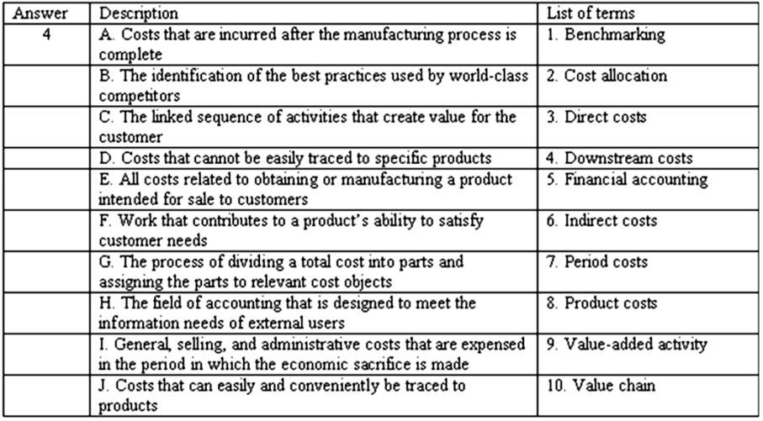

137) Select the term from the list provided that best matches each of the following descriptions. The first is done for you.

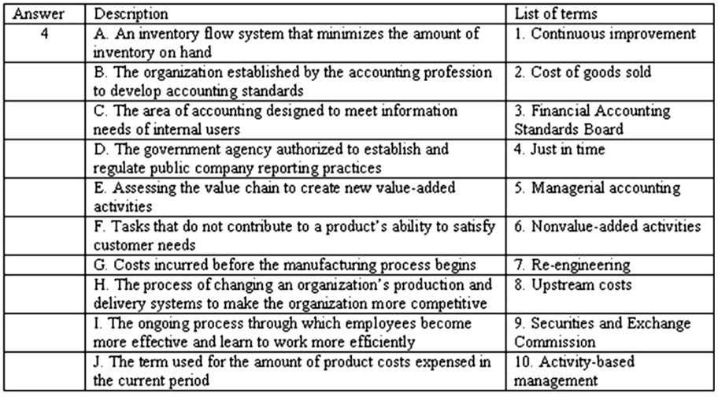

138) Complete the following table to compare and contrast financial and managerial accounting.

Characteristic | Financial Accounting | Managerial Accounting
Users
Level of aggregation
Regulation
Characteristic of information
Time horizon
Reporting frequency

139) Classify each of the following costs for Harrison Company as a selling or general and administrative period cost or as a direct or indirect product cost by entering the dollar amount(s) in the appropriate column(s):

A. Paid $75,000 in wages for employees who assemble the company's products.

B. Paid sales commissions of $58,000.

C. Paid $38,000 in salaries for factory supervisors.

D. Paid $88,000 in salaries for executives (president and vice presidents).

E. Recorded depreciation cost of $25,000. $13,000 was depreciation on factory equipment and $12,000 was depreciation on the company headquarters building.

F. Paid $4,000 for various supplies that it used in the factory (oil and materials used in machine maintenance).

G. Used $10,000 in prepaid corporate liability insurance.

 | Period Cost |  | Product Cost
Item | Selling expense | General and administrative expense | Direct cost | Indirect cost
A
B
C
D
E
F
G

140) The Giga Company produces tablet computers. The following information is provided:

a) Materials used | $ | 216,000
b) Advertising | $ | 40,000
c) Insurance, factory | $ | 20,000
d) Administrative salaries | $ | 50,000
e) Property taxes, factory | $ | 12,000
f) Utilities, administrative building | $ | 22,000
g) Factory labor | $ | 80,000
h) Sales commissions | $ | 56,000
i) Factory supervisor's salary | $ | 60,000
j) Research and development | $ | 18,000
k) Depreciation, factory | $ | 12,000
l) Depreciation, office | $ | 8,000
m) Indirect materials | $ | 14,000

Required:

Classify each of the company's costs as a period cost (general, selling, and administrative cost) or as a direct or indirect product cost. Enter the dollar amount of the cost in the appropriate column. After entering all amounts, calculate the total general, selling, and administrative cost, the total direct product cost, and the total indirect product cost.

Item | Period cost | Direct product cost | Indirect product cost
a)
b)
c)
d)
e)
f)
g)
h)
i)
j)
k)
l)
m)
Total

141) Jarvis Company provided the following information regarding its first year of operations:

Administrative salaries | $ | 60,000
Depreciation on factory equipment |  | 16,000
Indirect materials |  | 4,000
Marketing costs |  | 40,000
Salaries for factory supervisors |  | 28,000
Wages for production workers |  | 80,000
Raw materials used |  | 100,000
Research and development |  | 32,000
Rent on factory building |  | 18,000
Sales revenues |  | 432,000
Sales salaries and other selling costs |  | 56,000
Beginning inventory |  | 0 | units
Number of units produced |  | 20,000
Number of units sold |  | 18,000

Required:

Determine the following amounts:

(a) Total overhead costs.

(b) Total product costs.

(c) Product cost per unit.

(d) Total cost of ending finished goods inventory.

(e) Total cost of goods sold.

142) Arizona Company provided the following information regarding its most recent year of operations:

Administrative salaries | $ | 24,000
Direct labor |  | 48,000
Direct raw material |  | 80,000
Marketing and distribution costs |  | 60,000
Overheads costs |  | 36,000
Product design and testing |  | 30,000
Research and development |  | 40,000
Sales revenues |  | 410,000
Sales salaries and commissions |  | 54,000
Warranty costs |  | 4,000
Number of units produced |  | 20,000
Number of units sold |  | 20,000

Required:

Determine the following amounts:

(a) Total product costs

(b) Total upstream costs

(c) Total downstream costs

(d) Product cost per unit

(e) Total cost per unit, including product costs and upstream and downstream costs

(f) The selling price per unit that would be required if the company wishes to earn a profit margin equal to 25% of total cost

(g) Comment on the company's profitability at its current selling price

143) Reno Company provided the following information regarding its operations for the month ending September 30:

Administrative costs | $ | 30,000
Depreciation on factory equipment |  | 12,000
Indirect materials |  | 2,000
Marketing and distribution costs |  | 24,000
Salaries for factory supervisors |  | 20,000
Wages for production workers |  | 26,000
Raw materials used |  | 38,000
Sales revenue |  | 196,000
Selling costs |  | 18,000
Utilities for production facilities |  | 8,000
Number of units produced |  | 20,000
Number of units sold |  | 15,000

Required:

1) Compute the firm's total manufacturing overhead cost.

2) Prepare a schedule of inventory costs that shows total product costs, ending inventory, and cost of goods sold; and

3) Prepare an income statement for the month ending September 30.

144) The Szakos Company engaged in the following transactions during the current year:

a) Acquired $50,000 of cash by issuing common stock to owners

b) Paid $10,000 to acquire manufacturing equipment

c) Paid $5,000 cash for materials used in production

d) Paid $2,000 for wages of production workers

e) Paid $8,000 in general, selling, and administrative costs

f) Recognized $1,000 of depreciation on the manufacturing equipment

g) Sold inventory for $18,000 cash

h) The cost of the inventory sold was $6,500

Required:

Show the balance sheet and income statement effects of the transactions by completing the financial statement model provided.

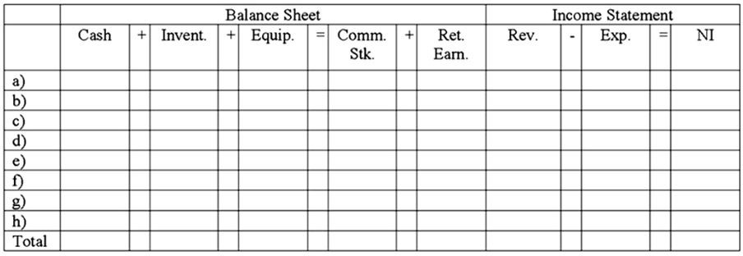

145) The Carson Company was started at the beginning of the current year when it acquired $20,000 by issuing common stock to its owners. During the year, the company incurred the following cash costs:

Direct material costs | $ | 10,000
Direct labor costs |  | 8,000
Overhead costs |  | 4,000
Selling and administrative costs |  | 2,000

The company produced 5,000 units of product and sold 4,500 units. The average selling price was $7.00 per unit. The accountant who prepared the firm's financial statements misclassified the selling and administrative costs as product costs.

Required:

Demonstrate the impact of the error on the company's financial statements by completing the following schedule.

 | Scenario 1: With the error |  |  |  | Scenario 2: Without the error
Income Statement:
Revenue
Less: Cost of goods sold
Gross margin
Less: Selling, general, and administrative expenses
Net income
Balance sheet:
Assets
Cash
Inventory
Total assets
Equity
Common stock
Retained earnings
Total Equity

146) The Jacobson Manufacturing Company was started at the beginning of the current year when it acquired $200,000 from its owners. During the year, the company incurred the following costs, all for cash:

Direct material costs | $ | 80,000
Direct labor costs |  | 100,000
Overhead costs |  | 40,000
Selling and administrative costs |  | 60,000

The company produced 10,000 units of product and sold 8,000 units. The average selling price was $34.00 per unit; all sales were for cash. The accountant who prepared the firm's financial statements misclassified the selling and administrative costs as product costs.

Required:

Demonstrate the impact of the error on the company's income statement and balance sheet by completing the following schedule:

 | Scenario 1: With the error |  |  |  | Scenario 2: Without the error
Income Statement:
Revenue
Less: Cost of goods sold
Gross margin
Less: Selling, general, and administrative expenses
Net income
Balance sheet:
Assets
Cash
Inventory
Total assets
Equity
Common stock
Retained earnings
Total Equity

