The Economy Today, 15e (Schiller)
Chapter 1 Economics: The Core Issues

1) Which of the following is not one of the three core economic issues that must be resolved?
A) How to produce the goods and services we select.
B) What to produce with unlimited resources.
C) Who should get the goods and services we produce.
D) What to produce with limited resources.

Answer: B
Difficulty: 2 Medium
Topic: Scarcity: The Core Problem
Learning Objective: 01-04 The three core economic questions that every society must answer.
Bloom's: Understand
AACSB: Reflective Thinking
Accessibility: Keyboard Navigation

2) The fundamental problem of economics is
A) The law of increasing opportunity costs.
B) The scarcity of resources relative to human wants.
C) How to get government to operate efficiently.
D) How to create employment for everyone.

Answer: B
Difficulty: 1 Easy
Topic: Scarcity: The Core Problem
Learning Objective: 01-01 What scarcity is.
Bloom's: Remember
AACSB: Reflective Thinking
Accessibility: Keyboard Navigation

3) In economics, scarcity means that
A) A shortage of a particular good will cause the price to fall.
B) A production possibilities curve cannot accurately represent the trade-off between two goods.
C) Society's desires exceed resources available.
D) The market mechanism has failed.

Answer: C
Difficulty: 1 Easy
Topic: Scarcity: The Core Problem
Learning Objective: 01-01 What scarcity is.
Bloom's: Remember
AACSB: Reflective Thinking
Accessibility: Keyboard Navigation

4) Given that resources are scarce,
A) A "free lunch" is possible, but only for a limited number of people.
B) Opportunity costs are experienced whenever choices are made.
C) Poor countries must make choices, but rich countries with abundant resources do not have to make choices.
D) Some choices involve opportunity costs while other choices do not.

Answer: B
Difficulty: 2 Medium
Topic: Scarcity: The Core Problem
Learning Objective: 01-02 How scarcity creates opportunity costs.
Bloom's: Understand
AACSB: Reflective Thinking
Accessibility: Keyboard Navigation

5) A consequence of the economic problem of scarcity is that
A) Choices have to be made about how resources are used.
B) There is never too much of any good or service produced.
C) The production of goods and services must be controlled by the government.
D) The production possibilities curve is bowed outward.

Answer: A
Difficulty: 2 Medium
Topic: Scarcity: The Core Problem
Learning Objective: 01-02 How scarcity creates opportunity costs.
Bloom's: Understand
AACSB: Reflective Thinking
Accessibility: Keyboard Navigation

6) The basic factors of production include
A) Land, labor, money, and capital.
B) Land, labor, money, and inputs.
C) Labor and money.
D) Land, labor, capital, and entrepreneurship.

Answer: D
Difficulty: 2 Medium
Topic: Scarcity: The Core Problem
Learning Objective: 01-01 What scarcity is.
Bloom's: Understand
AACSB: Reflective Thinking
Accessibility: Keyboard Navigation

7) Factors of production are
A) Scarce in every society.
B) Scarce only in advanced countries.
C) Scarce only in the poorest countries of the world.
D) Unlimited in quantity.

Answer: A
Difficulty: 2 Medium
Topic: Scarcity: The Core Problem
Learning Objective: 01-01 What scarcity is.
Bloom's: Understand
AACSB: Reflective Thinking
Accessibility: Keyboard Navigation

8) Which of the following is not a factor of production?
A) A psychiatrist.
B) $100,000 cash.
C) A bulldozer.
D) Six thousand acres of farmland.

Answer: B
Difficulty: 2 Medium
Topic: Scarcity: The Core Problem
Learning Objective: 01-01 What scarcity is.
Bloom's: Understand
AACSB: Reflective Thinking
Accessibility: Keyboard Navigation

9) With respect to factors of production, which of the following statements is not true?
A) Factors of production are also known as resources.
B) In order to produce any good or service, it is necessary to have factors of production.
C) Factors of production include land, labor, capital, and entrepreneurship.
D) Only those resources that are privately owned are counted as factors of production.

Answer: D
Difficulty: 2 Medium
Topic: Scarcity: The Core Problem
Learning Objective: 01-01 What scarcity is.
Bloom's: Understand
AACSB: Reflective Thinking
Accessibility: Keyboard Navigation

10) Which of the following is the best example of land?
A) The ethanol refined from corn.
B) A factory that produces new goods and services.
C) The water used to make a soft drink.
D) A barber's chair.

Answer: C
Difficulty: 2 Medium
Topic: Scarcity: The Core Problem
Learning Objective: 01-01 What scarcity is.
Bloom's: Understand
AACSB: Reflective Thinking
Accessibility: Keyboard Navigation

11) Capital, as economists use the term, refers to
A) The cash needed to start a new business.
B) The costs of operating a business.
C) Shares of stock issued by businesses.
D) Final goods that are used to produce other goods and services.

Answer: D
Difficulty: 1 Easy
Topic: Scarcity: The Core Problem
Learning Objective: 01-01 What scarcity is.
Bloom's: Remember
AACSB: Reflective Thinking
Accessibility: Keyboard Navigation

12) Which economist argued that free markets unleashed the "animal spirits" of entrepreneurs, propelling innovation, technology, and growth?
A) Lord Kelvin.
B) Kenneth Olsen.
C) Irving Fisher.
D) John Maynard Keynes.

Answer: D
Difficulty: 2 Medium
Topic: Scarcity: The Core Problem
Learning Objective: 01-01 What scarcity is.
Bloom's: Understand
AACSB: Reflective Thinking
Accessibility: Keyboard Navigation

13) The role of the entrepreneur in an economy is to
A) Bring the factors of production together and assume the risk of production.
B) Work with government planners to determine what goods are produced.
C) Arrange bank financing for the owners of new businesses.
D) Ensure full employment of labor.

Answer: A
Difficulty: 2 Medium
Topic: Scarcity: The Core Problem
Learning Objective: 01-01 What scarcity is.
Bloom's: Understand
AACSB: Reflective Thinking
Accessibility: Keyboard Navigation

14) Economics can be defined as the study of
A) For whom resources are allocated to increase efficiency.
B) How society spends the income of individuals.
C) How scarce resources are allocated.
D) None of the choices are correct.

Answer: C
Difficulty: 1 Easy
Topic: Scarcity: The Core Problem
Learning Objective: 01-01 What scarcity is.
Bloom's: Remember
AACSB: Reflective Thinking
Accessibility: Keyboard Navigation

15) Opportunity cost is
A) Measured only in dollars and cents.
B) The total dollar cost to society of producing the goods.
C) The difficulty associated with using one good in place of another.
D) What is given up in order to get something else.

Answer: D
Difficulty: 1 Easy
Topic: Scarcity: The Core Problem
Learning Objective: 01-02 How scarcity creates opportunity costs.
Bloom's: Remember
AACSB: Reflective Thinking
Accessibility: Keyboard Navigation

16) Opportunity cost may be defined as the
A) Goods or services that are forgone in order to obtain something else.
B) Dollar prices paid for final goods and services.
C) Dollar cost of producing a particular product.
D) Difference between wholesale and retail prices.

Answer: A
Difficulty: 1 Easy
Topic: Scarcity: The Core Problem
Learning Objective: 01-02 How scarcity creates opportunity costs.
Bloom's: Remember
AACSB: Reflective Thinking
Accessibility: Keyboard Navigation

17) The opportunity cost of studying for an economics test is
A) Negative because it may improve your grade.
B) Zero because you knew when you registered for the class that studying would be required.
C) The money you spent on tuition for the class.
D) The activity that is the best alternative use of your time.

Answer: D
Difficulty: 2 Medium
Topic: Scarcity: The Core Problem
Learning Objective: 01-02 How scarcity creates opportunity costs.
Bloom's: Understand
AACSB: Reflective Thinking
Accessibility: Keyboard Navigation

18) The "guns versus butter" dilemma that all nations confront is that
A) Guns and butter can be produced using the same resources at the same time.
B) An increase in national defense implies more sacrifices of civilian goods and services.
C) An increase in national defense is possible only if we produce more butter.
D) All of the choices are correct.

Answer: B
Difficulty: 2 Medium
Topic: Production Possibilities
Learning Objective: 01-02 How scarcity creates opportunity costs.
Bloom's: Understand
AACSB: Reflective Thinking
Accessibility: Keyboard Navigation

19) A production possibilities curve indicates the
A) Combinations of goods and services an economy is actually producing.
B) Maximum combinations of goods and services an economy can produce given its available resources and technology.
C) Maximum combinations of goods and services an economy can produce given unlimited resources.
D) Average combinations of goods and services an economy can produce given its available resources and technology.

Answer: B
Difficulty: 1 Easy
Topic: Production Possibilities
Learning Objective: 01-03 What the production-possibilities curve represents.
Bloom's: Remember
AACSB: Reflective Thinking
Accessibility: Keyboard Navigation

20) Which of the following is an assumption under which the production possibilities curve is drawn?
A) Total unemployment is zero.
B) The supply of resources is fixed.
C) The price level is changing.
D) Technology is changing.

Answer: B
Difficulty: 2 Medium
Topic: Production Possibilities
Learning Objective: 01-03 What the production-possibilities curve represents.
Bloom's: Understand
AACSB: Reflective Thinking
Accessibility: Keyboard Navigation

21) A point on a nation's production possibilities curve represents
A) An undesirable combination of goods and services.
B) Combinations of production that are unattainable, given current technology and resources.
C) Levels of production that will cause both unemployment and inflation.
D) The full employment of resources to achieve a particular combination of goods and services.

Answer: D
Difficulty: 2 Medium
Topic: Production Possibilities
Learning Objective: 01-03 What the production-possibilities curve represents.
Bloom's: Understand
AACSB: Reflective Thinking
Accessibility: Keyboard Navigation

22) The production possibilities curve illustrates which two of the following essential principles?
A) Factors of production and price signals.
B) Scarce resources and opportunity cost.
C) Market mechanisms and laissez faire.
D) Economic growth and market failure.

Answer: B
Difficulty: 2 Medium
Topic: Production Possibilities
Learning Objective: 01-03 What the production-possibilities curve represents.
Bloom's: Understand
AACSB: Reflective Thinking
Accessibility: Keyboard Navigation

23) If an economy experiences constant opportunity costs with respect to two goods, then the production possibilities curve between the two goods will be?
A) Bowed outward or concave from below.
B) A straight, downward-sloping line.
C) Bowed inward or convex from below.
D) Bowed outward until the two goods are equal, and then bowed inward.

Answer: B
Difficulty: 2 Medium
Topic: Production Possibilities
Learning Objective: 01-03 What the production-possibilities curve represents.
Bloom's: Understand
AACSB: Reflective Thinking
Accessibility: Keyboard Navigation

24) The production possibilities curve illustrates
A) The limitations that exist because of scarce resources.
B) That there is no limit to what an economy can produce.
C) That there is no limit to the level of output.
D) The existence of unlimited wants and resources.

Answer: A
Difficulty: 1 Easy
Topic: Production Possibilities
Learning Objective: 01-03 What the production-possibilities curve represents.
Bloom's: Remember
AACSB: Reflective Thinking
Accessibility: Keyboard Navigation

25) According to the law of increasing opportunity costs,
A) The more one is willing to pay for resources; the smaller will be the possible level of production.
B) Increasing the production of a particular good will cause the price of the good to remain constant.
C) In order to produce additional units of a particular good, it is necessary for society to sacrifice increasingly larger amounts of alternative goods.
D) None of the choices are correct.

Answer: C
Difficulty: 2 Medium
Topic: Production Possibilities
Learning Objective: 01-03 What the production-possibilities curve represents.
Bloom's: Understand
AACSB: Reflective Thinking
Accessibility: Keyboard Navigation

26) According to the law of increasing opportunity costs,
A) Greater production leads to greater inefficiency.
B) Greater production means factor prices rise.
C) Greater production of one good requires increasingly larger sacrifices of other goods.
D) Higher opportunity costs induce higher output per unit of input.

Answer: C
Difficulty: 2 Medium
Topic: Production Possibilities
Learning Objective: 01-03 What the production-possibilities curve represents.
Bloom's: Understand
AACSB: Reflective Thinking
Accessibility: Keyboard Navigation

27) If an economy experiences increasing opportunity costs with respect to two goods, then the production possibilities curve between the two goods will be
A) Bowed outward or concave from below.
B) A straight, downward-sloping line.
C) Bowed inward or convex from below.
D) Bowed outward until the two goods are equal, and then bowed inward.

Answer: A
Difficulty: 2 Medium
Topic: Production Possibilities
Learning Objective: 01-03 What the production-possibilities curve represents.
Bloom's: Understand
AACSB: Reflective Thinking
Accessibility: Keyboard Navigation

28) If the United States decides to convert automobile factories to tank production, as it did during World War II, but finds that some auto manufacturing facilities are not well suited to tank production, then
A) The production possibilities curve between tanks and automobiles will appear as a straight line.
B) The production possibilities curve between tanks and automobiles will shift outward.
C) Decreasing opportunity costs will occur with greater automobile production.
D) Increasing opportunity costs will occur with greater tank production.

Answer: D
Difficulty: 2 Medium
Topic: Production Possibilities
Learning Objective: 01-03 What the production-possibilities curve represents.
Bloom's: Understand
AACSB: Reflective Thinking
Accessibility: Keyboard Navigation

29) If North Korea is currently producing at efficiency, and it proceeds to increase the size of its military, then, as long as nothing else changes, its
A) Production possibilities curve will shift outward.
B) Production possibilities curve will shift inward.
C) Production of nonmilitary goods will increase.
D) Production of nonmilitary goods will decrease.

Answer: D
Difficulty: 2 Medium
Topic: Production Possibilities
Learning Objective: 01-03 What the production-possibilities curve represents.
Bloom's: Understand
AACSB: Reflective Thinking
Accessibility: Keyboard Navigation

30) When an economy is producing efficiently, it is
A) Producing a combination of goods and services beyond the production possibilities curve.
B) Getting the maximum goods and services possible from the available resources.
C) Experiencing decreasing opportunity costs.
D) Producing equal amounts of all goods.

Answer: B
Difficulty: 2 Medium
Topic: Production Possibilities
Learning Objective: 01-03 What the production-possibilities curve represents.
Bloom's: Understand
AACSB: Reflective Thinking
Accessibility: Keyboard Navigation

31) Which of the following is true when an economy is producing efficiently?
A) The economy is producing on the production possibilities curve.
B) The economy is producing outside the production possibilities curve.
C) The economy is getting the fewest goods and services from the available resources.
D) Everyone in the economy is happy.

Answer: A
Difficulty: 2 Medium
Topic: Production Possibilities
Learning Objective: 01-03 What the production-possibilities curve represents.
Bloom's: Understand
AACSB: Reflective Thinking
Accessibility: Keyboard Navigation

32) The points on a production possibilities curve show
A) Desired output.
B) Actual output.
C) Potential output.
D) None of the choices are correct.

Answer: C
Difficulty: 2 Medium
Topic: Production Possibilities
Learning Objective: 01-03 What the production-possibilities curve represents.
Bloom's: Understand
AACSB: Reflective Thinking
Accessibility: Keyboard Navigation

33) In terms of the production possibilities curve, inefficiency is represented by
A) All points on the curve.
B) All points outside the curve.
C) All points inside the curve.
D) A rightward shift of the curve.

Answer: C
Difficulty: 2 Medium
Topic: Production Possibilities
Learning Objective: 01-03 What the production-possibilities curve represents.
Bloom's: Understand
AACSB: Reflective Thinking
Accessibility: Keyboard Navigation

34) If an economy is producing inside the production possibilities curve, then
A) There is full employment of resources.
B) It is operating efficiently.
C) It can produce more of one good without giving up some of another good.
D) There are not enough resources available to produce more output.

Answer: C
Difficulty: 2 Medium
Topic: Production Possibilities
Learning Objective: 01-03 What the production-possibilities curve represents.
Bloom's: Understand
AACSB: Reflective Thinking
Accessibility: Keyboard Navigation

35) A technological advance would best be represented by
A) A shift outward of the production possibilities curve.
B) A shift inward of the production possibilities curve.
C) A movement from inside the production possibilities curve to a point on the production possibilities curve.
D) A movement from the production possibilities curve to a point inside the production possibilities curve.

Answer: A
Difficulty: 2 Medium
Topic: Production Possibilities
Learning Objective: 01-03 What the production-possibilities curve represents.
Bloom's: Understand
AACSB: Reflective Thinking
Accessibility: Keyboard Navigation

36) Which of the following events would allow the production possibilities curve to shift outward?
A) The economy's capital stock declines.
B) More teenagers enter the labor force.
C) Technology is lost.
D) People begin to retire at earlier ages.

Answer: B
Difficulty: 2 Medium
Topic: Production Possibilities
Learning Objective: 01-03 What the production-possibilities curve represents.
Bloom's: Understand
AACSB: Reflective Thinking
Accessibility: Keyboard Navigation

37) Economic growth would best be represented by a
A) Shift outward of the production possibilities curve.
B) Shift inward of the production possibilities curve.
C) Movement from inside the production possibilities curve to a point on the production possibilities curve.
D) Movement from the production possibilities curve to a point inside the production possibilities curve.

Answer: A
Difficulty: 2 Medium
Topic: Production Possibilities
Learning Objective: 01-03 What the production-possibilities curve represents.
Bloom's: Understand
AACSB: Reflective Thinking
Accessibility: Keyboard Navigation

38) Which of the following will cause the production possibilities curve to shift inward?
A) An increase in the working-age population.
B) A decrease in the size of the labor force.
C) A technological advance.
D) An increase in knowledge.

Answer: B
Difficulty: 2 Medium
Topic: Production Possibilities
Learning Objective: 01-03 What the production-possibilities curve represents.
Bloom's: Understand
AACSB: Reflective Thinking
Accessibility: Keyboard Navigation

39) Which of the following is not a basic decision that all nations must confront?
A) Should we have economic growth?
B) How should we produce goods and services?
C) For whom should goods and services be produced?
D) What goods and services should we produce?

Answer: A
Difficulty: 2 Medium
Topic: Three Basic Decisions
Learning Objective: 01-04 The three core economic questions that every society must answer.
Bloom's: Understand
AACSB: Reflective Thinking
Accessibility: Keyboard Navigation

40) In a market economy, the people who receive the goods and services that are produced are those who
A) Need the goods and services the most.
B) Have the most political power.
C) Want the goods and services the most.
D) Are willing to pay the highest price.

Answer: D
Difficulty: 2 Medium
Topic: Three Basic Decisions
Learning Objective: 01-04 The three core economic questions that every society must answer.
Bloom's: Understand
AACSB: Reflective Thinking
Accessibility: Keyboard Navigation

41) Adam Smith's invisible hand is now called
A) Economic growth.
B) The market mechanism.
C) Opportunity cost.
D) Laissez faire.

Answer: B
Difficulty: 2 Medium
Topic: The Mechanisms of Choice
Learning Objective: 01-05 How market and government approaches to economic problems differ.
Bloom's: Understand
AACSB: Reflective Thinking
Accessibility: Keyboard Navigation

42) The market mechanism may best be defined as
A) The use of market prices and sales to signal desired output.
B) The use of market signals and government directives to select economic outcomes.
C) The process by which the production possibilities curve shifts inward.
D) Price regulation by government.

Answer: A
Difficulty: 1 Easy
Topic: The Mechanisms of Choice
Learning Objective: 01-05 How market and government approaches to economic problems differ.
Bloom's: Remember
AACSB: Reflective Thinking
Accessibility: Keyboard Navigation

43) The market mechanism
A) Is not a very efficient means of communicating consumer demand to the producers of goods and services.
B) Works through central planning by government.
C) Eliminates market failures created by government.
D) Works because prices serve as a means of communication between consumers and producers.

Answer: D
Difficulty: 2 Medium
Topic: The Mechanisms of Choice
Learning Objective: 01-05 How market and government approaches to economic problems differ.
Bloom's: Understand
AACSB: Reflective Thinking
Accessibility: Keyboard Navigation

44) The invisible hand refers to
A) Intervention in the economy by the government bureaucrats we do not see and over whom we have no control.
B) Undiscovered natural resources.
C) The allocation of resources by market forces.
D) The person who has the responsibility to coordinate all the markets in a market economy.

Answer: C
Difficulty: 2 Medium
Topic: The Mechanisms of Choice
Learning Objective: 01-05 How market and government approaches to economic problems differ.
Bloom's: Understand
AACSB: Reflective Thinking
Accessibility: Keyboard Navigation

45) The doctrine of laissez faire is based on the belief that
A) Markets are likely to do a better job of allocating resources than government directives.
B) Government directives are likely to do a better job of allocating resources than markets.
C) Government failure does not exist.
D) Markets result in an unfair distribution of income.

Answer: A
Difficulty: 2 Medium
Topic: The Mechanisms of Choice
Learning Objective: 01-05 How market and government approaches to economic problems differ.
Bloom's: Understand
AACSB: Reflective Thinking
Accessibility: Keyboard Navigation
46) A city's decision to limit smoking in public areas is an example of
A) The invisible hand at work.
B) The market mechanism at work.
C) Market success.
D) Government intervention.

Answer: D
Difficulty: 3 Hard
Topic: The Mechanisms of Choice
Learning Objective: 01-05 How market and government approaches to economic problems differ.
Bloom's: Analyze
AACSB: Analytical Thinking
Accessibility: Keyboard Navigation

47) A mixed economy
A) Is justified by the superiority of laissez faire over government intervention.
B) Utilizes both market and nonmarket signals to allocate goods and services.
C) Relies on the use of central planning by private firms rather than the government.
D) Is one that allows trade with other countries.

Answer: B
Difficulty: 1 Easy
Topic: The Mechanisms of Choice
Learning Objective: 01-05 How market and government approaches to economic problems differ.
Bloom's: Remember
AACSB: Reflective Thinking
Accessibility: Keyboard Navigation

48) Which of the following may be used in an attempt to correct market failure?
A) The market mechanism.
B) Laws and regulations.
C) Laissez faire price policies.
D) Government failure.

Answer: B
Difficulty: 3 Hard
Topic: The Mechanisms of Choice
Learning Objective: 01-05 How market and government approaches to economic problems differ.
Bloom's: Analyze
AACSB: Analytical Thinking
Accessibility: Keyboard Navigation
49) When the invisible hand does not produce optimal outcomes for the economy, there is evidence of
A) Market failure.
B) Government failure.
C) Macroeconomic failure.
D) Scarcity.

Answer: A
Difficulty: 2 Medium
Topic: The Mechanisms of Choice
Learning Objective: 01-05 How market and government approaches to economic problems differ.
Bloom's: Understand
AACSB: Reflective Thinking
Accessibility: Keyboard Navigation

50) Government intervention may achieve a more optimal outcome than the market mechanism when addressing
A) Inefficient bureaucracy.
B) Consumption of cigarettes.
C) The supply of new hot dog stands.
D) None of the choices are correct.

Answer: B
Difficulty: 3 Hard
Topic: The Mechanisms of Choice
Learning Objective: 01-05 How market and government approaches to economic problems differ.
Bloom's: Analyze
AACSB: Analytical Thinking
Accessibility: Keyboard Navigation

51) If market signals result in pollution beyond the optimal level, then
A) The economy experiences government failure.
B) A laissez faire approach will reduce the level of pollution.
C) The market mechanism has failed to achieve efficiency.
D) The government is allocating resources inefficiently.

Answer: C
Difficulty: 2 Medium
Topic: The Mechanisms of Choice
Learning Objective: 01-05 How market and government approaches to economic problems differ.
Bloom's: Understand
AACSB: Reflective Thinking
Accessibility: Keyboard Navigation
52) Which of the following has occurred when government directives do not produce better economic outcomes?
A) Government failure.
B) Market failure.
C) Macroeconomic failure.
D) Scarcity.

Answer: A
Difficulty: 2 Medium
Topic: The Mechanisms of Choice
Learning Objective: 01-05 How market and government approaches to economic problems differ.
Bloom's: Understand
AACSB: Reflective Thinking
Accessibility: Keyboard Navigation

53) Which of the following is an example of government failure?
A) Bureaucratic delays.
B) Required use of pollution control technology that is obsolete.
C) Inefficient incentives.
D) All of the choices are correct.

Answer: D
Difficulty: 3 Hard
Topic: The Mechanisms of Choice
Learning Objective: 01-05 How market and government approaches to economic problems differ.
Bloom's: Apply
AACSB: Analytical Thinking
Accessibility: Keyboard Navigation

54) Macroeconomics focuses on the behavior of
A) Individual consumers.
B) Government agencies.
C) The overall economy.
D) All of the choices are correct.

Answer: C
Difficulty: 2 Medium
Topic: What Economics is All About
Learning Objective: 01-05 How market and government approaches to economic problems differ.
Bloom's: Understand
AACSB: Reflective Thinking
Accessibility: Keyboard Navigation
55) Which of the following is not a macroeconomic statement?
A) The unemployment rate for the United States rose to 5 percent in the last quarter.
B) The Federal Reserve lowered interest rates at its last meeting.
C) Congress increased the minimum wage rate in January.
D) Jenny's wage rate rose, and in response, she decided to work more hours.

Answer: D
Difficulty: 3 Hard
Topic: What Economics is All About
Learning Objective: 01-05 How market and government approaches to economic problems differ.
Bloom's: Analyze
AACSB: Analytical Thinking
Accessibility: Keyboard Navigation

56) The study of microeconomic theory focuses on
A) individual behavior in the economy
B) Operation of the entire economy.
C) Role of the banking system in the economy.
D) Interaction of international trade and domestic production of goods and services.

Answer: A
Difficulty: 2 Medium
Topic: What Economics is All About
Learning Objective: 01-05 How market and government approaches to economic problems differ.
Bloom's: Understand
AACSB: Reflective Thinking
Accessibility: Keyboard Navigation

57) Microeconomics is concerned with issues such as
A) The demand for bottled water by individuals.
B) The level of inflation in the economy.
C) Maintaining a strong level of economic growth.
D) All of the choices are correct.

Answer: A
Difficulty: 3 Hard
Topic: What Economics is All About
Learning Objective: 01-05 How market and government approaches to economic problems differ.
Bloom's: Analyze
AACSB: Analytical Thinking
Accessibility: Keyboard Navigation
58) Economic models are used by economists to
A) Predict economic behavior.
B) Develop economic policies.
C) Explain economic behavior.
D) All of the choices are correct.

Answer: D
Difficulty: 2 Medium
Topic: What Economics is All About
Learning Objective: 01-05 How market and government approaches to economic problems differ.
Bloom's: Understand
AACSB: Reflective Thinking
Accessibility: Keyboard Navigation

59) The Latin phrase ceteris paribus means
A) The production possibilities curve never shifts.
B) Laissez faire.
C) Other things remain equal.
D) The invisible hand.

Answer: C
Difficulty: 1 Easy
Topic: What Economics is All About
Learning Objective: 01-05 How market and government approaches to economic problems differ.
Bloom's: Remember
AACSB: Reflective Thinking
Accessibility: Keyboard Navigation

60)
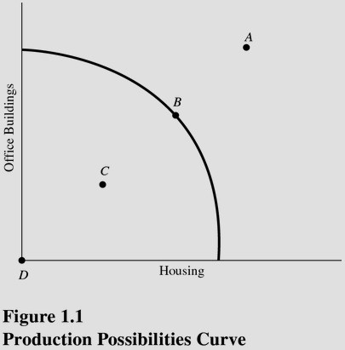
At which point is society employing some of its available technology but not all of it? (See Figure 1.1.)
A) A.
B) B.
C) C.
D) D.

Answer: C
Difficulty: 3 Hard
Topic: Production Possibilities
Learning Objective: 01-03 What the production-possibilities curve represents.
Bloom's: Apply
AACSB: Analytical Thinking
Accessibility: Keyboard Navigation

61)
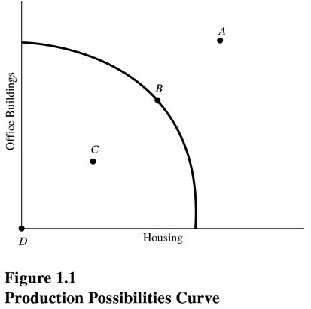
At which point is society producing the most output possible with the available resources and technology? (See Figure 1.1.)
A) A.
B) B.
C) C.
D) D.

Answer: B
Difficulty: 3 Hard
Topic: Production Possibilities
Learning Objective: 01-03 What the production-possibilities curve represents.
Bloom's: Apply
AACSB: Analytical Thinking
Accessibility: Keyboard Navigation

62)
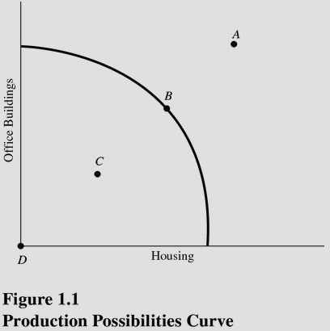
At which point is society producing some of each type of structure but still producing inefficiently? (See Figure 1.1.)
A) A.
B) B.
C) C.
D) D.

Answer: C
Difficulty: 3 Hard
Topic: Production Possibilities
Learning Objective: 01-03 What the production-possibilities curve represents.
Bloom's: Apply
AACSB: Analytical Thinking
Accessibility: Keyboard Navigation

63)
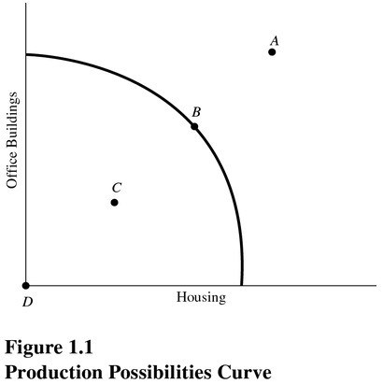
At which point might society be able to produce if new resources were discovered but cannot produce with current resources? (See Figure 1.1.)
A) A.
B) B.
C) C.
D) D.

Answer: A
Difficulty: 3 Hard
Topic: Production Possibilities
Learning Objective: 01-03 What the production-possibilities curve represents.
Bloom's: Apply
AACSB: Analytical Thinking
Accessibility: Keyboard Navigation

64)
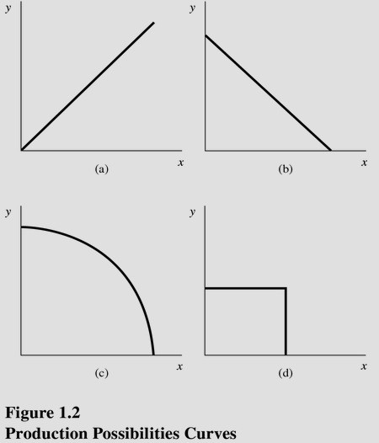
Choose the letter of the curve in Figure 1.2 that best represents a production possibilities curve for two goods that obey the law of increasing opportunity costs:
A) A.
B) B.
C) C.
D) D.

Answer: C
Difficulty: 3 Hard
Topic: Production Possibilities
Learning Objective: 01-03 What the production-possibilities curve represents.
Bloom's: Apply
AACSB: Analytical Thinking
Accessibility: Keyboard Navigation

65)
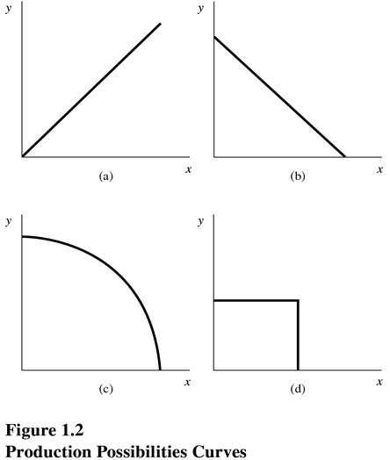
Choose the letter of the curve in Figure 1.2 that best represents a production possibilities curve for two goods for which there are constant opportunity costs:
A) A.
B) B.
C) C.
D) D.

Answer: B
Difficulty: 3 Hard
Topic: Production Possibilities
Learning Objective: 01-03 What the production-possibilities curve represents.
Bloom's: Apply
AACSB: Analytical Thinking
Accessibility: Keyboard Navigation

66)
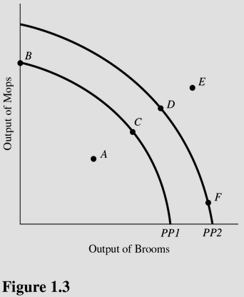
Using Figure 1.3 and starting from PP1, an increase in the capacity to produce can be represented by a movement from
A) Point A to point B.
B) Point A to point C.
C) Point B to point C.
D) Point C to point F.

Answer: D
Difficulty: 3 Hard
Topic: Production Possibilities
Learning Objective: 01-03 What the production-possibilities curve represents.
Bloom's: Apply
AACSB: Analytical Thinking
Accessibility: Keyboard Navigation

67)
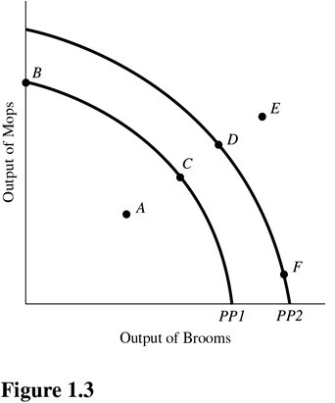
Using Figure 1.3 and PP1, at point A,
A) There is inefficient use of available resources.
B) The available technology keeps production inside PP1.
C) All available resources are being used efficiently.
D) An increase in the production of mops would definitely require a decrease in the production of brooms.

Answer: A
Difficulty: 3 Hard
Topic: Production Possibilities
Learning Objective: 01-03 What the production-possibilities curve represents.
Bloom's: Apply
AACSB: Analytical Thinking
Accessibility: Keyboard Navigation

68)
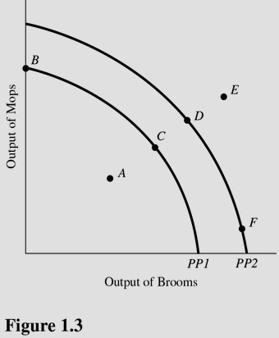
Which of the following is true about the combination of mops and brooms represented by point E in Figure 1.3 and using PP1?
A) Point E is efficient now.
B) Point E is attainable if this economy uses more of its available resources.
C) Point E is unattainable if this economy becomes more efficient.
D) Point E is attainable only if more resources become available or technological advances are made.

Answer: D
Difficulty: 3 Hard
Topic: Production Possibilities
Learning Objective: 01-03 What the production-possibilities curve represents.
Bloom's: Apply
AACSB: Analytical Thinking
Accessibility: Keyboard Navigation

69)
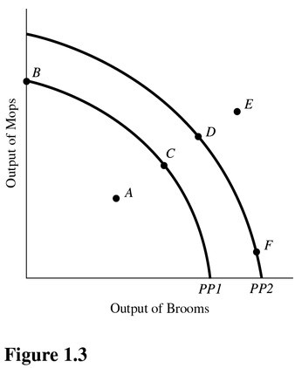
An increase in the proportion of the population that is unemployed above the normal rate is best represented in Figure 1.3 and using PP1 by a movement from point
A) C to point D.
B) D to point C.
C) C to point A.
D) E to point D.

Answer: C
Difficulty: 3 Hard
Topic: Production Possibilities
Learning Objective: 01-03 What the production-possibilities curve represents.
Bloom's: Apply
AACSB: Analytical Thinking
Accessibility: Keyboard Navigation

70)
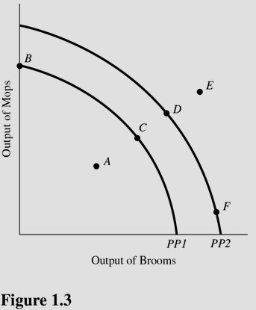
A movement from point F to point D in Figure 1.3 results in
A) A reallocation of resources from mop production to broom production.
B) Permanent unemployment of workers producing brooms.
C) A reallocation of resources from broom production to mop production.
D) More efficient production.

Answer: C
Difficulty: 3 Hard
Topic: Production Possibilities
Learning Objective: 01-03 What the production-possibilities curve represents.
Bloom's: Apply
AACSB: Analytical Thinking
Accessibility: Keyboard Navigation

71)
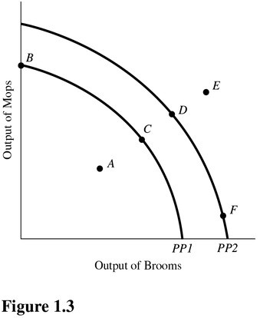
In Figure 1.3, a shift of the production possibilities curve from PP1 to PP2 could be caused by
A) A decrease in the quantity of raw materials available.
B) A decline in the production skills of workers.
C) The use of improved production technology.
D) All of the choices are correct.

Answer: C
Difficulty: 3 Hard
Topic: What Economics is All About
Learning Objective: 01-03 What the production-possibilities curve represents.
Bloom's: Apply
AACSB: Analytical Thinking
Accessibility: Keyboard Navigation

72)
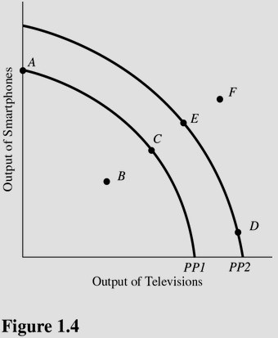
Using Figure 1.4 and starting at PP1, an increase in the capacity to produce can be represented by a movement from point
A) A to point B.
B) C to point E.
C) A to point C.
D) D to point E.

Answer: B
Difficulty: 3 Hard
Topic: Production Possibilities
Learning Objective: 01-03 What the production-possibilities curve represents.
Bloom's: Apply
AACSB: Analytical Thinking
Accessibility: Keyboard Navigation

73)
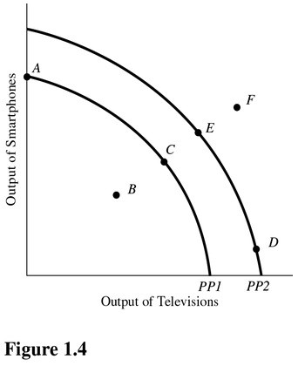
Which of the following is true about the combination of televisions and smartphones represented by point F in Figure 1.4?
A) Point F is inefficient now.
B) Point F is unattainable even with advances in technology.
C) Point F will be more easily attainable if the government takes control of all privately run factories.
D) Point F can possibly be reached if more economic resources become available or technology improves.

Answer: D
Difficulty: 3 Hard
Topic: Production Possibilities
Learning Objective: 01-03 What the production-possibilities curve represents.
Bloom's: Apply
AACSB: Analytical Thinking
Accessibility: Keyboard Navigation

74)
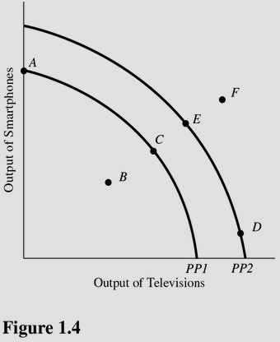
A movement from point C to point A in Figure 1.4 results in
A) More efficient production.
B) Permanent unemployment of workers producing plasma televisions.
C) A reallocation of resources from smartphone production to television production.
D) A reallocation of resources from television production to smartphone production.

Answer: D
Difficulty: 3 Hard
Topic: Production Possibilities
Learning Objective: 01-03 What the production-possibilities curve represents.
Bloom's: Apply
AACSB: Analytical Thinking
Accessibility: Keyboard Navigation

75)
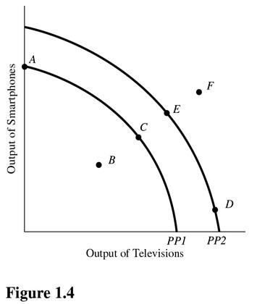
In Figure 1.4, a shift of the production possibilities curve from PP1 to PP2 could be caused by
A) An increase in the unemployment rate.
B) Implementation of training programs that improve the skills of workers.
C) A flu epidemic that makes many workers sick.
D) Tougher pollution controls for the producers of televisions and smartphones.

Answer: B
Difficulty: 3 Hard
Topic: Production Possibilities
Learning Objective: 01-03 What the production-possibilities curve represents.
Bloom's: Apply
AACSB: Analytical Thinking
Accessibility: Keyboard Navigation

76)
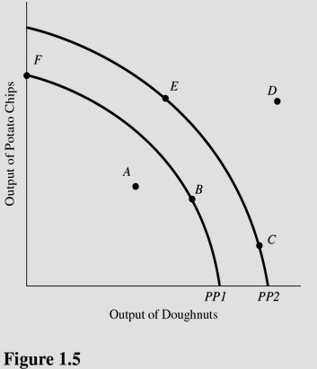
Using Figure 1.5, if an economy has the capacity to produce represented by PP2, then point E represents
A) A constant trade-off between potato chips and doughnuts.
B) A combination of potato chips and doughnuts that is not attainable.
C) An efficient use of resources.
D) None of the choices are correct.

Answer: C
Difficulty: 3 Hard
Topic: Production Possibilities
Learning Objective: 01-03 What the production-possibilities curve represents.
Bloom's: Apply
AACSB: Analytical Thinking
Accessibility: Keyboard Navigation

77)
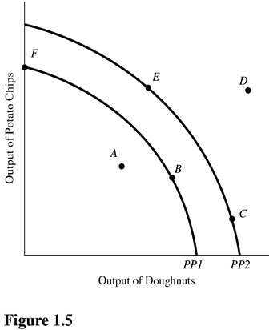
Using Figure 1.5, if an economy is currently producing on PP2, which of the following would shift the production possibilities curve toward PP1?
A) An increase in the quantity of labor available.
B) A decrease in the amount of capital available.
C) A decrease in the level of unemployment towards the normal level.
D) An advancement in technology.

Answer: B
Difficulty: 3 Hard
Topic: Production Possibilities
Learning Objective: 01-03 What the production-possibilities curve represents.
Bloom's: Apply
AACSB: Analytical Thinking
Accessibility: Keyboard Navigation

78)
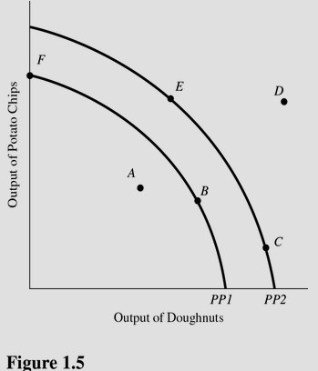
In Figure 1.5, at which of the following points would the opportunity cost of producing more doughnuts be greatest?
A) A.
B) F.
C) C.
D) E.

Answer: C
Difficulty: 3 Hard
Topic: Production Possibilities
Learning Objective: 01-03 What the production-possibilities curve represents.
Bloom's: Apply
AACSB: Analytical Thinking
Accessibility: Keyboard Navigation

79)
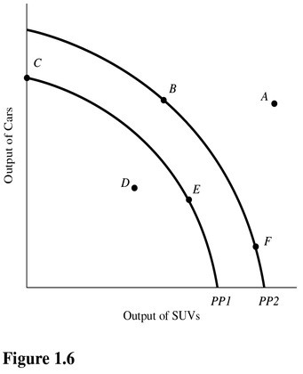
Using Figure 1.6, if an economy has the capacity to produce represented by PP1, then point E represents
A) A combination of cars and SUVs that is not attainable.
B) A constant trade-off between cars and SUVs.
C) A change in technology.
D) An efficient use of resources.

Answer: D
Difficulty: 3 Hard
Topic: Production Possibilities
Learning Objective: 01-03 What the production-possibilities curve represents.
Bloom's: Apply
AACSB: Analytical Thinking
Accessibility: Keyboard Navigation

80)
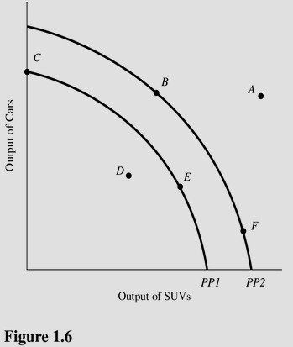
In Figure 1.6, if the opportunity cost of producing cars was zero at all levels of production, the production possibilities curve would be best be represented by a
A) Vertical line.
B) 45-degree line starting at the origin.
C) Horizontal line.
D) Circle.

Answer: A
Difficulty: 3 Hard
Topic: Production Possibilities
Learning Objective: 01-03 What the production-possibilities curve represents.
Bloom's: Apply
AACSB: Analytical Thinking
Accessibility: Keyboard Navigation

81)
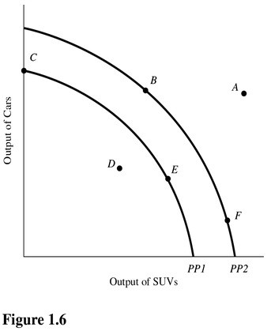
In Figure 1.6, at which of the following points would the opportunity cost of producing one more car be the lowest?
A) F.
B) B.
C) C.
D) D.

Answer: A
Difficulty: 3 Hard
Topic: Production Possibilities
Learning Objective: 01-03 What the production-possibilities curve represents.
Bloom's: Apply
AACSB: Analytical Thinking
Accessibility: Keyboard Navigation

82)
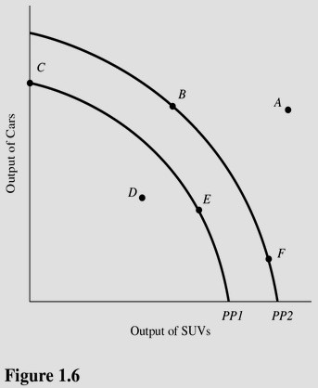
In Figure 1.6, at which of the following points would the opportunity cost of producing one more SUV be highest?
A) A.
B) B.
C) C.
D) F.

Answer: D
Difficulty: 3 Hard
Topic: Production Possibilities
Learning Objective: 01-03 What the production-possibilities curve represents.
Bloom's: Apply
AACSB: Analytical Thinking
Accessibility: Keyboard Navigation

83)
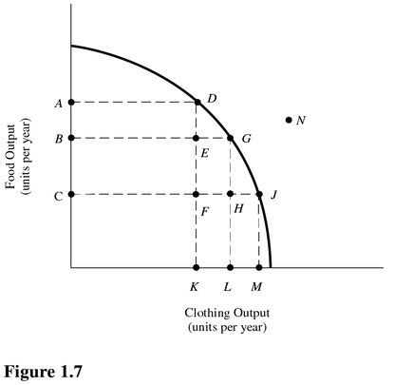
Refer to Figure 1.7. This economy will achieve efficiency in production at
A) Point D only.
B) Point G only.
C) Point J only.
D) Points D, G, and J.

Answer: D
Difficulty: 3 Hard
Topic: Production Possibilities
Learning Objective: 01-03 What the production-possibilities curve represents.
Bloom's: Apply
AACSB: Analytical Thinking
Accessibility: Keyboard Navigation

84)
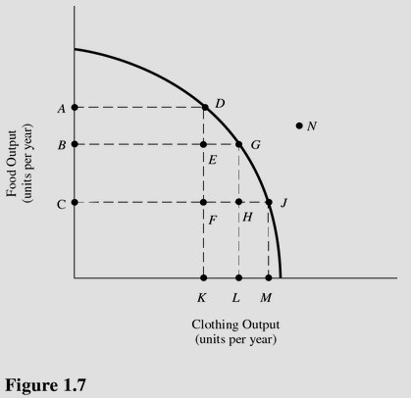
Refer to Figure 1.7. The cost of producing at point G rather than point D is
A) OA units of food.
B) KL units of clothing.
C) AB units of food.
D) OL units of clothing.

Answer: C
Difficulty: 3 Hard
Topic: Production Possibilities
Learning Objective: 01-03 What the production-possibilities curve represents.
Bloom's: Apply
AACSB: Analytical Thinking
Accessibility: Keyboard Navigation

85)
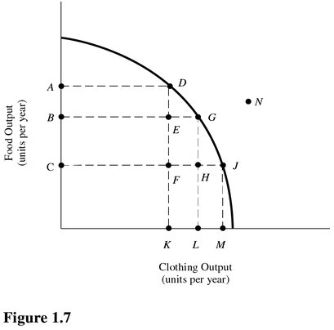
Refer to Figure 1.7. The benefit of producing at point G rather than point D is
A) OA units of food.
B) KL units of clothing.
C) AB units of food.
D) OL units of clothing.

Answer: B
Difficulty: 3 Hard
Topic: Production Possibilities
Learning Objective: 01-03 What the production-possibilities curve represents.
Bloom's: Apply
AACSB: Analytical Thinking
Accessibility: Keyboard Navigation

86)
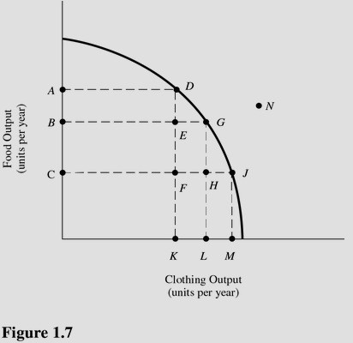
Refer to Figure 1.7. The cost of producing at point D rather than point J is
A) KM units of clothing.
B) AC units of food.
C) OM units of clothing.
D) OA units of food.

Answer: A
Difficulty: 3 Hard
Topic: Production Possibilities
Learning Objective: 01-03 What the production-possibilities curve represents.
Bloom's: Apply
AACSB: Analytical Thinking
Accessibility: Keyboard Navigation

87)
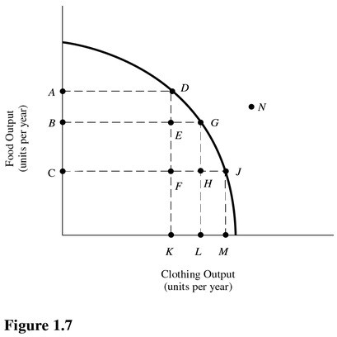
Refer to Figure 1.7. If this economy is currently producing at point F, then by employing more resources this economy
A) Can move to point D, but not points G or J.
B) Can move to points D, G, or J.
C) Can move to point G, but not points D or J.
D) Will remain at point F.

Answer: B
Difficulty: 3 Hard
Topic: Production Possibilities
Learning Objective: 01-03 What the production-possibilities curve represents.
Bloom's: Apply
AACSB: Analytical Thinking
Accessibility: Keyboard Navigation

88)
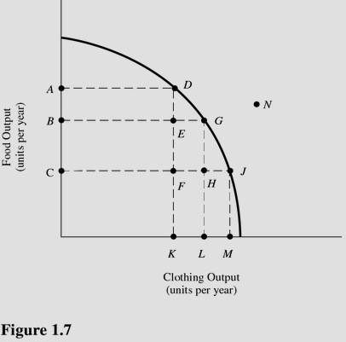
Refer to Figure 1.7. Which of the following points are considered to be inefficient?
A) D.
B) E.
C) G.
D) D, G, and J.

Answer: B
Difficulty: 3 Hard
Topic: Production Possibilities
Learning Objective: 01-03 What the production-possibilities curve represents.
Bloom's: Apply
AACSB: Analytical Thinking
Accessibility: Keyboard Navigation

89)
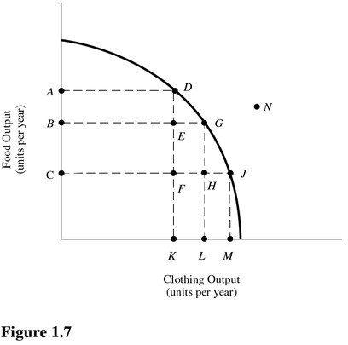
Refer to Figure 1.7. Which of the following points are unattainable, ceteris paribus?
A) G.
B) F.
C) N.
D) E.

Answer: C
Difficulty: 3 Hard
Topic: Production Possibilities
Learning Objective: 01-03 What the production-possibilities curve represents.
Bloom's: Apply
AACSB: Analytical Thinking
Accessibility: Keyboard Navigation

90)
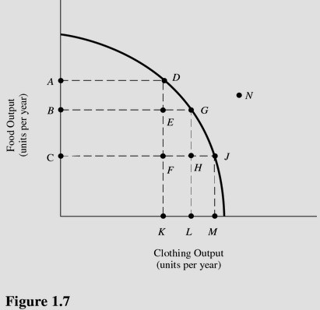
Refer to Figure 1.7. Which of the following points show unemployment of resources above the normal rate?
A) H.
B) J.
C) N.
D) D.

Answer: A
Difficulty: 3 Hard
Topic: Production Possibilities
Learning Objective: 01-03 What the production-possibilities curve represents.
Bloom's: Apply
AACSB: Analytical Thinking
Accessibility: Keyboard Navigation

91) Table 1.1 shows the hypothetical trade-off between different combinations of Stealth bombers and B-1 bombers that might be produced in a year with the limited U.S. capacity, ceteris paribus.

Table 1.1
Production Possibilities for Bombers

Combination | Number of B-1 Bombers | Opportunity cost(Foregone Stealth) | Number of Stealth Bombers | Opportunity cost (Foregone B-1)
S | 0 | NA | 10
T | 1 |  | 9
U | 2 |  | 7
V | 3 |  | 4 | NA

On the basis of Table 1.1, you may infer that the law of increasing opportunity costs applies to increasing production of
A) Stealth bombers but not to B-1 bombers.
B) B-1 bombers.
C) Both B-1 bombers and Stealth Bombers.
D) Neither B-1 bombers or Stealth Bombers.

Answer: C
Difficulty: 3 Hard
Topic: Production Possibilities
Learning Objective: 01-02 How scarcity creates opportunity costs.
Bloom's: Apply
AACSB: Analytical Thinking
Accessibility: Keyboard Navigation

92) Table 1.1 shows the hypothetical trade-off between different combinations of Stealth bombers and B-1 bombers that might be produced in a year with the limited U.S. capacity, ceteris paribus.

Table 1.1
Production Possibilities for Bombers

Combination | Number of B-1 Bombers | Opportunity cost (Foregone Stealth) | Number of Stealth Bombers | Opportunity cost (Foregone B-1)
S | 0 | NA | 10
T | 1 |  | 9
U | 2 |  | 7
V | 3 |  | 4 | NA

On the basis of Table 1.1, what is the opportunity cost of producing at point S rather than point T?
A) 1 Stealth bomber.
B) 1 B-1 bomber.
C) 10 Stealth bombers.
D) 0.9 Stealth bombers.

Answer: B
Difficulty: 3 Hard
Topic: Production Possibilities
Learning Objective: 01-02 How scarcity creates opportunity costs.
Bloom's: Apply
AACSB: Analytical Thinking
Accessibility: Keyboard Navigation

93) Table 1.1 shows the hypothetical trade-off between different combinations of Stealth bombers and B-1 bombers that might be produced in a year with the limited U.S. capacity, ceteris paribus.

Table 1.1
Production Possibilities for Bombers

Combination | Number of B-1 Bombers | Opportunity cost (Foregone Stealth) | Number of Stealth Bombers | Opportunity cost (Foregone B-1)
S | 0 | NA | 10
T | 1 |  | 9
U | 2 |  | 7
V | 3 |  | 4 | NA

On the basis Table 1.1, what is the opportunity cost of producing at point V rather than point U?
A) 3 B-1 bombers.
B) 1 B-1 bomber.
C) 4 Stealth bombers.
D) 3 Stealth bombers.

Answer: D
Difficulty: 3 Hard
Topic: Production Possibilities
Learning Objective: 01-02 How scarcity creates opportunity costs.
Bloom's: Apply
AACSB: Analytical Thinking
Accessibility: Keyboard Navigation

94) Table 1.1 shows the hypothetical trade-off between different combinations of Stealth bombers and B-1 bombers that might be produced in a year with the limited U.S. capacity, ceteris paribus.

Table 1.1
Production Possibilities for Bombers

Combination | Number of B-1 Bombers | Opportunity cost(Foregone Stealth) | Number of Stealth Bombers | Opportunity cost (Foregone B-1)
S | 0 | NA | 10
T | 1 |  | 9
U | 2 |  | 7
V | 3 |  | 4 | NA

In the production range of 7 to 9 Stealth bombers, the opportunity cost of producing 1 more Stealth bomber in terms of B-1s is
A) 0.
B) 3.
C) 0.5.
D) 2.

Answer: C
Difficulty: 3 Hard
Topic: Production Possibilities
Learning Objective: 01-02 How scarcity creates opportunity costs.
Bloom's: Apply
AACSB: Analytical Thinking
Accessibility: Keyboard Navigation

95) Table 1.1 shows the hypothetical trade-off between different combinations of Stealth bombers and B-1 bombers that might be produced in a year with the limited U.S. capacity, ceteris paribus.

Table 1.1
Production Possibilities for Bombers

Combination | Number of B-1 Bombers | Opportunity cost(Foregone Stealth) | Number of Stealth Bombers | Opportunity cost (Foregone B-1)
S | 0 | NA | 10
T | 1 |  | 9
U | 2 |  | 7
V | 3 |  | 4 | NA

The highest opportunity cost anywhere in Table 1.1 for Stealth bombers in terms of B-1 bombers is
A) 1 B bombers
B) 3 B bombers
C) 2 B bombers
D) 0.5 B bombers

Answer: A
Difficulty: 3 Hard
Topic: Production Possibilities
Learning Objective: 01-02 How scarcity creates opportunity costs.
Bloom's: Apply
AACSB: Analytical Thinking
Accessibility: Keyboard Navigation

96) Table 1.1 shows the hypothetical trade-off between different combinations of Stealth bombers and B-1 bombers that might be produced in a year with the limited U.S. capacity, ceteris paribus.

Table 1.1
Production Possibilities for Bombers

Combination | Number of B-1 Bombers | Opportunity cost(Foregone Stealth) | Number of Stealth Bombers | Opportunity cost (Foregone B-1)
S | 0 | NA | 10
T | 1 |  | 9
U | 2 |  | 7
V | 3 |  | 4 | NA

The highest opportunity cost in Table 1.1 for B-1 bombers in terms of Stealth bombers is
A) 1 Stealth bomber per B-1 bomber.
B) 3 Stealth bombers per B-1 bomber.
C) 2 Stealth bombers per B-1 bomber.
D) 0.5 Stealth bomber per B-1 bomber.

Answer: B
Difficulty: 3 Hard
Topic: Production Possibilities
Learning Objective: 01-02 How scarcity creates opportunity costs.
Bloom's: Apply
AACSB: Analytical Thinking
Accessibility: Keyboard Navigation

97) Table 1.1 shows the hypothetical trade-off between different combinations of Stealth bombers and B-1 bombers that might be produced in a year with the limited U.S. capacity, ceteris paribus.

Table 1.1
Production Possibilities for Bombers

Combination | Number of B-1 Bombers | Opportunity cost(Foregone Stealth) | Number of Stealth Bombers | Opportunity cost (Foregone B-1)
S | 0 | NA | 10
T | 1 |  | 9
U | 2 |  | 7
V | 3 |  | 4 | NA

The lowest opportunity cost e in Table 1.1 for B-1 bombers in terms of Stealth bombers is
A) 0 Stealth bombers per B-1 bomber.
B) 2 Stealth bombers per B-1 bomber.
C) 1 Stealth bomber per B-1 bomber.
D) 0.5 Stealth bomber per B-1 bomber.

Answer: C
Difficulty: 3 Hard
Topic: Production Possibilities
Learning Objective: 01-02 How scarcity creates opportunity costs.
Bloom's: Apply
AACSB: Analytical Thinking
Accessibility: Keyboard Navigation

98) Table 1.2 shows the hypothetical trade-off between different combinations of Stealth bombers and B-1 bombers that might be produced in a year with the limited U.S. capacity, ceteris paribus.

Table 1.2
Production Possibilities for Bombers

Combination | Number of B-1 Bombers | Opportunity cost(Foregone Stealth) | Number of Stealth Bombers | Opportunity cost (Foregone B-1)
A | 20 | Na | 195
B | 35 |  | 180
C | 45 |  | 150
D | 50 |  | 100 | NA

On the basis of Table 1.2, the law of increasing opportunity costs applies to
A) Both B-1 bombers and Stealth bombers.
B) B-1 bombers.
C) Stealth bombers but not to B-1 bombers.
D) Neither bomber.

Answer: A
Difficulty: 3 Hard
Topic: Production Possibilities
Learning Objective: 01-02 How scarcity creates opportunity costs.
Bloom's: Apply
AACSB: Analytical Thinking
Accessibility: Keyboard Navigation

99) Table 1.2 shows the hypothetical trade-off between different combinations of Stealth bombers and B-1 bombers that might be produced in a year with the limited U.S. capacity, ceteris paribus.

Table 1.2
Production Possibilities for Bombers

Combination | Number of B-1 Bombers | Opportunity cost(Foregone Stealth) | Number of Stealth Bombers | Opportunity cost (Foregone B-1)
A | 20 | Na | 195
B | 35 |  | 180
C | 45 |  | 150
D | 50 |  | 100 | NA

On the basis Table 1.2, if the economy is currently producing at point C, what is the opportunity cost of producing at point B?
A) 45 B-1 bombers.
B) 35 Stealth bombers.
C) 180 Stealth bombers.
D) 10 B-1 bombers.

Answer: D
Difficulty: 3 Hard
Topic: Production Possibilities
Learning Objective: 01-02 How scarcity creates opportunity costs.
Bloom's: Apply
AACSB: Analytical Thinking
Accessibility: Keyboard Navigation

100) Table 1.2 shows the hypothetical trade-off between different combinations of Stealth bombers and B-1 bombers that might be produced in a year with the limited U.S. capacity, ceteris paribus.

Table 1.2
Production Possibilities for Bombers

Combination | Number of B-1 Bombers | Opportunity cost(Foregone Stealth) | Number of Stealth Bombers | Opportunity cost (Foregone B-1)
A | 20 | NA | 195
B | 35 |  | 180
C | 45 |  | 150
D | 50 |  | 100 | NA

On the basis of your calculations in Table 1.2, what is gained by producing at point B rather than point C?
A) 45 B-1 bombers.
B) 30 Stealth bombers.
C) 180 Stealth bombers.
D) 10 B-1 bombers.

Answer: B
Difficulty: 3 Hard
Topic: Production Possibilities
Learning Objective: 01-02 How scarcity creates opportunity costs.
Bloom's: Apply
AACSB: Analytical Thinking
Accessibility: Keyboard Navigation

101) Table 1.2 shows the hypothetical trade-off between different combinations of Stealth bombers and B-1 bombers that might be produced in a year with the limited U.S. capacity, ceteris paribus.

Table 1.2
Production Possibilities for Bombers

Combination | Number of B-1 Bombers | Opportunity cost(Foregone Stealth) | Number of Stealth Bombers | Opportunity cost (Foregone B-1)
A | 20 | NA | 195
B | 35 |  | 180
C | 45 |  | 150
D | 50 |  | 100 | NA

On the basis of Table 1.2, what is gained by producing at point B rather than point A?
A) 35 B-1 bombers.
B) 195 Stealth bombers.
C) 15 B-1 bombers.
D) 15 Stealth bombers.

Answer: C
Difficulty: 3 Hard
Topic: Production Possibilities
Learning Objective: 01-02 How scarcity creates opportunity costs.
Bloom's: Apply
AACSB: Analytical Thinking
Accessibility: Keyboard Navigation

102) Table 1.2 shows the hypothetical trade-off between different combinations of Stealth bombers and B-1 bombers that might be produced in a year with the limited U.S. capacity, ceteris paribus.

Table 1.2
Production Possibilities for Bombers

Combination | Number of B-1 Bombers | Opportunity cost(Foregone Stealth) | Number of Stealth Bombers | Opportunity cost (Foregone B-1)
A | 20 | NA | 195
B | 35 |  | 180
C | 45 |  | 150
D | 50 |  | 100 | NA

Refer to Table 1.2. In the production range of 20 to 35 B-1 bombers, the opportunity cost of producing 1 more B-1 bomber is
A) 195/20 of Stealth bombers.
B) 35/20 of Stealth bombers.
C) 15 Stealth bombers.
D) 1 Stealth bomber.

Answer: D
Difficulty: 3 Hard
Topic: Production Possibilities
Learning Objective: 01-02 How scarcity creates opportunity costs.
Bloom's: Apply
AACSB: Analytical Thinking
Accessibility: Keyboard Navigation

103) Table 1.2 shows the hypothetical trade-off between different combinations of Stealth bombers and B-1 bombers that might be produced in a year with the limited U.S. capacity, ceteris paribus. Complete the table by calculating the required opportunity costs for both the B-1 and Stealth bombers.

Table 1.2
Production Possibilities for Bombers

Combination | Number of B-1 Bombers | Opportunity cost(Foregone Stealth) | Number of Stealth Bombers | Opportunity cost (Foregone B-1)
A | 20 | NA | 195
B | 35 |  | 180
C | 45 |  | 150
D | 50 |  | 100 | NA

The highest opportunity cost in Table 1.2 for B-1 bombers in terms of Stealth bombers is
A) 10 Stealth bombers per B-1
B) 33 B-1 bombers
C) 10 B-1 bombers
D) 10 Stealth bomber per B-1

Answer: A
Difficulty: 3 Hard
Topic: Production Possibilities
Learning Objective: 01-02 How scarcity creates opportunity costs.
Bloom's: Apply
AACSB: Analytical Thinking
Accessibility: Keyboard Navigation

104) Table 1.2 shows the hypothetical trade-off between different combinations of Stealth bombers and B-1 bombers that might be produced in a year with the limited U.S. capacity, ceteris paribus.

Table 1.2
Production Possibilities for Bombers

Combination | Number of B-1 Bombers | Opportunity cost(Foregone Stealth) | Number of Stealth Bombers | Opportunity cost (Foregone B-1)
A | 20 | NA | 195
B | 35 |  | 180
C | 45 |  | 150
D | 50 |  | 100 | NA

The lowest opportunity cost in Table 1.2 for Stealth Bombers is
A) 4 B-1 bombers
B) 3 B-1 bombers
C) 2 B-1 bombers
D) 10 B-1 bombers

Answer: D
Difficulty: 3 Hard
Topic: What Economics is All About
Learning Objective: 01-02 How scarcity creates opportunity costs.
Bloom's: Apply
AACSB: Analytical Thinking
Accessibility: Keyboard Navigation

105) Table 1.3 shows the hypothetical trade-off between different combinations of brushes and combs that might be produced in a year with the limited capacity for Country X, ceteris paribus.

Table 1.3
Production Possibilities for Brushes and Combs

Combination | Number of Brushes | Opportunity Cost of Brushes in Terms of Combs | Number of Combs | Opportunity Cost of Combs in Terms of Brushes
J | 0 |  | 4
K | 10 |  | 3
L | 17 |  | 2
M | 21 |  | 1
N | 23 |  | 0

Table 1.3
Production Possibilities for Brushes and Combs

Combination | Number of combs | Opportunity Cost(Foregone brushes) | Number of brushes | Opportunity Cost (Foregone combs)
J | 4 |  | 0 | NA
K | 3 |  | 10
L | 2 |  | 17
M | 1 |  | 21
N | 0 | NA | 23

On the basis of Table 1.3, what is the opportunity cost of producing at point M rather than point N?
A) 23 combs.
B) 21 combs.
C) 1 brush.
D) 2 brushes.

Answer: D
Difficulty: 3 Hard
Topic: Production Possibilities
Learning Objective: 01-02 How scarcity creates opportunity costs.
Bloom's: Apply
AACSB: Analytical Thinking
Accessibility: Keyboard Navigation

106) Table 1.3 shows the hypothetical trade-off between different combinations of brushes and combs that might be produced in a year with the limited capacity for Country X, ceteris paribus.

Table 1.3
Production Possibilities for Brushes and Combs

Combination | Number of combs | Opportunity Cost(Foregone brushes) | Number of brushes | Opportunity Cost (Foregone combs)
J | 4 |  | 0 | NA
K | 3 |  | 10
L | 2 |  | 17
M | 1 |  | 21
N | 0 | NA | 23

On the basis Table 1.3, what is gained by producing at point M rather than point N?
A) 23 combs.
B) 21 combs.
C) 1 comb.
D) 2 combs.

Answer: C
Difficulty: 3 Hard
Topic: Production Possibilities
Learning Objective: 01-02 How scarcity creates opportunity costs.
Bloom's: Apply
AACSB: Analytical Thinking
Accessibility: Keyboard Navigation

107) Table 1.3 shows the hypothetical trade-off between different combinations of brushes and combs that might be produced in a year with the limited capacity for Country X, ceteris paribus.

Table 1.3
Production Possibilities for Brushes and Combs

Combination | Number of combs | Opportunity Cost(Foregone brushes) | Number of brushes | Opportunity Cost (Foregone combs)
J | 4 |  | 0 | NA
K | 3 |  | 10
L | 2 |  | 17
M | 1 |  | 21
N | 0 | NA | 23

On the basis Table 1.3, what is gained from producing at point L rather than point K?
A) 17 combs.
B) 10 combs.
C) 1 brush.
D) 7 brushes.

Answer: D
Difficulty: 3 Hard
Topic: Production Possibilities
Learning Objective: 01-02 How scarcity creates opportunity costs.
Bloom's: Apply
AACSB: Analytical Thinking
Accessibility: Keyboard Navigation

108) Table 1.3 shows the hypothetical trade-off between different combinations of brushes and combs that might be produced in a year with the limited capacity for Country X, ceteris paribus.

Table 1.3
Production Possibilities for Brushes and Combs

Combination | Number of combs | Opportunity Cost(Foregone brushes) | Number of brushes | Opportunity Cost (Foregone combs)
J | 4 |  | 0 | NA
K | 3 |  | 10
L | 2 |  | 17
M | 1 |  | 21
N | 0 | NA | 23

On the basis of Table 1.3, the law of increasing opportunity costs applies to
A) Both brushes and combs.
B) Combs but not brushes.
C) Brushes but not combs.
D) Neither brushes nor combs.

Answer: A
Difficulty: 3 Hard
Topic: Production Possibilities
Learning Objective: 01-02 How scarcity creates opportunity costs.
Bloom's: Apply
AACSB: Analytical Thinking
Accessibility: Keyboard Navigation

109) Table 1.3 shows the hypothetical trade-off between different combinations of brushes and combs that might be produced in a year with the limited capacity for Country X, ceteris paribus.

Table 1.3
Production Possibilities for Brushes and Combs

Combination | Number of combs | Opportunity Cost(Foregone brushes) | Number of brushes | Opportunity Cost (Foregone combs)
J | 4 |  | 0 | NA
K | 3 |  | 10
L | 2 |  | 17
M | 1 |  | 21
N | 0 | NA | 23

On the basis of Table 1.3, in the production range of 2 to 3 combs the opportunity cost of producing 1 more comb in terms of brushes is
A) 3.33.
B) 7.0.
C) 0.67.
D) 0.14.

Answer: B
Difficulty: 3 Hard
Topic: Production Possibilities
Learning Objective: 01-02 How scarcity creates opportunity costs.
Bloom's: Apply
AACSB: Analytical Thinking
Accessibility: Keyboard Navigation

110) Table 1.3 shows the hypothetical trade-off between different combinations of brushes and combs that might be produced in a year with the limited capacity for Country X, ceteris paribus.

Table 1.3
Production Possibilities for Brushes and Combs

Combination | Number of combs | Opportunity Cost(Foregone brushes) | Number of brushes | Opportunity Cost (Foregone combs)
J | 4 |  | 0 | NA
K | 3 |  | 10
L | 2 |  | 17
M | 1 |  | 21
N | 0 | NA | 23

On the basis of Table 1.3, in the production range of 21 to 23 brushes the opportunity cost of producing one more comb in terms of brushes is
A) 1/21.
B) 21/23.
C) 1/2.
D) 4.

Answer: C
Difficulty: 3 Hard
Topic: Production Possibilities
Learning Objective: 01-02 How scarcity creates opportunity costs.
Bloom's: Apply
AACSB: Analytical Thinking
Accessibility: Keyboard Navigation

111) Table 1.3 shows the hypothetical trade-off between different combinations of brushes and combs that might be produced in a year with the limited capacity for Country X, ceteris paribus.

Table 1.3
Production Possibilities for Brushes and Combs

Combination | Number of combs | Opportunity Cost(Foregone brushes) | Number of brushes | Opportunity Cost (Foregone combs)
J | 4 |  | 0 | NA
K | 3 |  | 10
L | 2 |  | 17
M | 1 |  | 21
N | 0 | NA | 23

On the basis of Table 1.3, in the production range of 1 to 2 combs the opportunity cost of producing 1 more comb in terms of brushes is
A) 4.
B) 1/2.
C) 2/17.
D) 1/7.

Answer: A
Difficulty: 3 Hard
Topic: Production Possibilities
Learning Objective: 01-02 How scarcity creates opportunity costs.
Bloom's: Apply
AACSB: Analytical Thinking
Accessibility: Keyboard Navigation

112) Table 1.3 shows the hypothetical trade-off between different combinations of brushes and combs that might be produced in a year with the limited capacity for Country X, ceteris paribus.

Table 1.3
Production Possibilities for Brushes and Combs

Combination | Number of combs | Opportunity Cost(Foregone brushes) | Number of brushes | Opportunity Cost (Foregone combs)
J | 4 |  | 0 | NA
K | 3 |  | 10
L | 2 |  | 17
M | 1 |  | 21
N | 0 | NA | 23

On the basis of Table 1.3, the highest opportunity cost for brushes in terms of combs is
A) 0.10 comb per brush.
B) 23 combs per brush.
C) 0.50 comb per brush.
D) 0.29 comb per brush.

Answer: C
Difficulty: 3 Hard
Topic: Production Possibilities
Learning Objective: 01-02 How scarcity creates opportunity costs.
Bloom's: Apply
AACSB: Analytical Thinking
Accessibility: Keyboard Navigation

113) Table 1.3 shows the hypothetical trade-off between different combinations of brushes and combs that might be produced in a year with the limited capacity for Country X, ceteris paribus.

Table 1.3
Production Possibilities for Brushes and Combs

Combination | Number of combs | Opportunity Cost(Foregone brushes) | Number of brushes | Opportunity Cost (Foregone combs)
J | 4 |  | 0 | NA
K | 3 |  | 10
L | 2 |  | 17
M | 1 |  | 21
N | 0 | NA | 23

On the basis of Table 1.3, the lowest opportunity cost for combs in terms of brushes is
A) 10 brushes per comb.
B) 2 brushes per comb.
C) 0.33 brush per comb.
D) 8.5 brushes per comb.

Answer: B
Difficulty: 3 Hard
Topic: Production Possibilities
Learning Objective: 01-02 How scarcity creates opportunity costs.
Bloom's: Apply
AACSB: Analytical Thinking
Accessibility: Keyboard Navigation

114) Refer to the World View article titled "North Korea's Food Shortage Grows." On a production possibilities curve between private and public goods, a decrease in military spending in an effort to increase food production could be represented as
A) A movement along the production possibilities curve toward more public goods.
B) A movement along the production possibilities curve toward more private goods.
C) A shift outward of the production possibilities curve.
D) A shift inward of the production possibilities curve.

Answer: B
Difficulty: 1 Easy
Topic: Production Possibilities
Learning Objective: 01-02 How scarcity creates opportunity costs.
Bloom's: Remember
AACSB: Reflective Thinking
Accessibility: Keyboard Navigation
115) Refer to the World View article titled "North Korea's Food Shortage Grows." If North Korea reduces the size of its military and produces more food, this is most consistent with
A) A movement along the economy's production possibilities curve.
B) Privatization.
C) A laissez faire policy.
D) The law of increasing opportunity costs.

Answer: A
Difficulty: 1 Easy
Topic: Production Possibilities
Learning Objective: 01-02 How scarcity creates opportunity costs.
Bloom's: Remember
AACSB: Reflective Thinking
Accessibility: Keyboard Navigation

116) The Economy Tomorrow on "Harnessing the Sun" states that the percentage of electricity that is generated from burning oil and coal is:
A) Less than 10%.
B) Between 10% and 30%.
C) Between 30% and 50%.
D) Greater than 50%.

Answer: D
Difficulty: 3 Hard
Topic: The Mechanisms of Choice
Learning Objective: 01-02 How scarcity creates opportunity costs.
Bloom's: Apply
AACSB: Analytical Thinking
Accessibility: Keyboard Navigation

117)
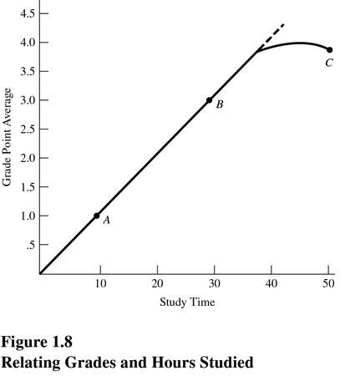
Figure 1.8 suggests that
A) The law of increasing opportunity cost does not apply.
B) Resources can be perfectly adapted between study time and grade point average.
C) The relationship between study time and grade point average is first linear, then nonlinear.
D) The relationship between study time and grade point average is constant.

Answer: C
Difficulty: 3 Hard
Topic: Opportunity Costs
Learning Objective: 01-02 How scarcity creates opportunity costs.
Bloom's: Apply
AACSB: Analytical Thinking
Accessibility: Keyboard Navigation

118)
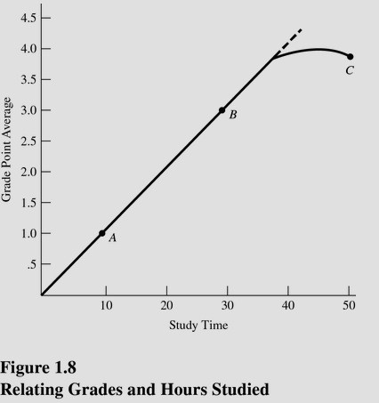
Refer to Figure 1.8. If the university decides to lower grading standards, then
A) This curve will shift rightward.
B) This curve will shift to the left.
C) The curve will begin to bend downward at an earlier point.
D) We will slide up the curve from point B to point C.

Answer: B
Difficulty: 3 Hard
Topic: Opportunity Costs
Learning Objective: 01-02 How scarcity creates opportunity costs.
Bloom's: Apply
AACSB: Analytical Thinking
Accessibility: Keyboard Navigation

119)
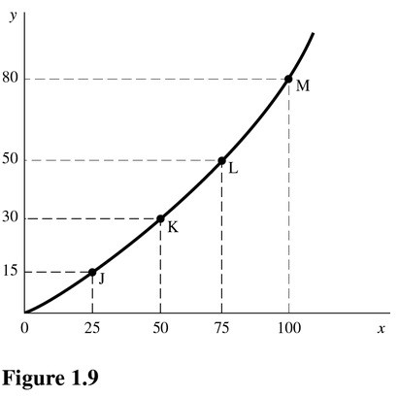
In Figure 1.9, as you move up the curve from point J toward point M, the slope
A) Increases.
B) Remains constant.
C) Decreases.
D) Becomes negative.

Answer: A
Difficulty: 3 Hard
Topic: Opportunity Costs
Learning Objective: 01-01 What scarcity is.
Bloom's: Apply
AACSB: Analytical Thinking
Accessibility: Keyboard Navigation

120)
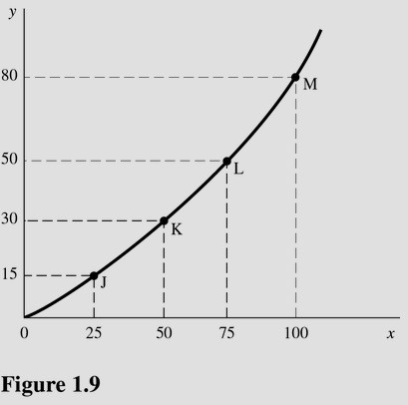
In Figure 1.9, the slope of the line between points L and M is
A) 1.20.
B) 0.80.
C) 0.75.
D) 0.67.

Answer: A
Difficulty: 3 Hard
Topic: Opportunity Costs
Learning Objective: 01-01 What scarcity is.
Bloom's: Apply
AACSB: Analytical Thinking
Accessibility: Keyboard Navigation

121)
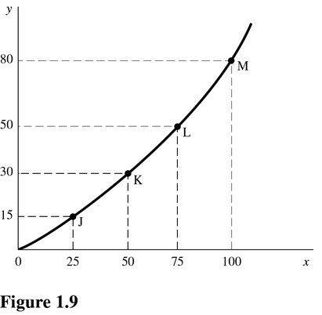
In Figure 1.9, the slope of the line between points K and L is
A) 1.25.
B) 0.80.
C) 0.75.
D) 0.60.

Answer: B
Difficulty: 3 Hard
Topic: Opportunity Costs
Learning Objective: 01-01 What scarcity is.
Bloom's: Apply
AACSB: Analytical Thinking
Accessibility: Keyboard Navigation

122)
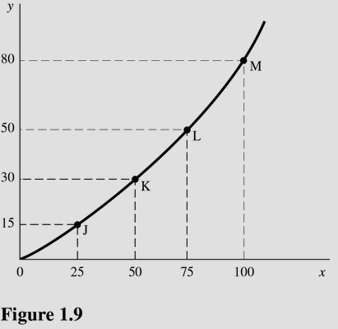
In Figure 1.9 the slope of the line is
A) Greater at point K than point L.
B) Equal to zero at all points.
C) The same at points J and K.
D) Greater at point M than point L.

Answer: D
Difficulty: 3 Hard
Topic: Opportunity Costs
Learning Objective: 01-01 What scarcity is.
Bloom's: Apply
AACSB: Analytical Thinking
Accessibility: Keyboard Navigation

123) The slope of a curve at any point is given by this formula:
A) The change in y coordinates between two points divided by the change in their x coordinates.
B) The change in x coordinates between two points divided by the change in their y coordinates.
C) The percentage change in y coordinates between two points divided by the percentage change in their x coordinates.
D) The percentage change in x coordinates between two points divided by the percentage change in their y coordinates.

Answer: A
Difficulty: 3 Hard
Topic: Opportunity Costs
Learning Objective: 01-01 What scarcity is.
Bloom's: Apply
AACSB: Analytical Thinking
Accessibility: Keyboard Navigation

124) A line that slopes downward from left to right has a
A) Negative slope.
B) Positive slope.
C) Slope that changes as you move along the curve.
D) Slope of zero.

Answer: A
Difficulty: 3 Hard
Topic: What Economics is All About
Learning Objective: 01-01 What scarcity is.
Bloom's: Apply
AACSB: Analytical Thinking
Accessibility: Keyboard Navigation

125) A linear function can be distinguished by
A) The continuous change in its slope.
B) The same slope throughout the line.
C) The changing relationship between the two variables.
D) A shift in the function.

Answer: B
Difficulty: 3 Hard
Topic: What Economics is All About
Learning Objective: 01-01 What scarcity is.
Bloom's: Apply
AACSB: Analytical Thinking
Accessibility: Keyboard Navigation

126) When the relationship between two variables changes,
A) There is movement from one point on the curve to another point on the curve.
B) The curve becomes linear.
C) The entire curve shifts.
D) All of the choices are correct.

Answer: C
Difficulty: 3 Hard
Topic: What Economics is All About
Learning Objective: 01-01 What scarcity is.
Bloom's: Apply
AACSB: Analytical Thinking
Accessibility: Keyboard Navigation

127) The fact that there are too few resources to satisfy all our wants is attributed to
A) Scarcity.
B) Greed.
C) Shortages.
D) Lack of money.

Answer: A
Difficulty: 2 Medium
Topic: Scarcity: The Core Problem
Learning Objective: 01-01 What scarcity is.
Bloom's: Understand
AACSB: Reflective Thinking
Accessibility: Keyboard Navigation

128) According to the text, there is no such thing as a free lunch because
A) The producer must charge something to cover the cost of production.
B) Resources used to produce the lunch could be used to produce other goods and services.
C) The government must raise taxes to pay for the lunches.
D) No one would pay for lunch anymore if they could get it for free.

Answer: B
Difficulty: 2 Medium
Topic: Scarcity: The Core Problem
Learning Objective: 01-02 How scarcity creates opportunity costs.
Bloom's: Understand
AACSB: Reflective Thinking
Accessibility: Keyboard Navigation

129) In using a tanks and trucks production possibilities curve with increasing opportunity cost, producing more and more tanks
A) Lowers the cost of each individual tank.
B) Can be done at a constant opportunity cost.
C) Requires us to give up larger and larger amounts of trucks per tank produced.
D) Is not possible due to scarcity.

Answer: C
Difficulty: 3 Hard
Topic: Production Possibilities
Learning Objective: 01-03 What the production-possibilities curve represents.
Bloom's: Apply
AACSB: Analytical Thinking
Accessibility: Keyboard Navigation

130) Producing at a point inside the production possibilities curve
A) Means society must be using its resources efficiently.
B) Is unattainable given the present level of technology.
C) Is feasible when the nation is at war but not feasible when the nation is at peace.
D) Suggests we are forgoing the ability to produce more of both goods.

Answer: D
Difficulty: 2 Medium
Topic: Production Possibilities
Learning Objective: 01-04 The three core economic questions that every society must answer.; 01-01 What scarcity is.; 01-03 What the production-possibilities curve represents.
Bloom's: Understand
AACSB: Reflective Thinking
Accessibility: Keyboard Navigation

131) Scarcity results when available resources cannot satisfy all desired uses of those resources.

Answer: TRUE
Explanation: Wants exceed resources.
Difficulty: 2 Medium
Topic: Scarcity: The Core Problem
Learning Objective: 01-01 What scarcity is.
Bloom's: Understand
AACSB: Reflective Thinking
Accessibility: Keyboard Navigation

132) Critics of government regulation argue that government interference in the marketplace stifles the "animal spirits" of entrepreneurship.

Answer: TRUE
Explanation: Regulation and intervention by the government reduce incentives to produce.
Difficulty: 2 Medium
Topic: The Mechanisms of Choice
Learning Objective: 01-05 How market and government approaches to economic problems differ.
Bloom's: Understand
AACSB: Reflective Thinking
Accessibility: Keyboard Navigation

133) Opportunity cost is a theoretical concept with no practical application.

Answer: FALSE
Explanation: Any activity requires that something be given up-an opportunity cost.
Difficulty: 2 Medium
Topic: Scarcity: The Core Problem
Learning Objective: 01-02 How scarcity creates opportunity costs.
Bloom's: Understand
AACSB: Reflective Thinking
Accessibility: Keyboard Navigation

134) Every time we use scarce resources in one way, we give up the opportunity to use them in other ways.

Answer: TRUE
Explanation: A cost is always involved in any activity.
Difficulty: 2 Medium
Topic: Scarcity: The Core Problem
Learning Objective: 01-02 How scarcity creates opportunity costs.
Bloom's: Understand
AACSB: Reflective Thinking
Accessibility: Keyboard Navigation

135) Production possibilities in an economy decrease as more resources and better technology are utilized.

Answer: FALSE
Explanation: More resources and better technology create a greater capacity to produce.
Difficulty: 2 Medium
Topic: Production Possibilities
Learning Objective: 01-03 What the production-possibilities curve represents.
Bloom's: Understand
AACSB: Reflective Thinking
Accessibility: Keyboard Navigation
136) All output combinations that lie outside a production possibilities curve are attainable with available resources and technology.

Answer: FALSE
Explanation: Attainable levels of production lie on or inside the production possibilities curve.
Difficulty: 2 Medium
Topic: Production Possibilities
Learning Objective: 01-03 What the production-possibilities curve represents.
Bloom's: Understand
AACSB: Reflective Thinking
Accessibility: Keyboard Navigation

137) Output combinations that lie inside the production possibilities curve are characterized by efficient use of resources.

Answer: FALSE
Explanation: Efficient levels of production lie on the production possibilities curve.
Difficulty: 2 Medium
Topic: Production Possibilities
Learning Objective: 01-03 What the production-possibilities curve represents.
Bloom's: Understand
AACSB: Reflective Thinking
Accessibility: Keyboard Navigation

138) If the economy is inside the production possibilities curve, then more output can be produced using existing resources.

Answer: TRUE
Explanation: Below the production possibilities curve, resources are not being fully employed, so we can get more production without sacrificing any goods.
Difficulty: 2 Medium
Topic: Production Possibilities
Learning Objective: 01-03 What the production-possibilities curve represents.
Bloom's: Understand
AACSB: Reflective Thinking
Accessibility: Keyboard Navigation

139) All economies must make decisions concerning what to produce, how to produce it, and for whom to produce.

Answer: TRUE
Explanation: These are the basic questions of how an economy will be organized.
Difficulty: 2 Medium
Topic: Three Basic Decisions
Learning Objective: 01-04 The three core economic questions that every society must answer.
Bloom's: Understand
AACSB: Reflective Thinking
Accessibility: Keyboard Navigation
140) The essential feature of the market mechanism is the price signal.

Answer: TRUE
Explanation: Prices guide buyers and sellers to achieve an optimal allocation of resources.
Difficulty: 2 Medium
Topic: The Mechanisms of Choice
Learning Objective: 01-04 The three core economic questions that every society must answer.
Bloom's: Understand
AACSB: Reflective Thinking
Accessibility: Keyboard Navigation

141) Government failure occurs when government intervention fails to improve economic outcomes or makes them worse.

Answer: TRUE
Explanation: In such a case, the market outcome would be preferred to government intervention.
Difficulty: 2 Medium
Topic: The Mechanisms of Choice
Learning Objective: 01-05 How market and government approaches to economic problems differ.
Bloom's: Understand
AACSB: Reflective Thinking
Accessibility: Keyboard Navigation

142) Microeconomics is concerned with individual performance as well as the economy as a whole.

Answer: FALSE
Explanation: Microeconomics looks at the building blocks of any economy: firms, workers, and governments.
Difficulty: 2 Medium
Topic: What Economics is All About
Learning Objective: 01-05 How market and government approaches to economic problems differ.
Bloom's: Understand
AACSB: Reflective Thinking
Accessibility: Keyboard Navigation

143) The Latin phrase ceteris paribus refers to holding other variables constant.

Answer: TRUE
Explanation: We must hold many variables constant when we study how one variable affects another.
Difficulty: 1 Easy
Topic: What Economics is All About
Learning Objective: 01-05 How market and government approaches to economic problems differ.
Bloom's: Remember
AACSB: Reflective Thinking
Accessibility: Keyboard Navigation
144) To calculate the slope of a line, find the vertical distance between two points and divide it by the horizontal distance between the same two points.

Answer: TRUE
Explanation: This is the same as rise over run, or change in y divided by change in x.
Difficulty: 1 Easy
Topic: What Economics is All About
Learning Objective: 01-01 What scarcity is.
Bloom's: Remember
AACSB: Reflective Thinking
Accessibility: Keyboard Navigation

145) The slope of a production possibilities curve is positive.

Answer: FALSE
Explanation: The production possibilities curve will always be downward-sloping, but it may be constant or nonconstant.
Difficulty: 2 Medium
Topic: Production Possibilities
Learning Objective: 01-03 What the production-possibilities curve represents.
Bloom's: Understand
AACSB: Reflective Thinking
Accessibility: Keyboard Navigation

146) When a curve shifts, the underlying relationship between the two variables has changed.

Answer: TRUE
Explanation: A shift in the curve reflects a change in the relationship between the two variables.
Difficulty: 2 Medium
Topic: What Economics is All About
Learning Objective: 01-01 What scarcity is.
Bloom's: Understand
AACSB: Reflective Thinking
Accessibility: Keyboard Navigation

147) Explain why an economist would say, "There is no such thing as a free lunch."

Answer: All resources are scarce. Any time a scarce resource is used in one way, the opportunity to use the resource in other ways is given up. The resources used to produce a 'free lunch' could have been used to produce other goods or services, so an opportunity cost is incurred.
Difficulty: 3 Hard
Topic: Scarcity: The Core Problem
Learning Objective: 01-02 How scarcity creates opportunity costs.
Bloom's: Analyze
AACSB: Analytical Thinking
Accessibility: Keyboard Navigation

148) Describe the shape of the typical production possibilities curve and explain why it has this shape.

Answer: The typical production possibilities curve bends or bows outward. It has this shape because opportunity costs increase as society produces more of a good. In order to get more of a particular good, increasing quantities of other goods must be given up. This is known as the law of increasing opportunity costs.
Difficulty: 2 Medium
Topic: Production Possibilities
Learning Objective: 01-03 What the production-possibilities curve represents.
Bloom's: Understand
AACSB: Reflective Thinking
Accessibility: Keyboard Navigation

149) Why do opportunity costs increase as society produces more of a good?

Answer: As society produces more of a good, ever-increasing quantities of other goods and services must be sacrificed or given up. This occurs mostly because there is difficulty experienced in moving resources from one industry to another. The mix of factor inputs also has an impact and may restrict output capabilities.
Difficulty: 2 Medium
Topic: Production Possibilities
Learning Objective: 01-02 How scarcity creates opportunity costs.
Bloom's: Understand
AACSB: Reflective Thinking
Accessibility: Keyboard Navigation

150) Explain the concept of inefficiency in terms of a production possibilities curve.

Answer: A production possibilities curve shows potential output using all available resources efficiently and current technology. If an economy does not use all the available resources efficiently with current technology available to it, then it will produce inside the production possibilities curve. This is referred to as inefficiency.
Difficulty: 2 Medium
Topic: Production Possibilities
Learning Objective: 01-03 What the production-possibilities curve represents.
Bloom's: Understand
AACSB: Reflective Thinking
Accessibility: Keyboard Navigation

151) Explain the difference between macroeconomics and microeconomics. Give examples of each.

Answer: Macroeconomics focuses on aggregate economic behavior. Full employment, price stability, and economic growth are macroeconomic issues. Microeconomics is concerned with the smaller components that actually contribute to the macroeconomy, such as individuals, particular business firms and industries, and government agencies.
Difficulty: 2 Medium
Topic: What Economics is All About
Learning Objective: 01-02 How scarcity creates opportunity costs.
Bloom's: Understand
AACSB: Reflective Thinking
Accessibility: Keyboard Navigation

152) How does the market mechanism answer the WHAT, HOW, and FOR WHOM questions?

Answer: The market mechanism answers the WHAT question through the indirect interactions of producers and consumers. Market prices and sales signal the desired output. Producers desire to maximize profits and look for the least-cost method of production. This answers the HOW question. The market distributes output to the highest bidder and in doing so answers the FOR WHOM question.
Difficulty: 2 Medium
Topic: The Mechanisms of Choice
Learning Objective: 01-04 The three core economic questions that every society must answer.
Bloom's: Understand
AACSB: Reflective Thinking
Accessibility: Keyboard Navigation

